PROJECT

**BCSP**

**–**

**064**

**ONLINE BOOK SHOPPING**

By

**SUNNY KUMAR**

# ENROLLMENT NO. : 2003607291

Under guidance

Of

# GUIDE NAME: BHANU PRATAP SINGH

Submitted to the School of Computer and Information Sciences, IGNOU

in partial fulfillment of the requirements for the award of the degree

Bachelors of Computer Application ( BCA )



Indira Gandhi National Open University Maidan Garhi

New Delhi – 110068.

|  |  |  |
| --- | --- | --- |
| S.NO | CONTENTS | PAGE NO. |
| 1 | SYNOPSIS | **01-27** |
| 2 | INTRODUCTION | **29** |
| 3 | AIM AND OBJECTIVES | **30** |
| 4 | SYSTEM ANALYSIS | **31** |
| 4.1 | IDENTIFICATION OF NEED | **32** |
| 4.2 | FEASIBILITY STUDY | **34** |
| 4.3 | PROJECT SCHEDULING | **35** |
| 4.4 | SOFTWARE PROCESS MODEL | **37** |
| 4.5 | DFD | **44** |
| 5 | ER DIAGRAM | **50** |
| 5.1 | SYSTEM DESIGN | **51** |
| 5.2 | DATA INTEGRITY & CONSTRAINTS | **53** |
| 5.3 | DATABASE DESIGN | **64** |
| 5.4 | USER INTERFACE DESIGN | **86-91** |
| 5.4 | ADMIN INTERFACE DESIGN | **92-97** |
| 6 | CODING | **98-201** |
| 7 | TESTING | **202-203** |
| 7.1 | LEVELS | **204-206** |
| 7.2 | DEBUGGING | **206-207** |
| 8 | VALIDATIONS | **208-213** |
| 9 | SYSTEM SECURITY MEASURES | **214-215** |
| 9.1 | DATABASE SECURITY | **216-217** |
| 10 | REPORTS | **218-220** |
| 11 | FUTURE SCOPE & FURTHER INHANCEMENT | **221** |
| 12 | BIBLIOGRAPHY | **222** |

**INDEX**

# INTRODUCTION

O

nline shopping is the platform where user could buy their products efficiently.

To excess these sites we have to go through the usage as well as its advantages. they provide excessive products to the users. Here users have many choices where they could get whatever they would like to buy.

In today’s world, usage of these websites are going at zenith.

Every person is getting use to have some essential things that they want. Online shopping saves time as well as provides convenience to the user.it reduces tiredness and gives relaxation.

On these sites, Heavy discounts are provided.

online shopping is the process whereby consumers directly buy goods and services from the seller interactively in real time without an intermediate services over the internet.

Online shopping is the process of buying goods and services from merchants who sells on the internet. Since emergence of the world wide web, merchants have sought to sell their products to people who surf the internet.

Shoppers can visit the web stores from comfort of their homes and shop as they sit in front of the computer. consumers buy the variety of items from online stores.

Infact , people can purchase just about anything from companies that provide their products online.

Books, clothing, households appliances, toys, hardware, software and health insurance are just some of the hundreds of products consumers can buy from an online store.

Many people choose to conduct shopping online because of the convenience.

For ex: when a person shops at a brick and mortar store.

She has to drive to the store, find a parking place and walk throughout the stores until she locates the product she needs.

After finding the items she wants to purchase, she may often need to stand in long lives at the cash register have any social interaction. It also doesn’t allow them to take the merchandise home the sameday they buy it.

Online shopping allow you to browse through endless possibilities and even offers merchandise that unavailable in stores.

If you are searching for a niche product that may not be disturbed totally, you’re sure to find what you’re looking for on the internet.

What’s ever more useful is the ability similar or not, online..

Shopping via internet eliminates the need to sift through a stores products with potential buys like pants, shirts, belts and shoes all slung over one arm. online shopping also eliminates the catchy, yet irritating music,as well as the hundreds, if not thousands of other like-minded individuals who seems to have decided to shop on the same day.

Say ‘goodbye’ to the days when you stood in line waiting and waiting some more for a store clerk to finally check out your items. Online shopping transaction occurs instantly saving you time to get your other errands done |

Additionally, unlike a store, online shopping has friendly customer services representatives available 24 hrs a day, 7days a week to assist you with locally, purchasing ans shipping your merchandise.

# AIM AND OBJECTIVES

The primary aim of this project is to demonstrate that with better interactive features in clothing web sites could improve sales for online retailers. The objectives of the project are as follows:

* To learn about the Online Book Shelf industry.
* To investigate potential problems with Online Book Shelf.
* To create a prototype web site focusing on one of the many problems that arises within Online Book Shelf.
* To evaluate the prototype with an existing online book shelf.

The classic tale of the tortoise and the hare, provided by Freedman, gave the inspiration that

Online Book Shelf is one the main markets that needs to be tapped in. Freedman’s prediction is that, slower starters or early laggards may prove to be some of the strongest categories online long term.

Within this dissertation, facts about Online Book Shelf are gathered to demonstrate whether Freedman’s prediction is correct.

# PROJECT CATEGORY

**OBJECT ORIENTED PROGRAMMING:-**Object-oriented programming (OOP) is a programming language model organized around [objects](http://searchsoa.techtarget.com/definition/object) rather than "actions" and data rather than logic. Historically, a program has been viewed as a logical procedure that takes input data, processes it, and produces output data.

## FEATURES OF OOPs:-

* **OBJECT:** Object is a collection of number of entities. Objects take up space in the memory. Objects are instances of classes. When a program is executed, the objects interact by sending messages to one another. Each object contains data and code to manipulate the data. Objects can interact without having the details of each other’s data or code.

* **CLASS:** Class is a collection of objects of similar type. Objects are variables of the type class. Once a class has been defined, we can create any number of objects belonging to that class.

* **ENCAPSULATION:** Data encapsulation is important feature of a class. Combining data and functions into a single unit called class and the process is known as Encapsulation.

* **ABSTRACTION:** Hiding the complexity of program is called Abstraction and only essential features are represented. In short we can say that internal working is hidden.

* **MESSAGE PASSING:** The process by which one object can interact with other object is called message passing.

* **INHERITANCE:** The process by which object of one class acquire the properties or features of objects of another class. The concept of inheritance provides the idea of reusability means we can add additional features to an existing class without modifying it. This is possible by driving a new class from the existing one.

* **POLYMORPHISM:** A Greek term means ability to take more than one form. An operation may exhibit different behaviors in different instances. The behavior depends upon the types of data used in the operation.

## RDBMS (Relational Database Management System):RDBMS stands for Relational

Database Management System. RDBMS data is a relational structure of database tables, fields and records. The data in RDBMS is stored in database objects called table. The table is a collection of related data entries and it consists of columns and rows. RDBMS also provide relational operators to manipulate the data stored into the database tables. RDBMS is the basis for SQL and for all modern database systems like SQL Server, ORACLE, MYSQL and Microsoft Access.

**INTERNET:** The Internet is the global system of interconnected computer networks that use the Internet protocol suite (TCP/IP) to link billions of devices worldwide. It is a network of networks that consists of millions of private, public, academic, business, and government networks of local to global scope, linked by a broad array of electronic, wireless, and optical networking technologies. The Internet carries an extensive range of information resources and services, such as the inter-linked hypertext documents and applications of the World Wide Web (WWW), electronic mail, telephony, and peer-to-peer networks for file sharing.

# TOOLS AND PLATFORMS

## SERVER SIDE REQUIREMENTS:-

**HARDWARE REQUIREMENTS: SOFTWARE REQUIREMENTS:**

|  |  |  |  |  |  |  |  |  |  |  |  |  |  |
| --- | --- | --- | --- | --- | --- | --- | --- | --- | --- | --- | --- | --- | --- |
| |  |  | | --- | --- | | **PROCESSOR** | **2.0 GHZ** | | **RAM** | **2 GB** | | **HARD DISK** | **8 GB** | | |  |  | | --- | --- | | **OPERATING SYSTEM** | **Any Compatible**  **Operating System** | | **LANGUAGE** | **PHP** | | **RDBMS** | **MS-SQL** | |

## CLIENT SIDE REQUIREMENTS:-

**SOFTWARE REQUIREMENTS:**

|  |  |
| --- | --- |
| **DEVICE** | **Any Display Device** |
| **BROWSER** | **Internet Explorer**  **6.0 or Any**  **Compatible**  **Browser** |
| **CONNECTION** | **Internet**  **Connection** |

# PHP AND MY SQL

## FRONT END: PHP

PHP is a [server-side scripting](https://en.wikipedia.org/wiki/Server-side_scripting) language designed for [web development](https://en.wikipedia.org/wiki/Web_development) but also used as a [general-purpose programming language.](https://en.wikipedia.org/wiki/General-purpose_programming_language) Originally created by [RasmusLerdorf](https://en.wikipedia.org/wiki/Rasmus_Lerdorf) in 1994, the PHP [reference implementation](https://en.wikipedia.org/wiki/Reference_implementation) is now produced by The PHP Group. While PHP originally stood for Personal Home Page. PHP code may be embedded into [HTML](https://en.wikipedia.org/wiki/HTML) code, or it can be used in combination with various [Web template systems](https://en.wikipedia.org/wiki/Web_template_system) and [web frameworks.](https://en.wikipedia.org/wiki/Web_framework) PHP code is usually processed by a PHP [interpreter](https://en.wikipedia.org/wiki/Interpreter_(computing)) implemented as a [module](https://en.wikipedia.org/wiki/Plugin_(computing)) in the web server or as a [Common Gateway Interface](https://en.wikipedia.org/wiki/Common_Gateway_Interface) (CGI) executable. The web server combines the results of the interpreted and executed PHP code, which may be any type of data, including images, with the generated web page. PHP code may also be executed with a [command-line interface](https://en.wikipedia.org/wiki/Command-line_interface) (CLI) and can be used to implement [standalonegraphical applications.](https://en.wikipedia.org/wiki/Computer_software)

## BACK END: MYSQL

MYSQL is a fast, easy-to-use RDBMS being used for many small and big businesses. MySQL is developed, marketed, and supported by MySQL AB, which is a Swedish company. MySQL is released under an open-source license. So you have nothing to pay to use it. MySQL is a very powerful program in its own right. It handles a large subset of the functionality of the most expensive and powerful database packages. MySQL uses a standard form of the well-known SQL data language. MySQL works on many operating systems and with many languages including PHP, PERL, C, C++, JAVA, etc. MySQL works very quickly and works well even with large data sets. MySQL is very friendly to PHP, the most appreciated language for web development. MySQL supports large databases, up to 50 million rows or more in a table. The default file size limit for a table is 4GB, but you can increase this (if your operating system can handle it) to a theoretical limit of 8 million terabytes (TB).

# SYSTEM ANALYSIS

"**System analysis**” is a problem solving technique that decomposes a system into its component pieces for the purpose of the studying how well those component parts work and interact to accomplish their purpose. According to the Merriam-Webster dictionary, systems analysis is "the process of studying a procedure or business in order to identify its goals and purposes and create systems and procedures that will achieve them in an efficient way". Analysis and synthesis, as scientific methods, always go hand in hand; they complement one another. Every synthesis is built upon the results of a preceding analysis, and every analysis requires a subsequent synthesis in order to verify and correct its results.

This field is closely related to requirements analysis or operations research. It is also "an explicit formal inquiry carried out to help someone (referred to as the decision maker) identify a better course of action and make a better decision than she might otherwise have made.

The principal objective of the systems-analysis phase is the specification of what the system needs to do to meet the requirements of end users. In the systems-design phase such specifications are converted to a hierarchy of charts that define the data required and the processes to be carried out on the data so that they can be expressed as instructions of a System program. Many information systems are implemented with generic software, rather than with such custom-built.

# SYSTEM REQUIREMENTS SPECIFICATION

## SRS (Software Requirement Specification)

The SRS fully describes what the software will do and how it will be expected to perform. An SRS minimizes the time and effort required by developers to achieve desired goals and also minimizes the development cost. A good SRS defines how an application will interact with system hardware, other programs and human users in a wide variety of real-world situations. Parameters such as operating speed, response time availability, portability, maintainability, foot print, security and speed of recovery from adverse events are evaluated. Methods of defining an SRS are described by the IEEE (Institute of Electrical and Electronics Engineers) specification 830-1998.

## Advantages: -

Software SRS establishes the basic for agreement between the client and the supplier on what the software product will do.

1. A SRS provides a reference for validation of the final product.
2. A high-quality SRS is a prerequisite to high-quality software.
3. A high-quality SRS reduces the development cost.

# SOFTWARE DEVELOPMENT LIFECYCLE

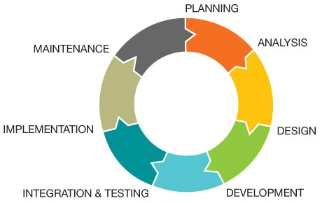

Software life cycle models describe phases of the software cycle and the order in which those phases are executed. Each phase produces deliverables required by the next phase in the life cycle. Requirements are translated into design. Code is produced according to the design which is called development phase. After coding and development the testing verifies the deliverable of the implementation phase against requirements.

There are following six phases in every Software development life cycle model:

1. Requirement gathering and analysis
2. Design
3. Implementation or coding
4. Testing
5. Deployment
6. Maintenance

1. **Requirement gathering and analysis:** - Business requirements are gathered in this phase. This phase is the main focus of the project managers and stake holders. Meetings with managers, stake holders and users are held in order to determine the requirements like; who is going to use the system? How will they use the system? What data should be input into the system? These are general questions that get answered during a requirements gathering phase. After requirement gathering these requirements are analyzed for their validity and the possibility of incorporating the requirements in the system to be development is also studied. Finally, a Requirement Specification document is created which serves the purpose of guideline for the next phase of the model.
2. **Design:** - In this phase the system and software design is prepared from the requirement specifications which were studied in the first phase. System Design helps in specifying hardware and system requirements and also helps in defining overall system architecture.
3. **Implementation / Coding:** - On receiving system design documents, the work is divided in modules/units and actual coding is started. Since, in this phase the code is produced so it is the main focus for the developer. This is the longest phase of the software development life cycle.
4. [**Testing**:](http://istqbexamcertification.com/what-is-a-software-testing/) - After the code is developed it is tested against the requirements to make sure that the product is actually solving the needs addressed and gathered during the requirements phase. During this phase unit testing, integration testing, system testing, acceptance testing are done.
5. **Deployment:** -After successful testing the product is delivered / deployed to the customer for their use.
6. **Maintenance: -** Once when the customers starts using the developed system then the actual problems comes up and needs to be solved from time to time. This process where the care is taken for the developed product is known as maintenance.

# SCHEDULING

A Gantt chart, commonly used in project management, is one of the most popular and useful ways of showing activities (tasks or events) displayed against time. On the left of the chart is a list of the activities and along the top is a suitable time scale. Each activity is represented by a bar; the position and length of the bar reflects the start date, duration and end date of the activity. This allows you to see at a glance:

* What the various activities are
* When each activity begins and ends
* How long each activity is scheduled to last
* Where activities overlap with other activities, and by how much
* The start and end date of the whole project

To summarize, a Gantt chart shows you what has to be done (the activities) and when (the schedule).

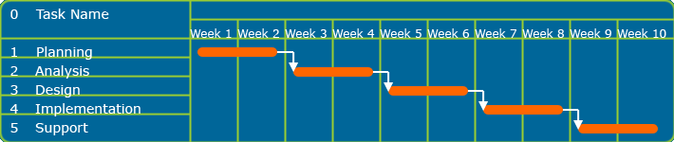 A simple Gantt chart Gantt charts are widely used in business to describe and monitor all kinds of projects according to the rules of project management.

# DATA FLOW DIAGRAM

# Zero Level DFD (Context Level)

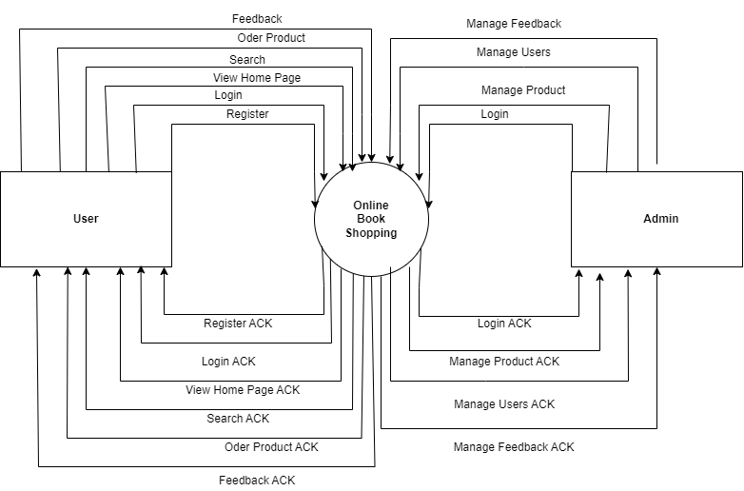

# First Level DFD (Customer’s View)

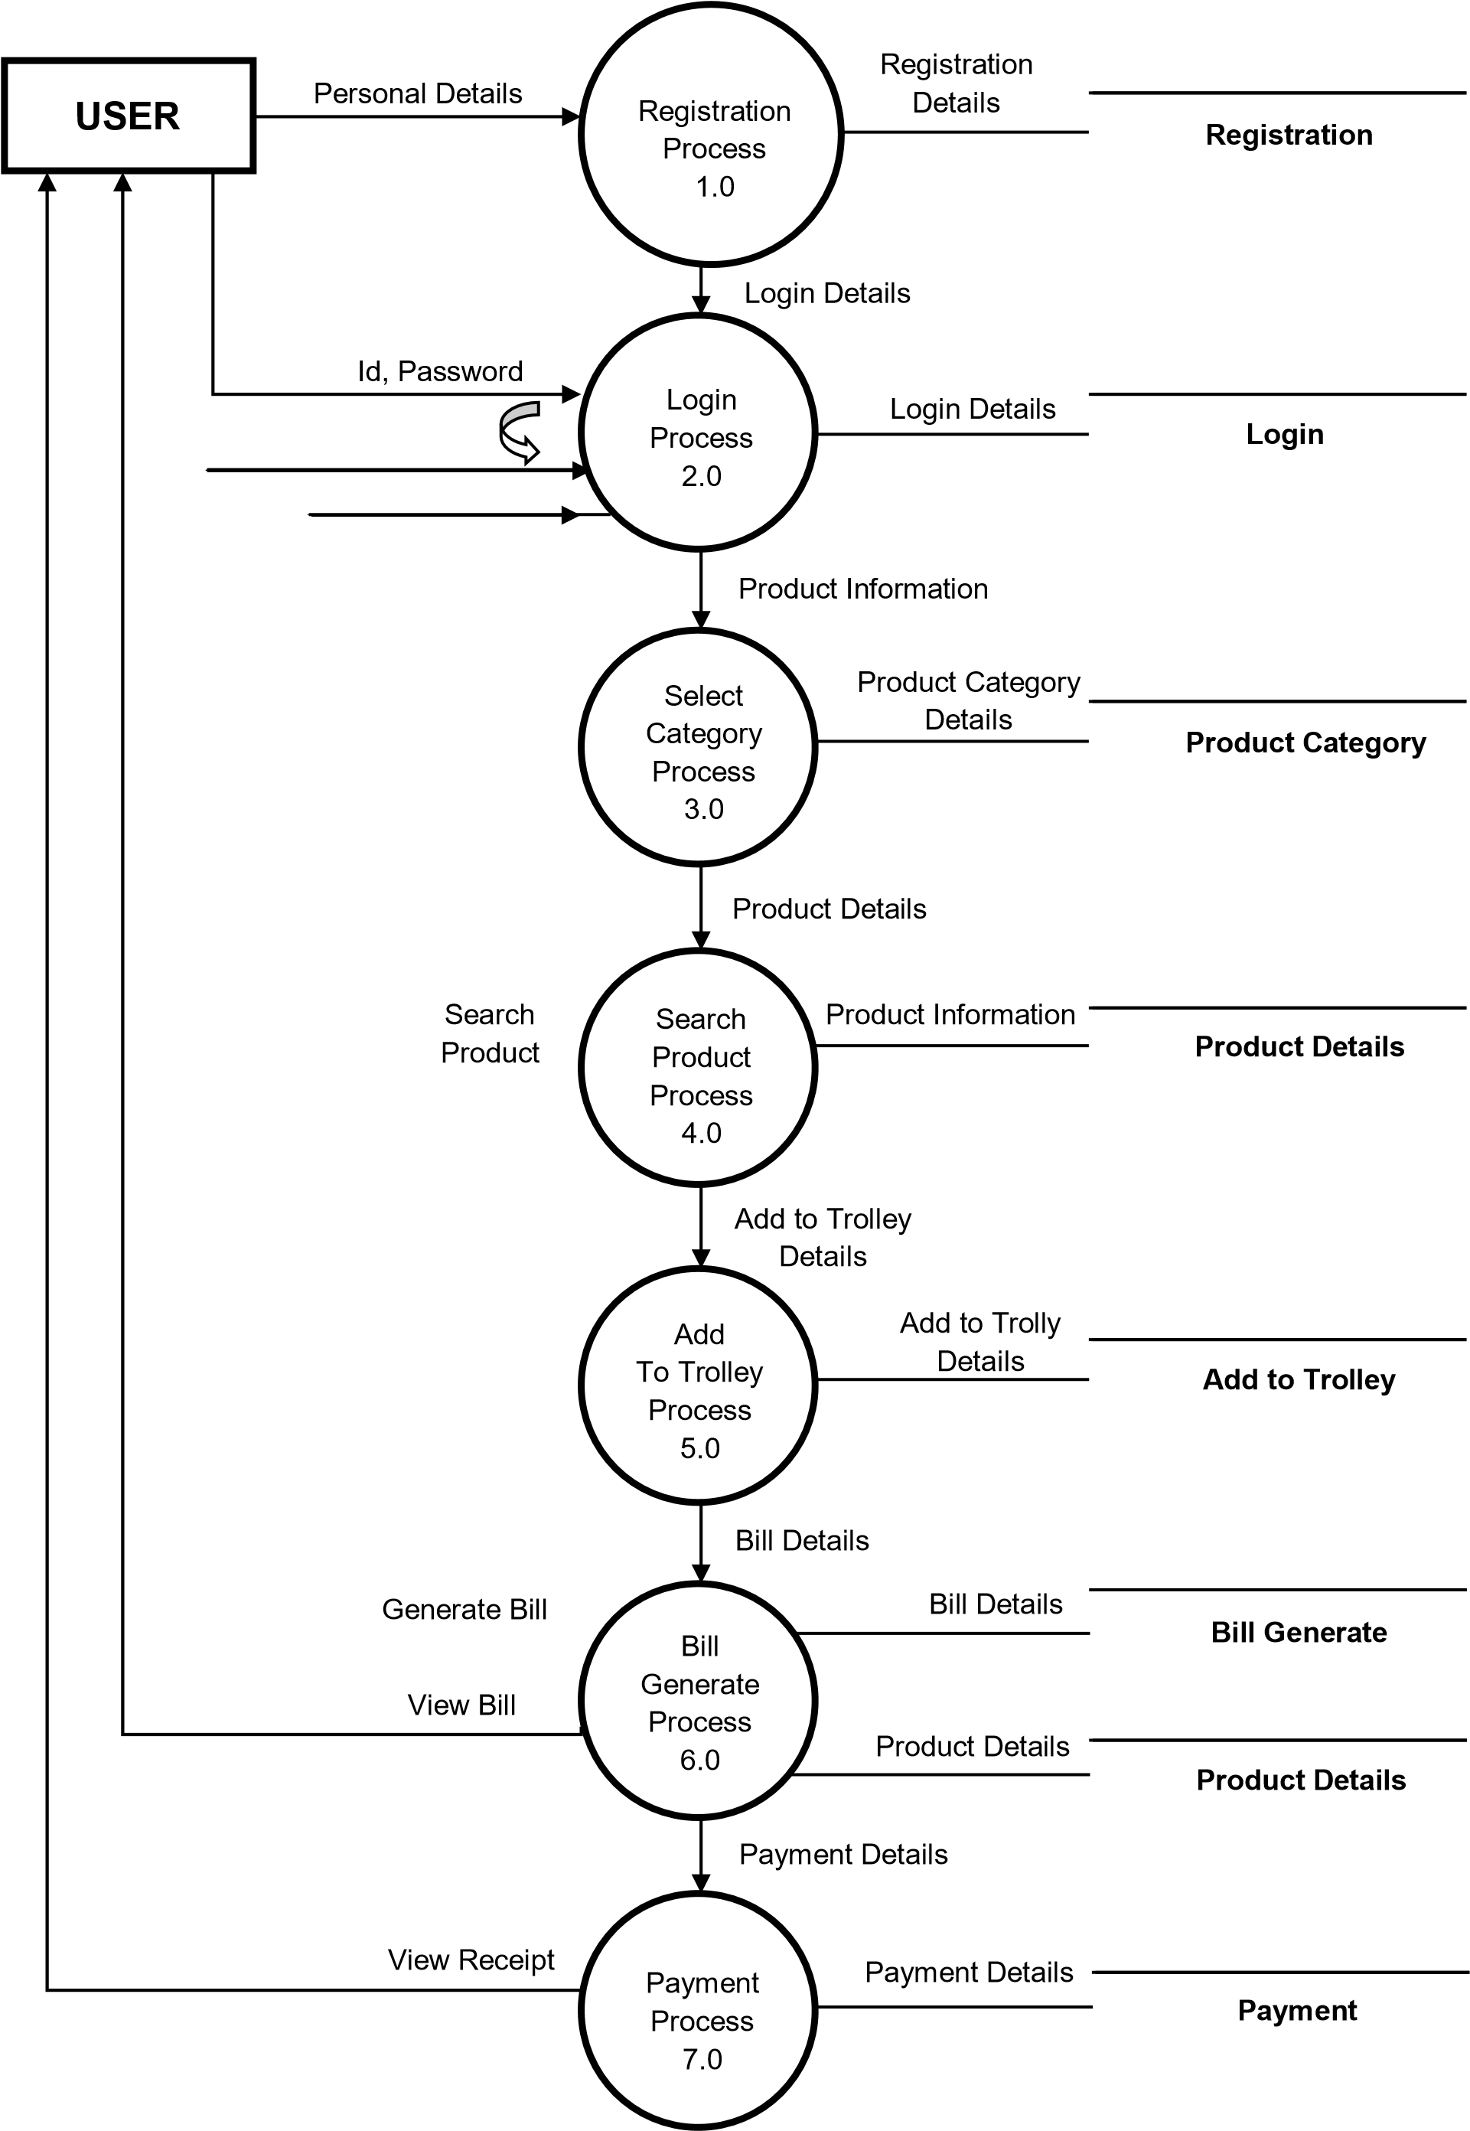

# First Level DFD (Admin’s View)

**ADMIN**

Login

Process

1.0

Authentication

Process

Add/Modify

Product Details

Process

2.1

Discount

Process

2.2

Receive

Payment

Process

2.3

Check

Ratings

Process

2.4

End

**Login**

**Product Details**

**Ratings**

Personal Details

Login Details

Valid Admin

Details

Invalid Id,

Password

Product

Details

Discount

Details

Payment

Details

Ratings

Details

Product

Information

Discount

Details

Payment

Information

Ratings

Information

**Discount Payment**

# Second Level DFD for Trolley

**CUSTOMER**

Select

Product

Process

4.1

Place

Order

Process

4.2

Generate

Receipt

Process

4.3

Payment Details

Customer Details

Receipt & Product

Details

**Payment**

**Product Details**

**Product Details**

Product

Information

Product

Information

Order

Information

# Second Level DFD for Search Product

**CUSTOMER**

Search

Product

Process

5.1

Add, Remove

& Update Product

Process

5.2

Confirm

Order

Process

5.3

Product Details

Order Details

User Details

Payment & Product

Details

**Product Details**

Get Product

Details

Add/Modify

Product Details

**ADMIN**

Admin Details

**ENTITY-RELATIONSHIP DIAGRAM**

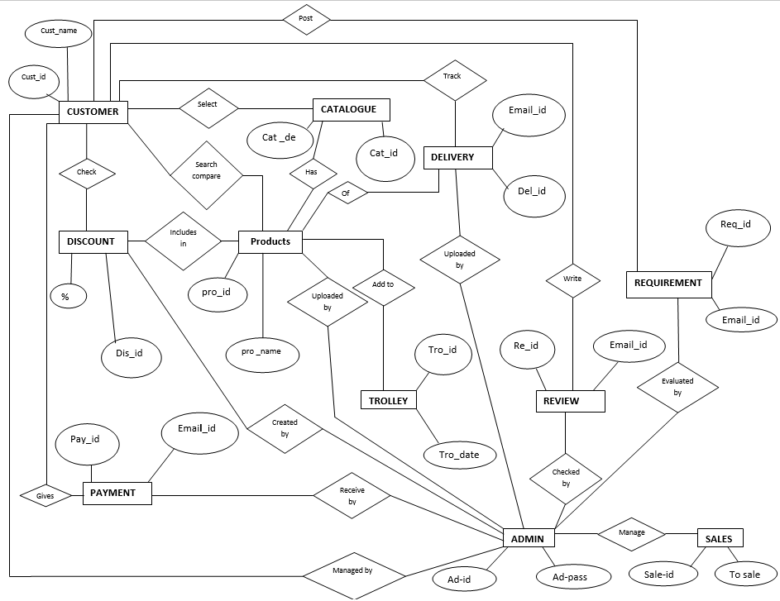

# DATABASE DESIGN

## 1. REGISTRATION AND LOGIN

|  |  |  |  |  |
| --- | --- | --- | --- | --- |
| SNO. | FIELD | DATATYPE | CONSTRAINTS | DESCRIPTION |
| 1 | C-ID | INT | Primary Key | Unique customer id |
| 2 | PASS | Varchar(30) | Not Null | Password of the customer |
| 3 | C-PASS | Varchar(30) | Not Null | Confirm password of the customer |
| 4 | C-MOBILE | Big int | Not Null | Mobile number of the customer |
| 5 | C-FNAME | Varchar(30) | Not Null | First name of the customer |
| 6 | C-SNAME | Varchar(30) | Not Null | Second name of the custome***r*** |

## 2, ADMIN LOGIN

|  |  |  |  |  |
| --- | --- | --- | --- | --- |
| SNO. | FIELD | DATATYPE | CONSTRAINTS | DESCRIPTION |
| 1 | ADM-ID | INT | Primary Key | Unique admin id |
| 2 | PASS | Varchar(30) | Not Null | Password of the customer |

## 3.CATALOGUE

|  |  |  |  |  |
| --- | --- | --- | --- | --- |
| SNO. | FIELD | DATATYPE | CONSTRAINTS | DESCRIPTION |
| 1 | CAT-ID | INT | Primary Key | Unique catalogue  id |
| 2 | CAT-NAME | Varchar(30) | Not Null | Catalogue name |
| 3 | CAT-DESC | Varchar(MAX) | Not Null | Catalogue description |

## 4.PRODUCT

|  |  |  |  |  |
| --- | --- | --- | --- | --- |
| SNO | FIELD | DATATYPE | CONSTRAINTS | DESCRIPTION |
| 1 | Pro-id | Int | Primary key | Unique product id |
| 2 | Pro-name | Varchar(30) | Not Null | Product Name |
| 3 | Cat-id | Int | Foreign Key | Unique Catalogue id |
| 4 | Author | Varchar(30) | Not Null | author |
| 5 | Publisher | Varchar(30) | Not Null | Product publisher |
| 6 | Pro-price | Float | Not Null | Product price |
| 7 | Pro-image1 | Varchar(30) | Not Null | Product image1 |
| 8 | Pro-image2 | Varchar(30) | Not Null | Product image2 |
| 9 | Pro-quantity | Int | Not Null | Product quality |
| 10 | Dis-id | Int | Foreign Key | Unique Discount id |

## 5.DISCOUNT

|  |  |  |  |  |
| --- | --- | --- | --- | --- |
| SNO. | FIELD | DATATYPE | CONSTRAINTS | DESCRIPTION |
| 1 | Dis-id | Int | Primary Key | Unique discount id |
| 2 | %d | Int | Not Null | Discount percentage |
| 3 | Date | Date | Not Null | Discount date |

## 6.ADD TO TROLLEY

|  |  |  |  |  |
| --- | --- | --- | --- | --- |
| SNO. | FIELD | DATATYPE | CONSTRAINTS | DESCRIPTION |
| 1 | Trolley-id | Int | Primary key | Unique trolley id |
| 2 | C-id | Int | Foreign key | Unique customer id |
| 3 | Pro-id | Int | Foreign key | Unique product id |
| 4 | Pro-price | Float | Not-Null | Product price |
| 5 | Pro-quantity | Int | Not-Null | Product quantity |
| 6 | Total-amt | Float | Not-Null | Total amount |
| 7 | Date | Date | Not-Null | Date of trolley |

## 7.PAYMENT

|  |  |  |  |  |
| --- | --- | --- | --- | --- |
| SNO. | FIELD | DATATYPE | CONSTRAINTS | DESCRIPTION |
| 1 | Pay-id | Int | Primary Key | Unique payment id |
| 2 | C-id | Int | Foreign Key | Unique customer id |
| 3 | Trolley –id | Int | Foreign Key | Unique trolley id |
| 4 | Pay-Mode | Varchar(30) | Not Null | Mode of payment |
| 5 | Pay-Date | Date | Not Null | Date of payment |
| 6 | Total-amt | Float | Not Null | total amount |

## *8.*DELIVERY

|  |  |  |  |  |
| --- | --- | --- | --- | --- |
| SNO. | FIELD | DATATYPE | CONSTRAINTS | DESCRIPTION |
| 1 | Del-id | Int | Primary key | Unique delivery id |
| 2 | Pay-id | Int | Foreign key | Unique Payment id |
| 3 | C-id | Int | Foreign key | Unique customer id |
| 4 | Pay-date | Date | Not Null | Date of payment |
| 5 | Del-date | Date | Not Null | Date of delivery |

## 9.REVIEW AND RATING

|  |  |  |  |  |
| --- | --- | --- | --- | --- |
| SNO. | FIELD | DATATYPE | CONSTRAINTS | DESCRIPTION |
| 1 | RR-id | Int | Primary key | Unique review and  rating |
| 2 | C-id | Int | Foreign key | Unique customer id |
| 3 | R-msg | varchar(30) | Not Null | Review message |
| 4 | Rating | Int | Not Null | Rating in stars |
| 5 | Date | Date | Not Null | Date of review and rating |

## 10.REFUND PRODUCT

|  |  |  |  |  |
| --- | --- | --- | --- | --- |
| SNO. | FIELD | DATATYPE | CONSTRAINTS | DESCRIPTION |
| 1 | RP-id | Int | Primary key | Unique refund  product id |
| 2 | C-id | Int | Foreign key | Unique customer id |
| 3 | Pro-id | Int | Foreign key | Unique product id |
| 4 | R-Reason | varchar(30) | Not Null | Refund reason |
| 5 | Date | Date | Not Null | Product date |
| 6 | R-date | Date | Not Null | Date of refund |

## 11.SALES

|  |  |  |  |  |
| --- | --- | --- | --- | --- |
| SNO. | FIELD | DATATYPE | CONSTRAINTS | DESCRIPTION |
| 1 | Sale-id | Int | Primary key | Unique sales id |
| 2 | Cat-id | Int | Foreign key | Unique catalogue id |
| 3 | T-amt | Float | Not Null | Total amount |
| 4 | Date | Date | Not Null | Date of sales |

# INPUT TO THE SYSTEM

## CUSTOMER

* Registration And Login
* Check Catalogue
* Search Product
* Compare Product
* Add To Trolley
* Check Discount
* Give Payment
* Delivery
* Refund Product • Give Review And Rating

## ADMIN

* Login
* Make Catalogue
* Upload Products
* Create Discount
* Receive Payment
* Upload Delivery
* Refund And Replace Product
* Check Review And Rating
* Sales • About Us

# MODULE DESCRIPTION

## CUSTOMER

* **Registration And Login:-**It is important for the customer to register himself/herself to the site they signed up. It is mandatory for the customer to login to the website so that they could get benefits whatever website is having into it.

* **Check Catalogue:-**Website provides various catalogues so that customers could get choices.customers can check various types of products in catalogue easily.customers could access through the products of their choice.

* **Search Product:-**Website provide tremendous platforms to the customers so that customers could get choices of whatever product they are thinking of and match their choice as well.

* **Compare Product:-**Website give variety to the customers so that they could compare their product as per the range,brands,quality,quantity,etc.

* **Add To Trolley:-**Customers choose different products of their choice that are added to trolley/cart.They could place various orders whatever they want. They get different benefits while placing orders.

* **Check Discount:-**Online shopping website gives numerous discounts to enhance customers to get attracted towards heavy discounts over the product of their choice.

* **Give Payment:-**Customers have choices whether mode of payment they want to access. Customers pay through credit mode as well as debit mode.some customers think that payment in cash is the easiest mode of payment.

* **Delivery:-**Customers could check placed order through the medium of either go through mails or through the inbox messages.

* **Refund Product:-**If customers have any of the issue in their products they could get their money either in vallet or in their bank accounts.if there is any defect in the product or customer swings up their mood to have different product at the place of the product he/she ordered before,they could complaint through the webpage they linked up and company will give another product in some duration of around 5 to 7 days.

* **Give Review And Rating:-**Customers have relevant power to give their Suggestions as well as comments while going through the products they used and how much efficient quality of product is having. Customers give rating through the website excessibility and review down through the products they are going through.

## ADMIN

* **Login:-** Admin enter valid id and password and enter into the website and manage the whole process.

* **Make Catalogue:-**Admin maintains the whole catalogue of the website so that customer could work upon the provided list without doings much efforts in finding the products through the lists. maintaining catalogue saves time and provide accuracy of the outputs.

* **Upload Products:-**Admin has treaty to upload products on online store websites so that customers could find varieties of the products and could buy of whatever demand they are having.

* **Create Discount:-**Admin has right to create discounts on their valid websites to enhance their sales as well as profits itself.if they provide discounts,customers will get much attracted towards their products and made their mind to buy them.

* **Receive Payment:-**Admin receives payments from the customers that were endulged in their website.

* **Upload Delivery:-**Admin uploads his delivery service with different modes of mediums like-administrative assistant cover letter template,job posting,cv templates etc.

* **Refund And Replace Product:-**Admin can check the reasons why customer made the process of refund and replace. What were the situations that build up these circumstances.

* **Check Review And Rating:-**Admin checkout the reviews made by the customers on their websites.reviews are made with the help of the comments enrolled by the customers on the website.rating enhances the shape and style of the provided websites.rating and reviews enhances the productivity as well as creativity of the admin towards the usage of that website.

* **Sales :-**Admin checkout the sales made in eacy and every month.they made surveys to overtake which website is working as leading website and which is working at low level just to initiate what are the requirements of the customers and what are the demands of the customers.

* **About Us:-**Admin can add about us page in which he can add mission,scope and purpose of this website.this page helps users to read and explode this website.

# OUTPUT FROM THE SYSTEM

## • Report of all Registered Customers

This Report shows Information about Customer .Admin can check all the registered customer’s details.

* **Report of all Products**

Admin can check all the details of the products.

* **Report of Payments**

This Report shows the Payment done by the Customer and received by the Admin.

* **Report of all Bills**

Admin can check all the bill details of the customers.

* **Report of all Review and Rating**

Admin can check all the reviews and ratings given by the customers.

* **Report of all Refund Products**

Admin can check all the refund products made by customers.

# TESTING AND SECURITY

**Software testing** is an investigation conducted to provide stakeholders with information about the quality of the [software](https://en.wikipedia.org/wiki/Software) product or service under test.Software testing can also provide an objective, independent view of the software to allow the business to appreciate and understand the risks of software implementation. Test techniques include the process of executing a program or application with the intent of finding [software bugs](https://en.wikipedia.org/wiki/Software_bug) (errors or other defects), and verifying that the software product is fit for use.

## Types of software Testing

**Black box testing** – Internal system design is not considered in this type of testing. Tests are based on requirements and functionality.

**White box testing** – This testing is based on knowledge of the internal logic of an application’s code. Also known as Glass box Testing. Internal software and code working should be known for this type of testing. Tests are based on coverage of code statements, branches, paths, conditions.

**Unit testing** – Testing of individual software components or modules.Typically done by the programmer and not by testers, as it requires detailed knowledge of the internal program design and code.may require developing test driver modules or test harnesses.

**Incremental integration testing** – Bottom up approach for testing i.e continuous testing of an application as new functionality is added; Application functionality and modules should be independent enough to test separately. done by programmers or by testers.

**Integration testing** – Testing of integrated modules to verify combined functionality after integration. Modules are typically code modules, individual applications, client and server applications on a network, etc. This type of testing is especially relevant to client/server and distributed systems.

**Functional testing** – This type of testing ignores the internal parts and focus on the output is as per requirement or not. Black-box type testing geared to functional requirements of an application.

**System testing** – Entire system is tested as per the requirements. Black-box type testing that is based on overall requirements specifications, covers all combined parts of a system.

**End-to-end testing** – Similar to system testing, involves testing of a complete application environment in a situation that mimics real-world use, such as interacting with a database, using network communications, or interacting with other hardware, applications, or systems if appropriate.

**Sanity testing** – Testing to determine if a new software version is performing well enough to accept it for a major testing effort. If application is crashing for initial use then system is not stable enough for further testing and build or application is assigned to fix.

**Regression testing** – Testing the application as a whole for the modification in any module or functionality.Difficult to cover all the system in regression testing so typically automation tools are used for these testing types.

**Acceptance testing** -Normally this type of testing is done to verify if system meets the customer specified requirements. User or customer do this testing to determine whether to accept application.

**Load testing** –Its a performance testing to check system behavior under load. Testing an application under heavy loads, such as testing of a web site under a range of loads to determine at what point the system’s response time degrades or fails.

**Stress testing** – System is stressed beyond its specifications to check how and when it fails. Performed under heavy load like putting large number beyond storage capacity, complex database queries, continuous input to system or database load.

**Performance testing** – Term often used interchangeably with ‘stress’ and ‘load’ testing. To check whether system meets performance requirements.Used different performance and load tools to do this.

**Usability testing** – User-friendliness check. Application flow is tested, Can new user understand the application easily, Proper help documented whenever user stuck at any point. Basically system navigation is checked in this testing.

**Install/uninstall testing** – Tested for full, partial, or upgrade install/uninstall processes on different operating systems under different hardware, software environment.

**Recovery testing** – Testing how well a system recovers from crashes, hardware failures, or other catastrophic problems.

**Security testing** – Can system be penetrated by any hacking way. Testing how well the system protects against unauthorized internal or external access. Checked if system, database is safe from external attacks.

**Compatibility testing** – Testing how well software performs in a particular hardware/software/operating system/network environment and different combination s of above.

**Comparison testing** – Comparison of product strengths and weaknesses with previous versions or other similar products.

**Alpha testing** – In house virtual user environment can be created for this type of testing. Testing is done at the end of development. Still minor design changes may be made as a result of such testing.

**Beta testing** – Testing typically done by end-users or others. Final testing before releasing application for commercial purpose.

## SECURITY MEASURES

**Database security** concerns the use of a broad range of information security controls to protect databases (potentially including the data, the database applications or stored functions, the database systems, the database servers and the associated network links) against compromises of their confidentiality, integrity and availability. It involves various types or categories of controls, such as technical, procedural/administrative and physical. *Database security* is a specialist topic within the broader realms of [computer security,](https://en.wikipedia.org/wiki/Computer_security) [information security](https://en.wikipedia.org/wiki/Information_security) and [risk management.](https://en.wikipedia.org/wiki/Risk_management)

Security risks to database systems include, for example:

* Unintended activity or misuse by authorized database users, database administrators, or network/systems managers, or by unauthorized users or hackers (e.g. inappropriate access to sensitive data, metadata or functions within databases, or inappropriate changes to the database programs, structures or security configurations);
* Malware infections causing incidents such as unauthorized access, leakage or disclosure of personal or proprietary data, deletion of or damage to the data or programs, interruption or denial of authorized access to the database, attacks on other systems and the unanticipated failure of database services;
* Overloads, performance constraints and capacity issues resulting in the inability of authorized users to use databases as intended;
* Physical damage to database servers caused by computer room fires or floods, overheating, lightning, accidental liquid spills, static discharge, electronic breakdowns/equipment failures and obsolescence;
* Design flaws and programming bugs in databases and the associated programs and systems, creating various security vulnerabilities (e.g. unauthorized [privilege escalation)](https://en.wikipedia.org/wiki/Privilege_escalation), data loss/corruption, performance degradation etc.
* Data corruption and/or loss caused by the entry of invalid data or commands, mistakes in database or system administration processes, sabotage/criminal damage etc.

# FUTURE SCOPE

This project can enhanced after adding some more useful modules in the project. Utmost care and back-up procedures must be established to ensure 100% successful implementation of the computerized Search system. The future of this project is not limited in specific area but have a wide range. To make the project most powerful in future I have the maximum criteria. More triggers will be added to this system once they got identified with ease of understanding.

The most positive point of this project is that it is easy to understandable and accessible by any user which is either related to computer or not and its Feedback mechanism is also a measure functionality of this project which help us to scale the future of this system to higher level.

# BIBLIOGRAPHY

## BOOKS

* Software Engineering

A Practitioner’s Approach

By- Roger S. Pressman

Bruce R.Maxim

* PHP And MySQL Web Development

By-Luke Weling

* IGNOU Study Material

## LINKS

* <https://www.w3schools.com/php/>
* <https://www.tutorialspoint.com/mysql>
* <https://www.smartdraw.com/data-flow-diagram>

**PROJECT REPORT**

**TITLE OF THE PROJECT**

**ONLINE BOOK STORE**

# INTRODUCTION

O

nline shopping is the platform where user could buy their products efficiently.

To excess these sites we have to go through the usage as well as its advantages. they provide excessive products to the users. Here users have many choices where they could get whatever they would like to buy.

In today’s world, usage of these websites are going at zenith.

Every person is getting use to have some essential things that they want. Online shopping saves time as well as provides convenience to the user.it reduces tiredness and gives relaxation.

On these sites, Heavy discounts are provided.

online shopping is the process whereby consumers directly buy goods and services from the seller interactively in real time without an intermediate services over the internet.

Online shopping is the process of buying goods and services from merchants who sells on the internet. Since emergence of the world wide web, merchants have sought to sell their products to people who surf the internet.

Shoppers can visit the web stores from comfort of their homes and shop as they sit in front of the computer. consumers buy the variety of items from online stores.

Infact , people can purchase just about anything from companies that provide their products online.

Books, clothing, households appliances, toys, hardware, software and health insurance are just some of the hundreds of products consumers can buy from an online store.

Many people choose to conduct shopping online because of the convenience.

For ex: when a person shops at a brick and mortar store.

She has to drive to the store, find a parking place and walk throughout the stores until she locates the product she needs.

After finding the items she wants to purchase, she may often need to stand in long lives at the cash register have any social interaction. It also doesn’t allow them to take the merchandise home the sameday they buy it.

Online shopping allow you to browse through endless possibilities and even offers merchandise that unavailable in stores.

If you are searching for a niche product that may not be disturbed totally, you’re sure to find what you’re looking for on the internet.

What’s ever more useful is the ability similar or not, online..

Shopping via internet eliminates the need to sift through a stores products with potential buys like pants, shirts, belts and shoes all slung over one arm. online shopping also eliminates the catchy, yet irritating music,as well as the hundreds, if not thousands of other like-minded individuals who seems to have decided to shop on the same day.

Say ‘goodbye’ to the days when you stood in line waiting and waiting some more for a store clerk to finally check out your items. Online shopping transaction occurs instantly saving you time to get your other errands done |

Additionally, unlike a store, online shopping has friendly customer services representatives available 24 hrs a day, 7days a week to assist you with locally, purchasing ans shipping your merchandise.

# AIM AND OBJECTIVES

The primary aim of this project is to demonstrate that with better interactive features in clothing web sites could improve sales for online retailers. The objectives of the project are as follows:

* To learn about the Online Book Shelf industry.
* To investigate potential problems with Online Book Shelf.
* To create a prototype web site focusing on one of the many problems that arises within Online Book Shelf.
* To evaluate the prototype with an existing online book shelf.

The classic tale of the tortoise and the hare, provided by Freedman, gave the inspiration that

Online Book Shelf is one the main markets that needs to be tapped in. Freedman’s prediction is that, slower starters or early laggards may prove to be some of the strongest categories online long term.

Within this dissertation, facts about Online Book Shelf are gathered to demonstrate whether Freedman’s prediction is correct.

**SYSTEM ANALYSIS**

"**System analysis**” is a problem solving technique that decomposes a system into its component pieces for the purpose of the studying how well those component parts work and interact to accomplish their purpose. According to the Merriam-Webster dictionary, systems analysis is "the process of studying a procedure or business in order to identify its goals and purposes and create systems and procedures that will achieve them in an efficient way". Analysis and synthesis, as scientific methods, always go hand in hand; they complement one another. Every synthesis is built upon the results of a preceding analysis, and every analysis requires a subsequent synthesis in order to verify and correct its results.

This field is closely related to requirements analysis or operations research. It is also "an explicit formal inquiry carried out to help someone (referred to as the decision maker) identify a better course of action and make a better decision than she might otherwise have made.

The principal objective of the systems-analysis phase is the specification of what the system needs to do to meet the requirements of end users. In the systems-design phase such specifications are converted to a hierarchy of charts that define the data required and the processes to be carried out on the data so that they can be expressed as instructions of a System program. Many information systems are implemented with generic software, rather than with such custom-built.

**REQUIREMENT SPECIFICATION**

The requirements of the system are as follows:-

• To allow customer to see policies detail just on a mouse click.

• To allow customer to buy policies only after the registration.

• To maintain the detail of registered customer.

• To allow registered customer to add nominee.

• To permit registered customer to update nominee.

• To allow customer to provide feedback.

• To maintain the admin detail.

• To permit valid admin to add and delete policies from the four categories of policies. The four categories are Motor Insurance, Life Insurance, Health Insurance and Term Deposit.

**IDENTIFICATION OF NEED**

Online shopping — that glorious invention which allows people to buy things from the comfort of their homes. No more travelling to multiple stores to find the right product; no more having to deal with over-enthusiastic sales persons; no more standing in long lines at the checkout counter. The [e-commerce boom](https://yourstory.com/tag/e-commerce-boom/) has certainly changed the way we shop for the better. But, like everything else, the world of online shopping is not all roses. Despite all the efforts of e-commerce companies to alleviate them, there are a few problems that customers still have to face while [shopping online](https://yourstory.com/tag/online-shopping/). Six of these problems are listed below.

**Quality issues**

The biggest problem while buying things online is that you have no guarantee of a product's quality. Reviews are not always reliable and all the research can't assure you of a product's quality; fraudulent sellers who intentionally mislead customers to [increase sales](https://yourstory.com/read/8c73095f6e-how-to-increase-sales-from-your-site/) are the prime reason for faulty/sub-par products being sold online. With the volume of goods e-commerce companies handle these days, it can be quite difficult for them to conduct quality checks on each and every one of the products they're selling. Additionally, the issue of getting the correct size remains a serious drawback for buying clothing and footwear online. Sizes vary from brand to brand, and since you can't try out the products before buying them, [selecting the size](https://yourstory.com/2015/04/fitrrati/) is always a gamble.

## **Delivery and logistics**

## One predicament that constantly turns up while shopping online is when the order will be delivered. While all e-commerce sites have order tracking systems for their customers, they aren’t always accurate. Delivery personnel often turn up at our homes when we're at work or out somewhere as there's no way to fix a particular time slot for the delivery to take place. This same issue exists while returning products. Another problem is that the vast majority of the Indian population which lives in [rural areas](https://yourstory.com/2015/07/inthree-boonbox/) and Tier-III cities is unable to shop online because not all e-commerce sites provide delivery services to their locations.

## **Digital payment failures**

## Whether a customer is paying by credit/debit card, netbanking, or one of the several [digital wallets](https://yourstory.com/2016/11/rbi-raises-digital-wallet-limit/) that exist today, the failure of digital payments always looms overhead while making online transactions. A faltering internet connection or a technical glitch often results in the payable amount being debited from a customer's account without being credited to the selling party. And retrieving this amount is anything but a quick process; one has to inform the site and then wait around 7-10 days before the amount is refunded to their bank accounts. But this situation is steadily improving as the sector is focusing more on [cashless transactions](https://yourstory.com/2017/02/dream-cashless-india-cannot-manifest-without-adequate-consumer-education/) and customers are getting more informed about making payments online.

## **Additional charges**

## How many times has it happened that you've spotted a great deal on a product and when you're one click away from purchasing it you noticed an additional shipping charge. This is commonplace on all e-commerce sites when your order amount isn't high enough to qualify for free shipping. And even when it is, sometimes these shipping charges are added on each individual product (if you're buying multiple products of course) and not the collective order.

## **Lack of security**

## Cyber security, or more precisely the lack of it, is a [major problem](https://yourstory.com/2016/10/un-day-cybersecurity/) on the internet today. E-commerce sites record important customer data like name, phone number, address, and bank details. If these sites don't implement stringent cyber security measures, your data is at risk of falling into the wrong hands who can then wreak havoc on your bank account. Most of the big players in online shopping certainly have the best-in-class security measures to protect their customers' details, but the same can't be said about the countless smaller sites who may not have the expertise to do so.

Online shopping is far too convenient to get hindered by these problems. But if e-commerce sites can fix these [issues](https://yourstory.com/2016/01/challenges-e-commerce-companies/), they will certainly improve customer experience and hence generate more sales

**FEASIBILITY STUDY**

A feasibility study is a way to evaluate the practicality and desirability of a project. Before a company invests time and money into a project, they need to know how successful the project will be before investing. Sometimes companies want to understand input costs, the amount of research that will need to be done, or even the marketability of a project. With input prices, it is essential that companies understand, (even before they put time and research into the project), how much it would cost to go through with their product. Companies also like to know if they put time into research and go through with their change or promotion of a product, how the public/people will react to the change. Will people be fighting over the new product or will it fall through? The purpose of feasibility studies is to provide companies information and analysis on whether or not you or your company should pursue this course of action.

Feasibility reports are usually used to sway decision makers towards one direction or the other. Many times there is only one course of action but, there needs to be a second course of action.Online Shopping is one of today’s fastest growing businesses in the market. The online business shop industry is fairly new and has great potential for growth. The online shopping or online retailing business is a form of electronic commerce allowing consumers to directly buy goods or services from a seller over the internet without an intermediary service. Print” is an online shop that provides customers customized t-shirts with the help of the internet. It is an online based store, because nowadays customers are attracted to online shopping not only because of the high level of convenience, but also because of the broader selection, competitive pricing, and greater access to information. Business organizations seek to offer online shopping because it is much lower cost compared to bricks and mortar stores, offers access to a worldwide market, increases customer value and builds sustainable capabilities.Online shops are now by various other names, but “print” is better because it gives excellent services and good qualities of t-shirt. The proposed business will be classified as a pronto Dustless. There will be a website created for the customer to make its own design. There’s also an available page in some website like backbone, twitter and etc. Where there’s a link that will direct them to “print”s website that will be convenient for the customers. And for those who don’t have an idea yet on their shirt design there will be a ready designed t-shirt to at least give them an idea.Since the customer will be the one who will make their own t-shirt design it will offer a feature that will be trending and exclusive for the customer. The financial feasibility of the proposed project will be discussed as follows: the profitability index should be equal to or greater than 1. 00. Since, the profitability index of “print” is 9. 83, it shows that there is a higher rate of return. The higher the project’s profitability index the more profitable that project is per investment pesos. At the end of the first year 1 1,117. 99 of the initial 61,848 investment have been recovered.

**PROJECT SCHEDULING**

Project scheduling is a mechanism to communicate what tasks need to get done and which organizational resources will be allocated to complete those tasks in what timeframe. A project schedule is a document collecting all the work needed to deliver the project on time.But when it comes to creating a project schedule, well, that’s something few have deep experience with.What and who is being scheduled, and for what purposes, and where is this scheduling taking place, anyway?A project is made up of many tasks, and each task is given a start and end (or due date), so it can be completed on time. Likewise, people have different schedules, and their availability and vacation or leave dates need to be documented in order to successfully plan those tasks.Whereas people in the past might have printed calendars on a shared wall in the water-cooler room, or shared spreadsheets via email, today most teams use [online project scheduling tools](https://www.projectmanager.com/scheduling). Typically, project scheduling is just one feature within a larger project management software solution, and there are many different places in the software where scheduling takes place.

For example, most tools have task lists, which enable the manager to schedule multiple tasks, their due dates, sometimes the planned effort against that task, and then assign that task to a person. The software might also have resource scheduling, basically the ability to schedule the team’s availability, but also the availability of non-human resources like machines or buildings or meeting rooms.

Because projects have so many moving parts, and are frequently changing, project scheduling software automatically updates tasks that are dependent on one another, when one scheduled task is not completed on time. It also generates automated email alerts, so team members know when their scheduled tasks are due or overdue, and to let the manager know when someone’s availability has changed.

Project scheduling is simple when managed online, thankfully, especially since the software does all the hard part for you!

An interactive Gantt chart is crucial. You can add tasks and dates into your Gantt chart to have a visual representation of each task’s duration. Better still, as dates change—as they inevitably do—you can simply drag and drop those changes and the whole Gantt chart is updated instantly.

There’s also automating processes to help with efficiencies. Email notifications are a great way to know immediately when a team member has completed a task. When they update, you know because your software is online and responding in real-time.

Continuing with automation, it’s one way to [scheduling tasks](https://www.projectmanager.com/blog/scheduling-different-project-tasks) more efficiently. If there are recurring tasks on a project, they can be scheduled in your PM tool so that once set you don’t have to worry about scheduling the same task over and over again.

Your tasks aren’t going to complete themselves. That’s why you have assembled a team, but if that team isn’t scheduled the way you have carefully scheduled your task list, then you’re not managing your project.

Over the course of a project’s lifecycle team members are going to take off for holidays, personal days or vacation. If you’re not prepared for these times, and have scheduled other team members to pick up the slack in their absence, your schedule will suffer.

Integrating your calendar into a project management software is a simple way to stay on top of your resources. There’s no reason to use a standalone calendar that sends you to another application every time you need to check on a team member’s availability.

Another way to stay on top of your scheduling is by integrating your task scheduling view on the Gantt chart with resource and workload scheduling features. You can schedule your team’s workload through color-coding, so you know at-a-glance who is behind, ahead or on schedule with their tasks.

**Software Process Models**

A software process model is a simplified representation of a software process. Each model represents a process from a specific perspective.

We’re going to take a quick glance about very general process models. These generic models are abstractions of the process that can be used to explain different approaches to the software development. They can be adapted and extended to create more specific processes.

Some methodologies are sometimes known as **software development life cycle**(SDLC) methodologies, though this term could also be used more generally to refer to any methodology.

Waterfall Model

The waterfall model is a sequential approach, where each fundamental activity of a process represented as a separate phase, arranged in linear order.

In the waterfall model, you must plan and schedule all of the activities before starting working on them (plan-driven process).

Plan-driven process is a process where all the activities are planned first, and the progress is measured against the plan. While the agile process, planning is incremental and it’s easier to change the process to reflect requirement changes*.*

The phases of the waterfall model are: **Requirements, Design, Implementation, Testing, and Maintenance.**

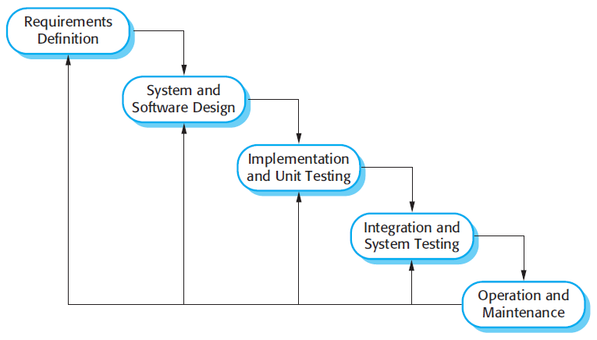

#### The Nature of Waterfall Phases

In principle, the result of each phase is one or more documents that should be approved and the next phase shouldn’t be started until the previous phase has completely been finished.

In practice, however, these phases overlap and feed information to each other. For example, during design, problems with requirements can be identified, and during coding, some of the design problems can be found, etc.

The software process therefore is not a simple linear but involves feedback from one phase to another. So, documents produced in each phase may then have to be modified to reflect the changes made.

In principle, the waterfall model should only be applied when requirements are well understood and unlikely to change radically during development as this model has a relatively rigid structure which makes it relatively hard to accommodate change when the process in underway.

**Prototyping**

A prototype is a version of a system or part of the system that’s developed quickly to check the customer’s requirements or feasibility of some design decisions.

So, a prototype is useful when a customer or developer is not sure of the requirements, or of algorithms, efficiency, business rules, response time, etc.

In prototyping, the client is involved throughout the development process, which increases the likelihood of client acceptance of the final implementation.

While some prototypes are developed with the expectation that they will be discarded, it is possible in some cases to evolve from prototype to working system.

A software prototype can be used:

**[1]** In the **requirements engineering**, a prototype can help with the elicitation and validation of system requirements.

It allows the users to experiment with the system, and so, refine the requirements. They may get new ideas for requirements, and find areas of strength and weakness in the software.

Furthermore, as the prototype is developed, it may reveal errors and in the requirements. The specification maybe then modified to reflect the changes.

**[2]** In the **system design**, a prototype can help to carry out deign experiments to check the feasibility of a proposed design.

For example, a database design may be prototype-d and tested to check it supports efficient data access for the most common user queries.

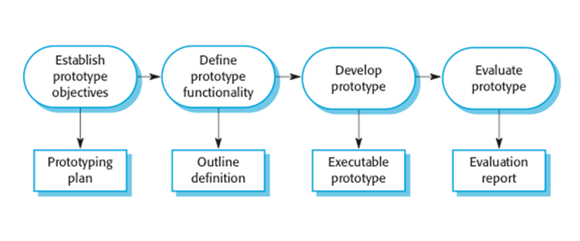

The phases of a prototype are:

1. **Establish objectives**: The objectives of the prototype should be made explicit from the start of the process. Is it to validate system requirements, or demonstrate feasibility, etc.
2. **Define prototype functionality**: Decide what are the inputs and the expected output from a prototype. To reduce the prototyping costs and accelerate the delivery schedule, you may ignore some functionality, such as response time and memory utilization unless they are relevant to the objective of the prototype.
3. **Develop the prototype**: The initial prototype is developed that includes only user interfaces.
4. **Evaluate the** **prototype**: Once the users are trained to use the prototype, they then discover requirements errors. Using the feedback both the specifications and the prototype can be improved. If changes are introduced, then a repeat of steps 3 and 4 may be needed.

Prototyping is not a standalone, complete development methodology, but rather an approach to be used in the context of a full methodology (such as incremental, spiral, etc).

**Incremental Development**

Incremental development is based on the idea of developing an initial implementation, exposing this to user feedback, and evolving it through several versions until an acceptable system has been developed.

The activities of a process are not separated but interleaved with feedback involved across those activities.

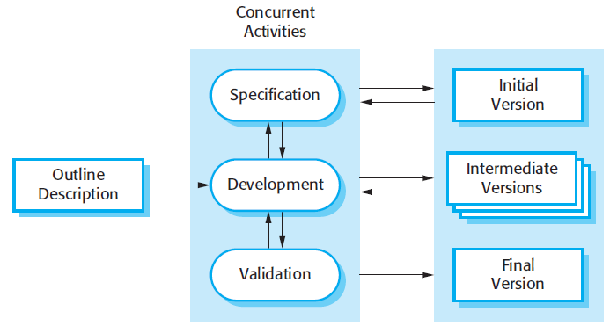Each system increment reflects a piece of the functionality that is needed by the customer. Generally, the early increments of the system should include the most important or most urgently required functionality.

This means that the customer can evaluate the system at early stage in the development to see if it delivers what’s required. If not, then only the current increment has to be changed and, possibly, new functionality defined for later increments.

**Spiral Model**

The spiral model is a risk-driven where the process is represented as spiral rather than a sequence of activities.

It was designed to include the best features from the waterfall and prototyping models, and introduces a new component; risk-assessment.

Each loop (from review till service — see figure below) in the spiral represents a phase. Thus the first loop might be concerned with system feasibility, the next loop might be concerned with the requirements definition, the next loop with system design, and so on.

Each loop in the spiral is split into four sectors:

1. **Objective setting**: The objectives and risks for that phase of the project are defined.
2. **Risk assessment and reduction:** For each of the identified project risks, a detailed analysis is conducted, and steps are taken to reduce the risk. For example, if there’s a risk that the requirements are inappropriate, a prototype may be developed.
3. **Development and validation:** After risk evaluation, a process model for the system is chosen. So if the risk is expected in the user interface then we must prototype the user interface. If the risk is in the development process itself then use the waterfall model.
4. **Planning:**The project is reviewed and a decision is made whether to continue with a further loop or not.

Spiral model has been very influential in helping people think about iteration in software processes and introducing the risk-driven approach to development. In practice, however, the model is rarely used.

### Iterative Development

Iterative development model aims to develop a system through building small portions of all the features, across all components.

We build a product which meets the initial scope and release it quickly for customer feedback. An early version with limited features important to establish market and get customer feedback.

In each increment, a slice of system features is delivered, passing through the requirements till the deployment.

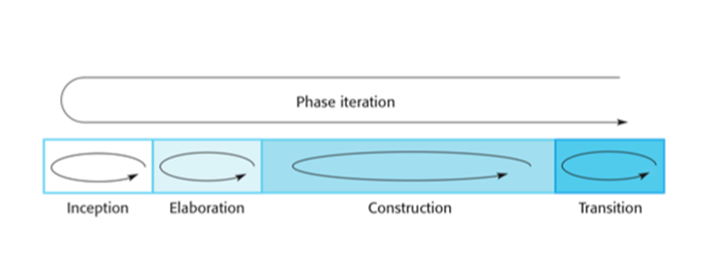

The phases of iterative development are:

1. **Inception:**The goal is to establish a business case for the system. We should identify all the external entities that will interact with the system, and define these interactions. Then, uses this information to assess the contribution that the system makes to the business. If the contribution is minor, then the project may be cancelled.
2. **Elaboration:**We develop an understanding of the problem domain and architecture framework, develop the project plan, and identify risks.
3. **Construction:**Incrementally fills-in the architecture with production-ready code produced from analysis, design, implementation, and testing of the requirements. The components of the system are dependent on each other and they’re developed in parallel and integrated during this phase. On the completion of this phase, you should have a complete working software.
4. **Transition:**We deliver the system into the production operating environment.

*All the phases will be done once, while the construction phase will be incrementally visited for each increment; for each slice of system features.*

**Agile**

Agility is flexibility, it is a state of dynamic, adapted to the specific circumstances.

The agile methods refers to a group of software development models based on the incremental and iterative approach, in which the increments are small and typically, new releases of the system are created and made available to customers every few weeks.

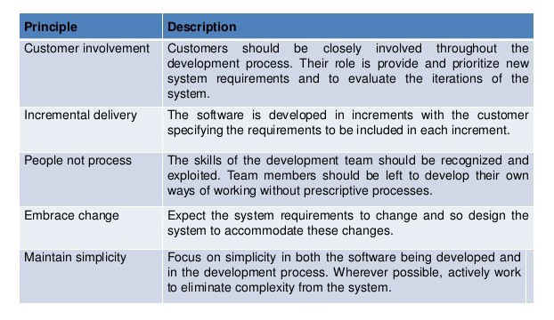

The principles of agile methods

They involve customers in the development process to propose requirements changes. They minimize documentation by using informal communications rather than formal meetings with written documents.

They are best suited for application where the requirements change rapidly during the development process.

There are a number of different agile methods available such as: Scrum, Crystal, Agile Modeling (AM), Extreme Programming (XP), etc.

**DATA FLOW DIAGRAM**

A **Data Flow Diagram** (**DFD**) is a graphical representation of the "flow" of data through an [information system](http://en.wikipedia.org/wiki/Information_system), modeling its process aspects. A DFD is often used as a preliminary step to create an overview of the system, which can later be elaborated. DFDs can also be used for the visualization of data processing (structured design).

A DFD shows what kind of information will be input to and output from the system, where the data will come from and go to, and where the data will be stored. The graphical depiction identifies each source of data and how it interacts with other data sources to reach a common output.

Entity

Process

Data Store

Data Flow

**Zero Level DFD (Context Level)**



# First Level DFD (Customer’s View)



# First Level DFD (Admin’s View)

**ADMIN**

Login

Process

1.0

Authentication

Process

Add/Modify

Product Details

Process

2.1

Discount

Process

2.2

Receive

Payment

Process

2.3

Check

Ratings

Process

2.4

End

**Login**

**Product Details**

**Ratings**

Personal Details

Login Details

Valid Admin

Details

Invalid Id,

Password

Product

Details

Discount

Details

Payment

Details

Ratings

Details

Product

Information

Discount

Details

Payment

Information

Ratings

Information

**Discount Payment**

# Second Level DFD for Trolley

**CUSTOMER**

Select

Product

Process

4.1

Place

Order

Process

4.2

Generate

Receipt

Process

4.3

Payment Details

Customer Details

Receipt & Product

Details

**Payment**

**Product Details**

**Product Details**

Product

Information

Product

Information

Order

Information

# Second Level DFD for Search Product

**CUSTOMER**

Search

Product

Process

5.1

Add, Remove

& Update Product

Process

5.2

Confirm

Order

Process

5.3

Product Details

Order Details

User Details

Payment & Product

Details

**Product Details**

Get Product

Details

Add/Modify

Product Details

**ADMIN**

Admin Details

**ENTITY-RELATIONSHIP DIAGRAM**



**SYSTEM DESIGN**

**MODULE DESCRIPTION**

**CUSTOMER**

* **Registration And Login:-**It is important for the customer to register himself/herself to the site they signed up. It is mandatory for the customer to login to the website so that they could get benefits whatever website is having into it.
* **Check Catalogue:-**Website provides various catalogues so that customers could get choices.customers can check various types of products in catalogue easily.customers could access through the products of their choice.
* **Search Product:-**Website provide tremendous platforms to the customers so that customers could get choices of whatever product they are thinking of and match their choice as well.
* **Compare Product:-**Website give variety to the customers so that they could compare their product as per the range,brands,quality,quantity,etc.
* **Add To Trolley:-**Customers choose different products of their choice that are added to trolley/cart.They could place various orders whatever they want. They get different benefits while placing orders.
* **Check Discount:-**Online shopping website gives numerous discounts to enhance customers to get attracted towards heavy discounts over the product of their choice.
* **Give Payment:-**Customers have choices whether mode of payment they want to access. Customers pay through credit mode as well as debit mode.some customers think that payment in cash is the easiest mode of payment.
* **Delivery:-**Customers could check placed order through the medium of either go through mails or through the inbox messages.
* **Refund Product:-**If customers have any of the issue in their products they could get their money either in vallet or in their bank accounts.if there is any defect in the product or customer swings up their mood to have different product at the place of the product he/she ordered before,they could complaint through the webpage they linked up and company will give another product in some duration of around 5 to 7 days.
* **Give Review And Rating:-**Customers have relevant power to give their Suggestions as well as comments while going through the products they used and how much efficient quality of product is having. Customers give rating through the website excessibility and review down through the products they are going through.

**ADMIN**

* **Login:-** Admin enter valid id and password and enter into the website and manage the whole process.
* **Make Catalogue:-**Admin maintains the whole catalogue of the website so that customer could work upon the provided list without doings much efforts in finding the products through the lists. maintaining catalogue saves time and provide accuracy of the outputs.
* **Upload Products:-**Admin has treaty to upload products on online store websites so that customers could find varieties of the products and could buy of whatever demand they are having.

* **Create Discount:-**Admin has right to create discounts on their valid websites to enhance their sales as well as profits itself.if they provide discounts,customers will get much attracted towards their products and made their mind to buy them.
* **Receive Payment:-**Admin receives payments from the customers that were endulged in their website.
* **Upload Delivery:-**Admin uploads his delivery service with different modes of mediums like-administrative assistant cover letter template,job posting,cv templates etc.
* **Refund And Replace Product:-**Admin can check the reasons why customer made the process of refund and replace. What were the situations that build up these circumstances.
* **Check Review And Rating:-**Admin checkout the reviews made by the customers on their websites.reviews are made with the help of the comments enrolled by the customers on the website.rating enhances the shape and style of the provided websites.rating and reviews enhances the productivity as well as creativity of the admin towards the usage of that website.
* **Sales :-**Admin checkout the sales made in eacy and every month.they made surveys to overtake which website is working as leading website and which is working at low level just to initiate what are the requirements of the customers and what are the demands of the customers.
* **About Us:-**Admin can add about us page in which he can add mission,scope and purpose of this website.this page helps users to read and explode this website.

**DATA INTEGRITY AND CONSTRAINTS**

Data integrity refers to maintaining and assuring the accuracy and consistency of data over its entire life-cycle and is a critical aspect to the design, implementation and usage of any system which stores, processes, or retrieves data.

--

-- Database: `apparel`

--

-- --------------------------------------------------------

--

-- Table structure for table `admin`

--

CREATE TABLE `admin` (

`ADM_ID` varchar(50) NOT NULL DEFAULT '0',

`PASS` varchar(30) NOT NULL

) ENGINE=InnoDB DEFAULT CHARSET=latin1 COLLATE=latin1_swedish_ci;

--

-- Dumping data for table `admin`

--

INSERT INTO `admin` (`ADM_ID`, `PASS`) VALUES

('1001', '12345');

-- --------------------------------------------------------

--

-- Table structure for table `catalogue`

--

CREATE TABLE `catalogue` (

`CAT_ID` int(11) NOT NULL,

`CAT_NAME` varchar(300) NOT NULL,

`CAT_DESC` varchar(2000) NOT NULL

) ENGINE=InnoDB DEFAULT CHARSET=latin1 COLLATE=latin1_swedish_ci;

--

-- Dumping data for table `catalogue`

--

INSERT INTO `catalogue` (`CAT_ID`, `CAT_NAME`, `CAT_DESC`) VALUES

(12, 'Poetry', 'poetry'),

(14, 'Biography', 'Biography'),

(15, 'Historical', 'history\r\n\r\n');

-- --------------------------------------------------------

--

-- Table structure for table `delivery`

--

CREATE TABLE `delivery` (

`DEL_ID` int(11) NOT NULL,

`PAY_ID` int(11) NOT NULL,

`PRO_ID` int(11) NOT NULL,

`DEL_date` date NOT NULL,

`address` varchar(200) DEFAULT NULL

) ENGINE=InnoDB DEFAULT CHARSET=latin1 COLLATE=latin1_swedish_ci;

--

-- Dumping data for table `delivery`

--

INSERT INTO `delivery` (`DEL_ID`, `PAY_ID`, `PRO_ID`, `DEL_date`, `address`) VALUES

(7, 11, 13, '2023-09-13', 'A-1/151, A block');

-- --------------------------------------------------------

--

-- Table structure for table `discount`

--

CREATE TABLE `discount` (

`DIS_ID` int(11) NOT NULL,

`PERC_D` int(11) NOT NULL,

`Date` date NOT NULL

) ENGINE=InnoDB DEFAULT CHARSET=latin1 COLLATE=latin1_swedish_ci;

--

-- Dumping data for table `discount`

--

INSERT INTO `discount` (`DIS_ID`, `PERC_D`, `Date`) VALUES

(3, 10, '2023-09-06');

-- --------------------------------------------------------

--

-- Table structure for table `payment`

--

CREATE TABLE `payment` (

`PAY_ID` int(11) NOT NULL,

`PRO_ID` int(11) NOT NULL,

`Trolley_id` int(11) NOT NULL,

`PAY_MODE` varchar(20) NOT NULL,

`PAY_date` date NOT NULL,

`Total_AMT` float NOT NULL

) ENGINE=InnoDB DEFAULT CHARSET=latin1 COLLATE=latin1_swedish_ci;

--

-- Dumping data for table `payment`

--

INSERT INTO `payment` (`PAY_ID`, `PRO_ID`, `Trolley_id`, `PAY_MODE`, `PAY_date`, `Total_AMT`) VALUES

(11, 13, 34, 'Credit', '2023-09-06', 1980);

-- --------------------------------------------------------

--

-- Table structure for table `product`

--

CREATE TABLE `product` (

`PRO_ID` int(11) NOT NULL,

`PRO_NAME` varchar(30) NOT NULL,

`CAT_ID` int(11) NOT NULL,

`Author` varchar(30) NOT NULL,

`Publisher` varchar(30) NOT NULL,

`PRO_PRICE` float NOT NULL,

`PRO_Qty` varchar(30) NOT NULL,

`PRO_IMAGE1` varchar(2000) NOT NULL,

`PRO_IMAGE2` varchar(2000) NOT NULL,

`DIS_ID` int(11) DEFAULT NULL

) ENGINE=InnoDB DEFAULT CHARSET=latin1 COLLATE=latin1_swedish_ci;

--

-- Dumping data for table `product`

--

INSERT INTO `product` (`PRO_ID`, `PRO_NAME`, `CAT_ID`, `Author`, `Publisher`, `PRO_PRICE`, `PRO_Qty`, `PRO_IMAGE1`, `PRO_IMAGE2`, `DIS_ID`) VALUES

(11, 'Howl', 12, ' Allen Ginsberg', 'Cbs Publisher', 1999, '1', 'Product/howl.jpg', 'Product/howl.jpg', 3),

(12, 'Bazm-e-Shayari', 12, 'Roomi', 'Mirza World Book House', 1200, '1', 'Product/Bazm-e-Shayari.jpg', 'Product/Bazm-e-Shayari.jpg', 3),

(13, 'Gumaan Jaun Elia', 12, 'Jaun Elia', 'Sahitya Books', 1100, '1', 'Product/Gumaan-Jaun-Elia.jpg', 'Product/Gumaan-Jaun-Elia.jpg', 3),

(14, 'Yani', 12, 'Jaun Elia', 'Sahitya Books', 750, '1', 'Product/Yani-Jaun-Elia.jpg', 'Product/Yani-Jaun-Elia.jpg', 3),

(15, 'Maa Teresa', 14, 'Sudev Ray Chaudhary', 'Cbs Publisher', 990, '1', 'Product/maa teresa.jpg', 'Product/maa teresa.jpg', 3),

(16, 'Ravinder Nath Tagore', 14, 'Maheshwar Mishra', 'Diamond Books', 500, '1', 'Product/tagore.jpg', 'Product/tagore.jpg', 3),

(17, 'Dr. B.R. Ambedkar', 14, 'Arjun Mishr ', 'Diamond Books', 1299, '1', 'Product/ambedkar.jpg', 'Product/ambedkar.jpg', 3),

(18, 'Shrinivas Ramanujan', 14, 'Arun kumar Govil', 'Mirza World Book House', 750, '1', 'Product/ramanujan.jpg', 'Product/ramanujan.jpg', 3),

(19, 'Hamari Virasat', 15, 'Tejpal singh Dhama', 'Krantikari', 250, '1', 'Product/itihas.jpg', 'Product/itihas.jpg', 3),

(20, 'Adhunik Bharatiya Itihas', 15, 'StudyIQ Publications ', 'StudyIQ Publications ', 650, '1', 'Product/adjunik.jpg', 'Product/adjunik.jpg', 3);

-- --------------------------------------------------------

--

-- Table structure for table `refund`

--

CREATE TABLE `refund` (

`RP_ID` int(11) NOT NULL,

`PAY_ID` int(11) NOT NULL,

`R_RSN` varchar(200) NOT NULL,

`DATE` date NOT NULL,

`C_MOBILE` bigint(20) DEFAULT NULL

) ENGINE=InnoDB DEFAULT CHARSET=latin1 COLLATE=latin1_swedish_ci;

-- --------------------------------------------------------

--

-- Table structure for table `regs`

--

CREATE TABLE `regs` (

`C_ID` int(11) NOT NULL,

`PASS` varchar(30) NOT NULL,

`C_MOBILE` bigint(20) NOT NULL,

`C_FNAME` varchar(30) NOT NULL,

`C_SNAME` varchar(30) NOT NULL,

`ADDRESS` varchar(30) NOT NULL

) ENGINE=InnoDB DEFAULT CHARSET=latin1 COLLATE=latin1_swedish_ci;

--

-- Dumping data for table `regs`

--

INSERT INTO `regs` (`C_ID`, `PASS`, `C_MOBILE`, `C_FNAME`, `C_SNAME`, `ADDRESS`) VALUES

(8, '123', 8595807736, 'Sunny', 'Kumar', 'A-1/151\r\nA block'),

(9, '9315', 9315, 'Abhishek', 'Pandey', 'delhi'),

(10, '123', 123, 'Sunny', 'Kumar', 'A-1/151\r\nA block');

-- --------------------------------------------------------

--

-- Table structure for table `review`

--

CREATE TABLE `review` (

`RR_ID` int(11) NOT NULL,

`PRO_ID` int(11) NOT NULL,

`R_MSG` varchar(20) NOT NULL,

`RATING` varchar(30) NOT NULL,

`Date` date NOT NULL

) ENGINE=InnoDB DEFAULT CHARSET=latin1 COLLATE=latin1_swedish_ci;

--

-- Dumping data for table `review`

--

INSERT INTO `review` (`RR_ID`, `PRO_ID`, `R_MSG`, `RATING`, `Date`) VALUES

(8, 13, '', 'bad', '0000-00-00');

-- --------------------------------------------------------

--

-- Table structure for table `sales`

--

CREATE TABLE `sales` (

`SALES_ID` int(11) NOT NULL,

`PRO_ID` int(11) NOT NULL,

`AMT` float NOT NULL,

`D_Date` date NOT NULL

) ENGINE=InnoDB DEFAULT CHARSET=latin1 COLLATE=latin1_swedish_ci;

-- --------------------------------------------------------

--

-- Table structure for table `trolley`

--

CREATE TABLE `trolley` (

`Trolley_id` int(11) NOT NULL,

`PRO_ID` int(11) NOT NULL,

`C_MOBILE` bigint(50) NOT NULL,

`PRO_PRICE` float NOT NULL,

`PRO_QUANTITY` int(11) DEFAULT NULL,

`Total_AMT` float NOT NULL,

`T_Date` date NOT NULL,

`T_STATUS` varchar(50) NOT NULL DEFAULT 'no'

) ENGINE=InnoDB DEFAULT CHARSET=latin1 COLLATE=latin1_swedish_ci;

--

-- Dumping data for table `trolley`

--

INSERT INTO `trolley` (`Trolley_id`, `PRO_ID`, `C_MOBILE`, `PRO_PRICE`, `PRO_QUANTITY`, `Total_AMT`, `T_Date`, `T_STATUS`) VALUES

(1, 12, 9315, 1200, 4, 4320, '2023-09-07', 'no');

--

-- Indexes for dumped tables

--

--

-- Indexes for table `admin`

--

ALTER TABLE `admin`

ADD PRIMARY KEY (`ADM_ID`);

--

-- Indexes for table `catalogue`

--

ALTER TABLE `catalogue`

ADD PRIMARY KEY (`CAT_ID`);

--

-- Indexes for table `delivery`

--

ALTER TABLE `delivery`

ADD PRIMARY KEY (`DEL_ID`),

ADD KEY `r4` (`PAY_ID`),

ADD KEY `r5` (`PRO_ID`);

--

-- Indexes for table `discount`

--

ALTER TABLE `discount`

ADD PRIMARY KEY (`DIS_ID`);

--

-- Indexes for table `payment`

--

ALTER TABLE `payment`

ADD PRIMARY KEY (`PAY_ID`),

ADD KEY `r2` (`PRO_ID`),

ADD KEY `r3` (`Trolley_id`);

--

-- Indexes for table `product`

--

ALTER TABLE `product`

ADD PRIMARY KEY (`PRO_ID`),

ADD KEY `reg1` (`DIS_ID`),

ADD KEY `reg2` (`CAT_ID`);

--

-- Indexes for table `refund`

--

ALTER TABLE `refund`

ADD PRIMARY KEY (`RP_ID`);

--

-- Indexes for table `regs`

--

ALTER TABLE `regs`

ADD PRIMARY KEY (`C_ID`);

--

-- Indexes for table `review`

--

ALTER TABLE `review`

ADD PRIMARY KEY (`RR_ID`),

ADD KEY `r6` (`PRO_ID`);

--

-- Indexes for table `sales`

--

ALTER TABLE `sales`

ADD PRIMARY KEY (`SALES_ID`),

ADD KEY `r9` (`PRO_ID`);

--

-- Indexes for table `trolley`

--

ALTER TABLE `trolley`

ADD PRIMARY KEY (`Trolley_id`),

ADD KEY `r1` (`PRO_ID`);

--

-- AUTO_INCREMENT for dumped tables

--

--

-- AUTO_INCREMENT for table `catalogue`

--

ALTER TABLE `catalogue`

MODIFY `CAT_ID` int(11) NOT NULL AUTO_INCREMENT, AUTO_INCREMENT=16;

--

-- AUTO_INCREMENT for table `delivery`

--

ALTER TABLE `delivery`

MODIFY `DEL_ID` int(11) NOT NULL AUTO_INCREMENT, AUTO_INCREMENT=8;

--

-- AUTO_INCREMENT for table `discount`

--

ALTER TABLE `discount`

MODIFY `DIS_ID` int(11) NOT NULL AUTO_INCREMENT, AUTO_INCREMENT=4;

--

-- AUTO_INCREMENT for table `payment`

--

ALTER TABLE `payment`

MODIFY `PAY_ID` int(11) NOT NULL AUTO_INCREMENT, AUTO_INCREMENT=12;

--

-- AUTO_INCREMENT for table `product`

--

ALTER TABLE `product`

MODIFY `PRO_ID` int(11) NOT NULL AUTO_INCREMENT, AUTO_INCREMENT=23;

--

-- AUTO_INCREMENT for table `refund`

--

ALTER TABLE `refund`

MODIFY `RP_ID` int(11) NOT NULL AUTO_INCREMENT, AUTO_INCREMENT=3;

--

-- AUTO_INCREMENT for table `regs`

--

ALTER TABLE `regs`

MODIFY `C_ID` int(11) NOT NULL AUTO_INCREMENT, AUTO_INCREMENT=11;

--

-- AUTO_INCREMENT for table `review`

--

ALTER TABLE `review`

MODIFY `RR_ID` int(11) NOT NULL AUTO_INCREMENT, AUTO_INCREMENT=9;

--

-- AUTO_INCREMENT for table `sales`

--

ALTER TABLE `sales`

MODIFY `SALES_ID` int(11) NOT NULL AUTO_INCREMENT, AUTO_INCREMENT=3;

--

-- AUTO_INCREMENT for table `trolley`

--

ALTER TABLE `trolley`

MODIFY `Trolley_id` int(11) NOT NULL AUTO_INCREMENT, AUTO_INCREMENT=2;

--

-- Constraints for dumped tables

--

--

-- Constraints for table `delivery`

--

ALTER TABLE `delivery`

ADD CONSTRAINT `delivery_ibfk_1` FOREIGN KEY (`PAY_ID`) REFERENCES `payment` (`PAY_ID`),

ADD CONSTRAINT `delivery_ibfk_2` FOREIGN KEY (`PRO_ID`) REFERENCES `product` (`PRO_ID`);

--

-- Constraints for table `payment`

--

ALTER TABLE `payment`

ADD CONSTRAINT `payment_ibfk_1` FOREIGN KEY (`PRO_ID`) REFERENCES `product` (`PRO_ID`),

ADD CONSTRAINT `payment_ibfk_2` FOREIGN KEY (`Trolley_id`) REFERENCES `trolley` (`Trolley_id`);

--

-- Constraints for table `product`

--

ALTER TABLE `product`

ADD CONSTRAINT `product_ibfk_1` FOREIGN KEY (`DIS_ID`) REFERENCES `discount` (`DIS_ID`),

ADD CONSTRAINT `product_ibfk_2` FOREIGN KEY (`CAT_ID`) REFERENCES `catalogue` (`CAT_ID`);

--

-- Constraints for table `review`

--

ALTER TABLE `review`

ADD CONSTRAINT `review_ibfk_1` FOREIGN KEY (`PRO_ID`) REFERENCES `product` (`PRO_ID`);

--

-- Constraints for table `sales`

--

ALTER TABLE `sales`

ADD CONSTRAINT `sales_ibfk_1` FOREIGN KEY (`PRO_ID`) REFERENCES `product` (`PRO_ID`);

--

-- Constraints for table `trolley`

--

ALTER TABLE `trolley`

ADD CONSTRAINT `trolley_ibfk_1` FOREIGN KEY (`PRO_ID`) REFERENCES `product` (`PRO_ID`);

COMMIT;

# DATABASE DESIGN

## 1. REGISTRATION AND LOGIN

|  |  |  |  |  |
| --- | --- | --- | --- | --- |
| SNO. | FIELD | DATATYPE | CONSTRAINTS | DESCRIPTION |
| 1 | C-ID | INT | Primary Key | Unique customer id |
| 2 | PASS | Varchar(30) | Not Null | Password of the customer |
| 3 | C-PASS | Varchar(30) | Not Null | Confirm password of the customer |
| 4 | C-MOBILE | Big int | Not Null | Mobile number of the customer |
| 5 | C-FNAME | Varchar(30) | Not Null | First name of the customer |
| 6 | C-SNAME | Varchar(30) | Not Null | Second name of the custome***r*** |

## 2, ADMIN LOGIN

|  |  |  |  |  |
| --- | --- | --- | --- | --- |
| SNO. | FIELD | DATATYPE | CONSTRAINTS | DESCRIPTION |
| 1 | ADM-ID | INT | Primary Key | Unique admin id |
| 2 | PASS | Varchar(30) | Not Null | Password of the customer |

## 3.CATALOGUE

|  |  |  |  |  |
| --- | --- | --- | --- | --- |
| SNO. | FIELD | DATATYPE | CONSTRAINTS | DESCRIPTION |
| 1 | CAT-ID | INT | Primary Key | Unique catalogue  id |
| 2 | CAT-NAME | Varchar(30) | Not Null | Catalogue name |
| 3 | CAT-DESC | Varchar(MAX) | Not Null | Catalogue description |

## 4.PRODUCT

|  |  |  |  |  |
| --- | --- | --- | --- | --- |
| SNO | FIELD | DATATYPE | CONSTRAINTS | DESCRIPTION |
| 1 | Pro-id | Int | Primary key | Unique product id |
| 2 | Pro-name | Varchar(30) | Not Null | Product Name |
| 3 | Cat-id | Int | Foreign Key | Unique Catalogue id |
| 4 | Author | Varchar(30) | Not Null | author |
| 5 | Publisher | Varchar(30) | Not Null | Product publisher |
| 6 | Pro-price | Float | Not Null | Product price |
| 7 | Pro-image1 | Varchar(30) | Not Null | Product image1 |
| 8 | Pro-image2 | Varchar(30) | Not Null | Product image2 |
| 9 | Pro-quantity | Int | Not Null | Product quality |
| 10 | Dis-id | Int | Foreign Key | Unique Discount id |

## 5.DISCOUNT

|  |  |  |  |  |
| --- | --- | --- | --- | --- |
| SNO. | FIELD | DATATYPE | CONSTRAINTS | DESCRIPTION |
| 1 | Dis-id | Int | Primary Key | Unique discount id |
| 2 | %d | Int | Not Null | Discount percentage |
| 3 | Date | Date | Not Null | Discount date |

## 6.ADD TO TROLLEY

|  |  |  |  |  |
| --- | --- | --- | --- | --- |
| SNO. | FIELD | DATATYPE | CONSTRAINTS | DESCRIPTION |
| 1 | Trolley-id | Int | Primary key | Unique trolley id |
| 2 | C-id | Int | Foreign key | Unique customer id |
| 3 | Pro-id | Int | Foreign key | Unique product id |
| 4 | Pro-price | Float | Not-Null | Product price |
| 5 | Pro-quantity | Int | Not-Null | Product quantity |
| 6 | Total-amt | Float | Not-Null | Total amount |
| 7 | Date | Date | Not-Null | Date of trolley |

## 7.PAYMENT

|  |  |  |  |  |
| --- | --- | --- | --- | --- |
| SNO. | FIELD | DATATYPE | CONSTRAINTS | DESCRIPTION |
| 1 | Pay-id | Int | Primary Key | Unique payment id |
| 2 | C-id | Int | Foreign Key | Unique customer id |
| 3 | Trolley –id | Int | Foreign Key | Unique trolley id |
| 4 | Pay-Mode | Varchar(30) | Not Null | Mode of payment |
| 5 | Pay-Date | Date | Not Null | Date of payment |
| 6 | Total-amt | Float | Not Null | total amount |

## *8.*DELIVERY

|  |  |  |  |  |
| --- | --- | --- | --- | --- |
| SNO. | FIELD | DATATYPE | CONSTRAINTS | DESCRIPTION |
| 1 | Del-id | Int | Primary key | Unique delivery id |
| 2 | Pay-id | Int | Foreign key | Unique Payment id |
| 3 | C-id | Int | Foreign key | Unique customer id |
| 4 | Pay-date | Date | Not Null | Date of payment |
| 5 | Del-date | Date | Not Null | Date of delivery |

## 9.REVIEW AND RATING

|  |  |  |  |  |
| --- | --- | --- | --- | --- |
| SNO. | FIELD | DATATYPE | CONSTRAINTS | DESCRIPTION |
| 1 | RR-id | Int | Primary key | Unique review and  rating |
| 2 | C-id | Int | Foreign key | Unique customer id |
| 3 | R-msg | varchar(30) | Not Null | Review message |
| 4 | Rating | Int | Not Null | Rating in stars |
| 5 | Date | Date | Not Null | Date of review and rating |

## 10.REFUND PRODUCT

|  |  |  |  |  |
| --- | --- | --- | --- | --- |
| SNO. | FIELD | DATATYPE | CONSTRAINTS | DESCRIPTION |
| 1 | RP-id | Int | Primary key | Unique refund  product id |
| 2 | C-id | Int | Foreign key | Unique customer id |
| 3 | Pro-id | Int | Foreign key | Unique product id |
| 4 | R-Reason | varchar(30) | Not Null | Refund reason |
| 5 | Date | Date | Not Null | Product date |
| 6 | R-date | Date | Not Null | Date of refund |

## 11.SALES

|  |  |  |  |  |
| --- | --- | --- | --- | --- |
| SNO. | FIELD | DATATYPE | CONSTRAINTS | DESCRIPTION |
| 1 | Sale-id | Int | Primary key | Unique sales id |
| 2 | Cat-id | Int | Foreign key | Unique catalogue id |
| 3 | T-amt | Float | Not Null | Total amount |
| 4 | Date | Date | Not Null | Date of sales |

**USER INTERFACE DESIGN**

* Home.php
* Register.php

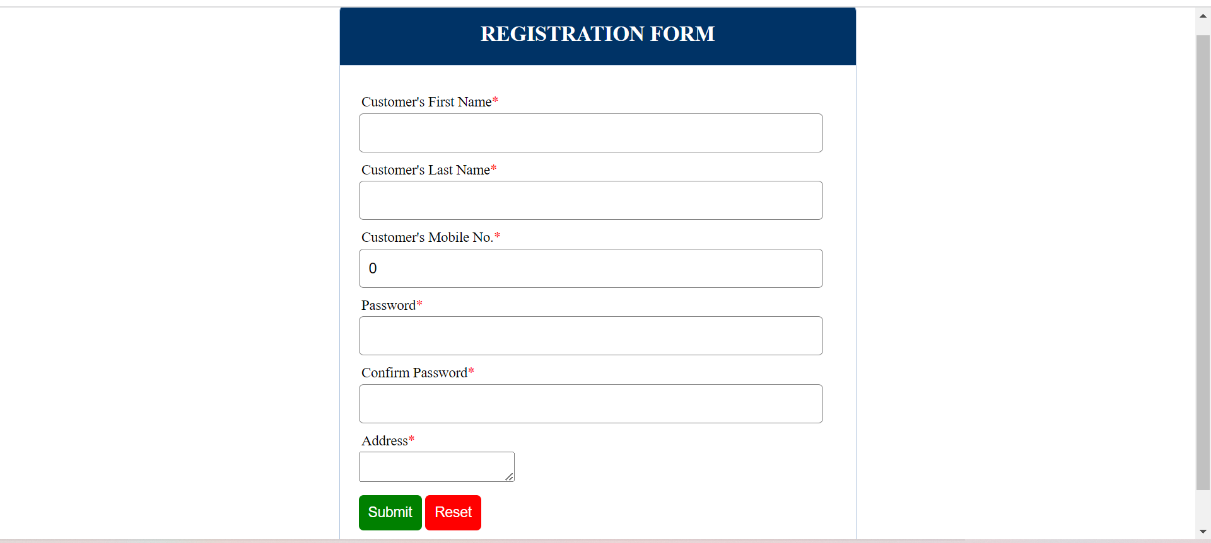

* Login.php

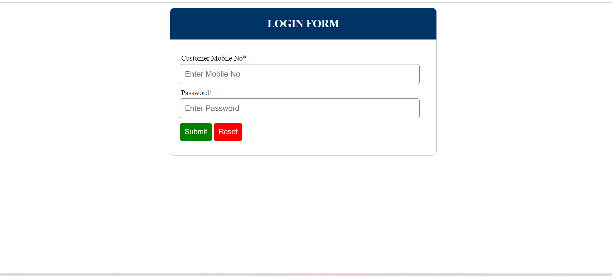

* **Check_catalogue.php (Poetry)**

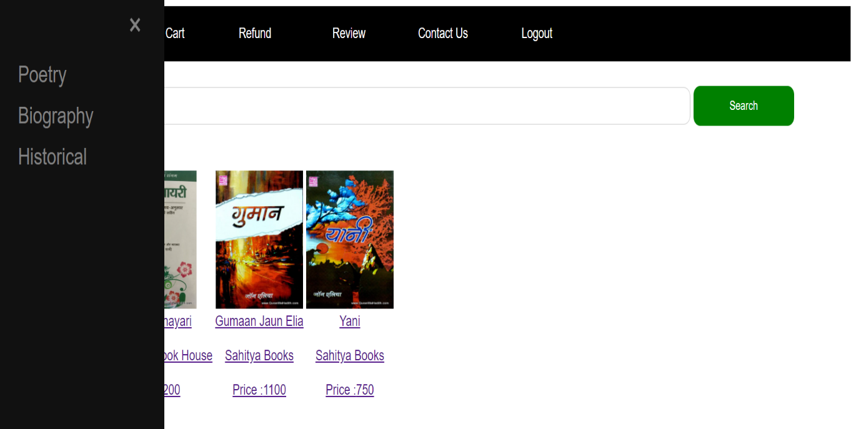

* **Check_catalogue.php (Biographical)**

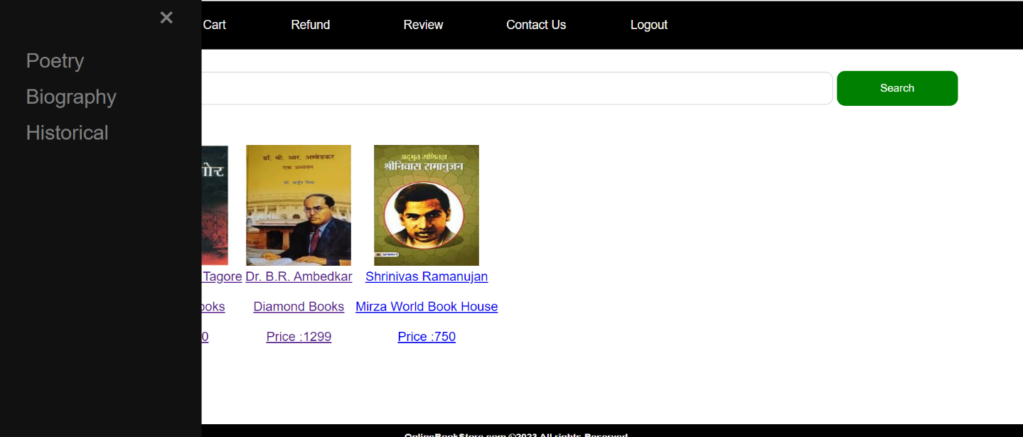

* **Check_catalogue.php (historical)**

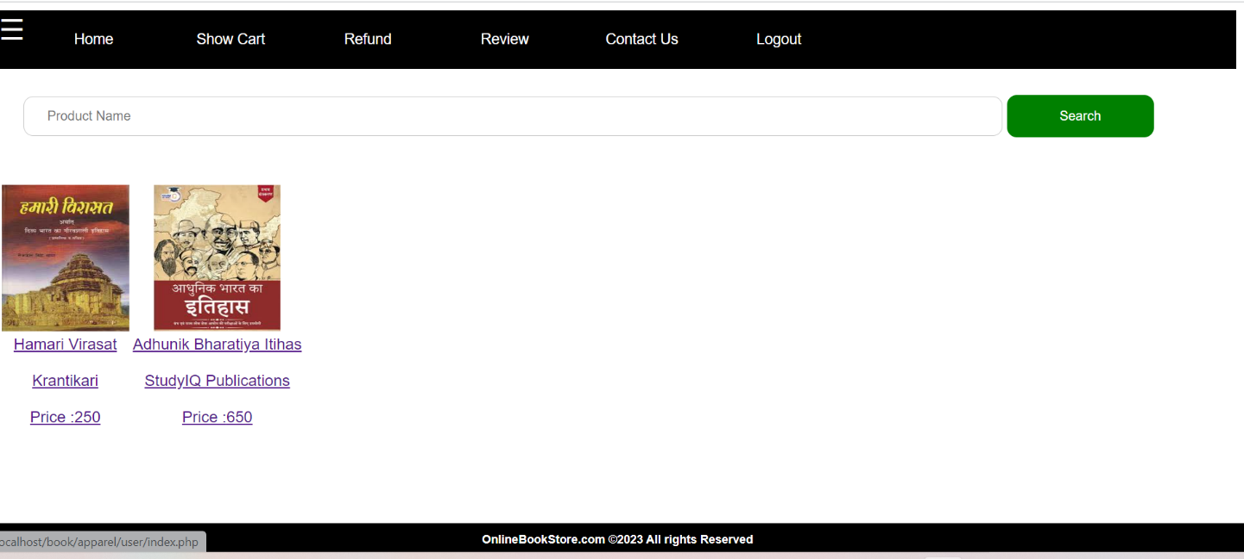

* **Search product.php**

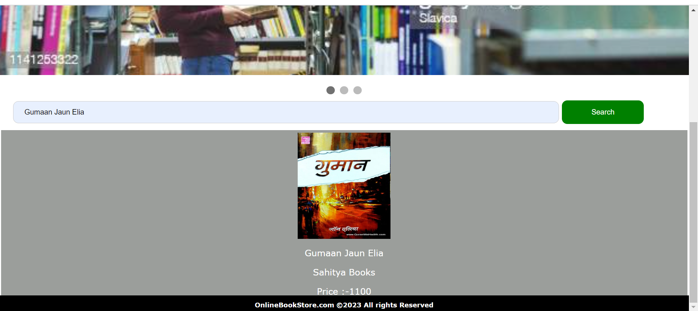

* **View.php**

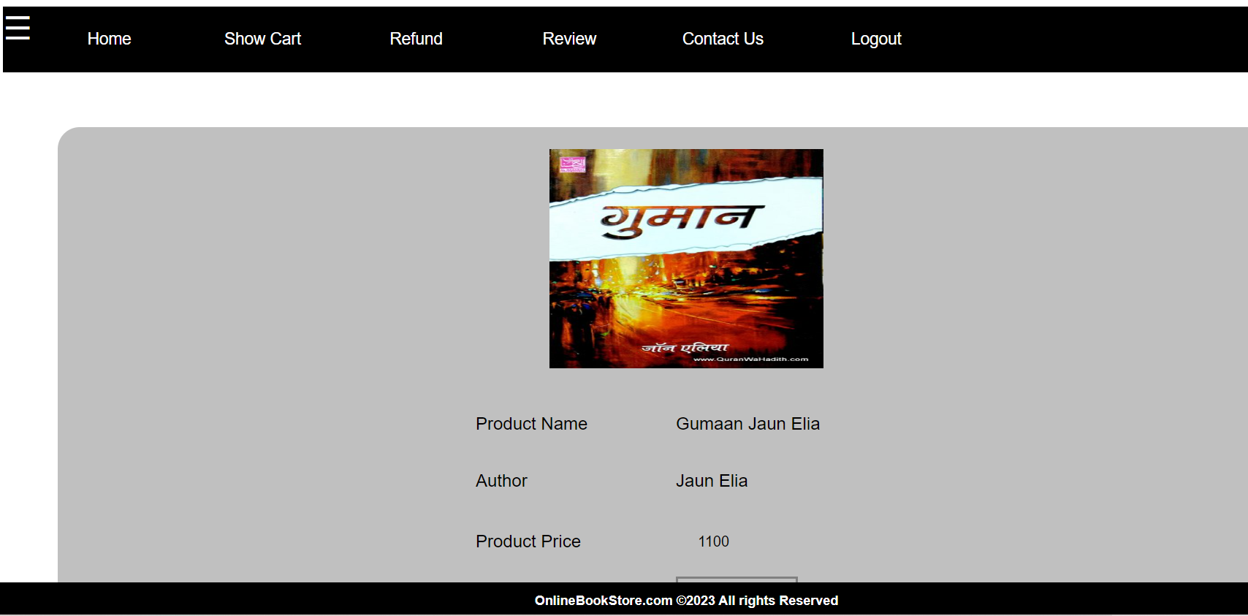

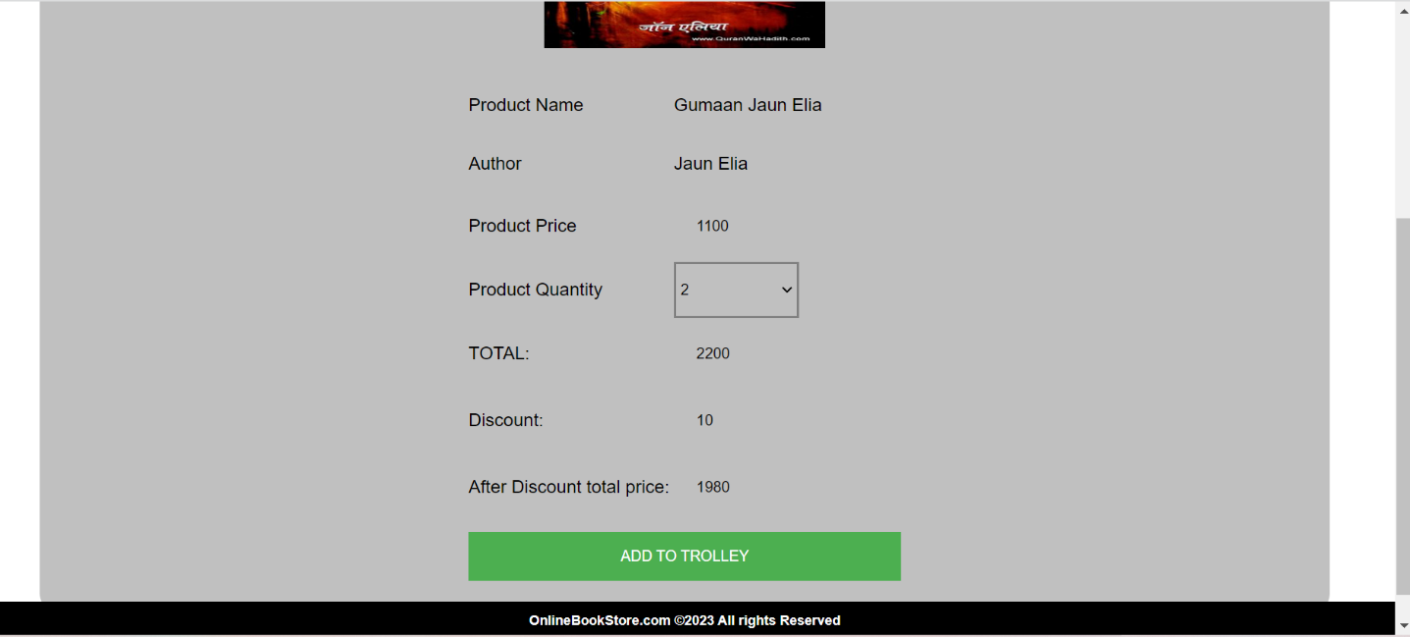

* **Trolley.php**

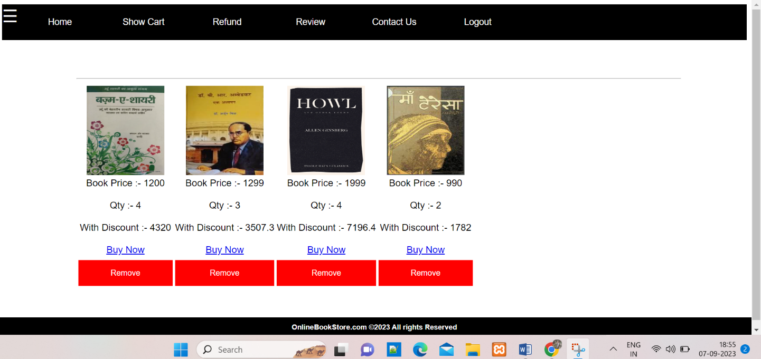

* **Payment.php**

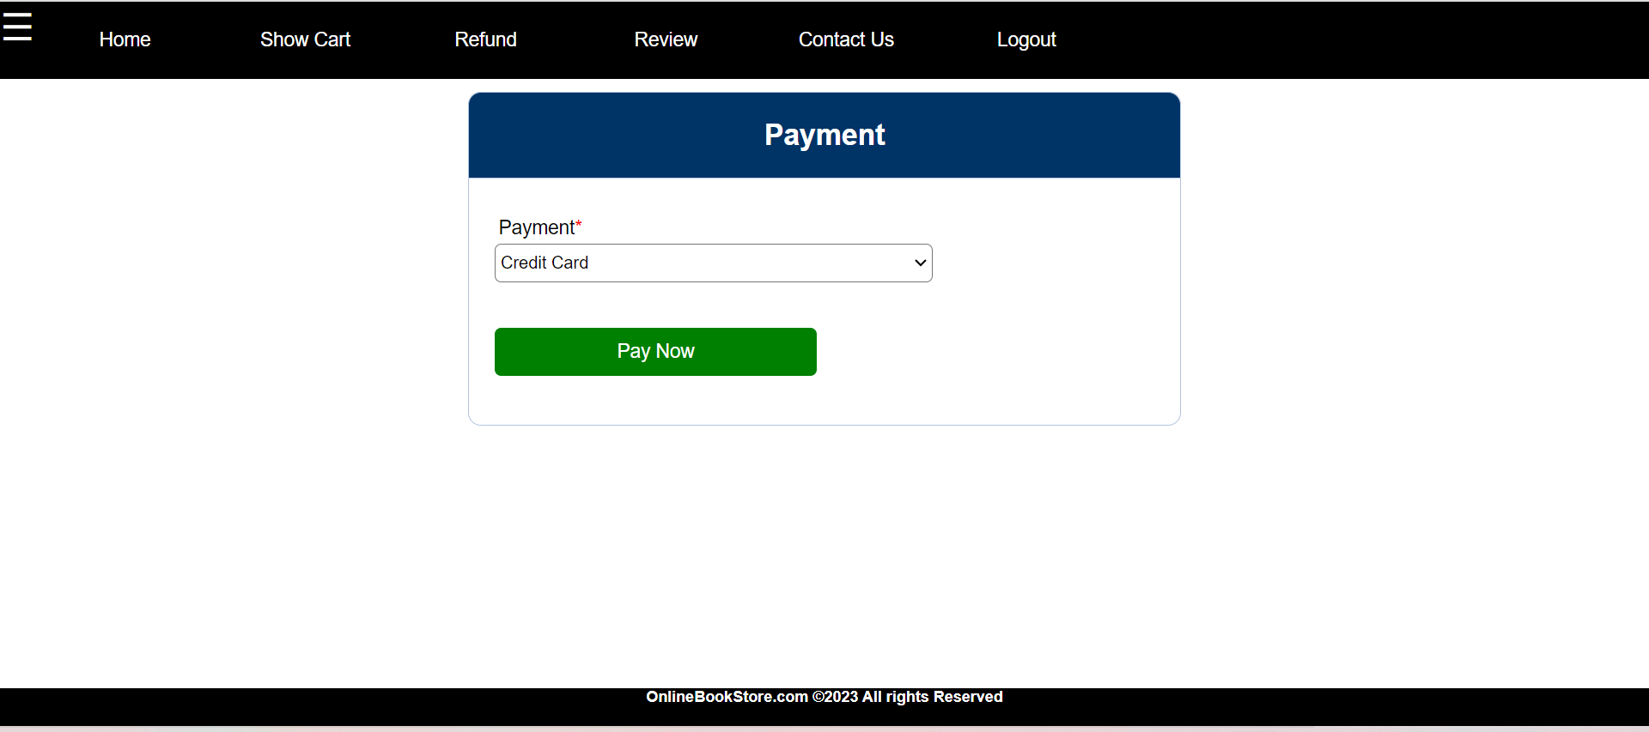

* **Delivery.php**

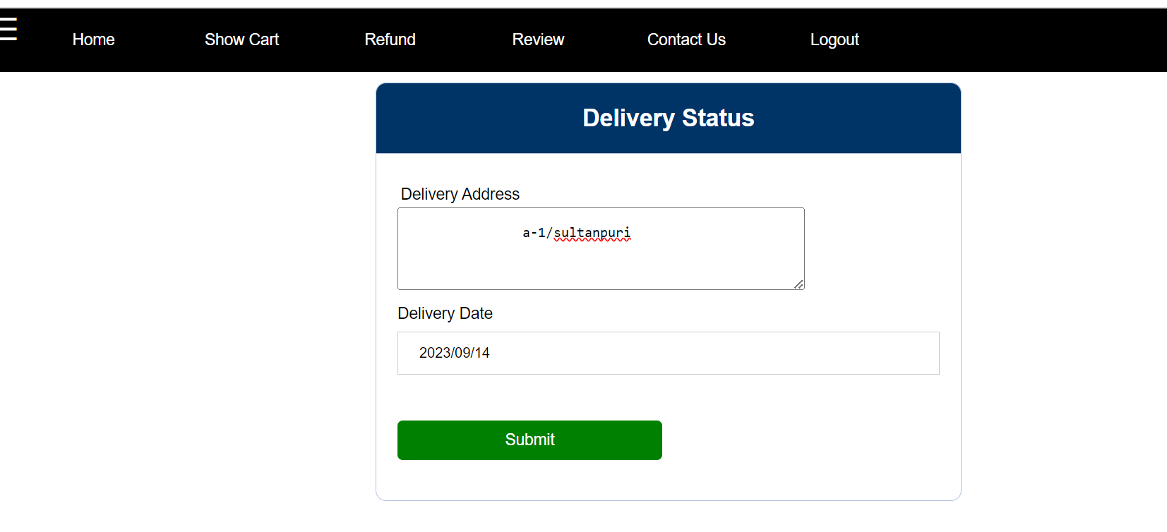

* **Refund.php**

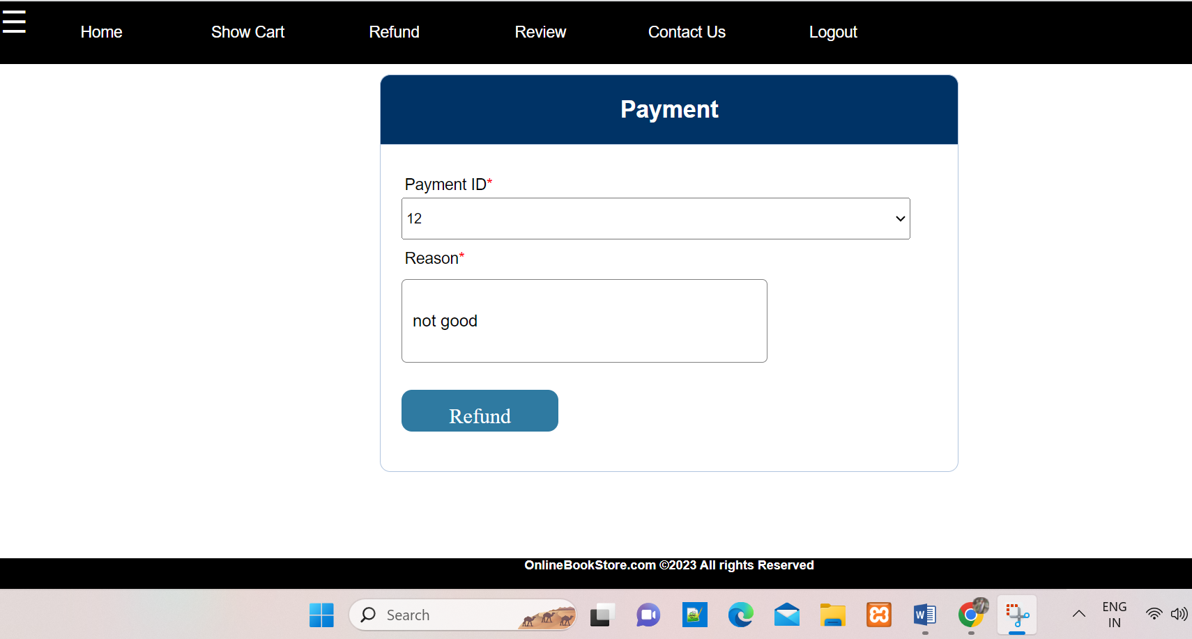

* **Review.php**

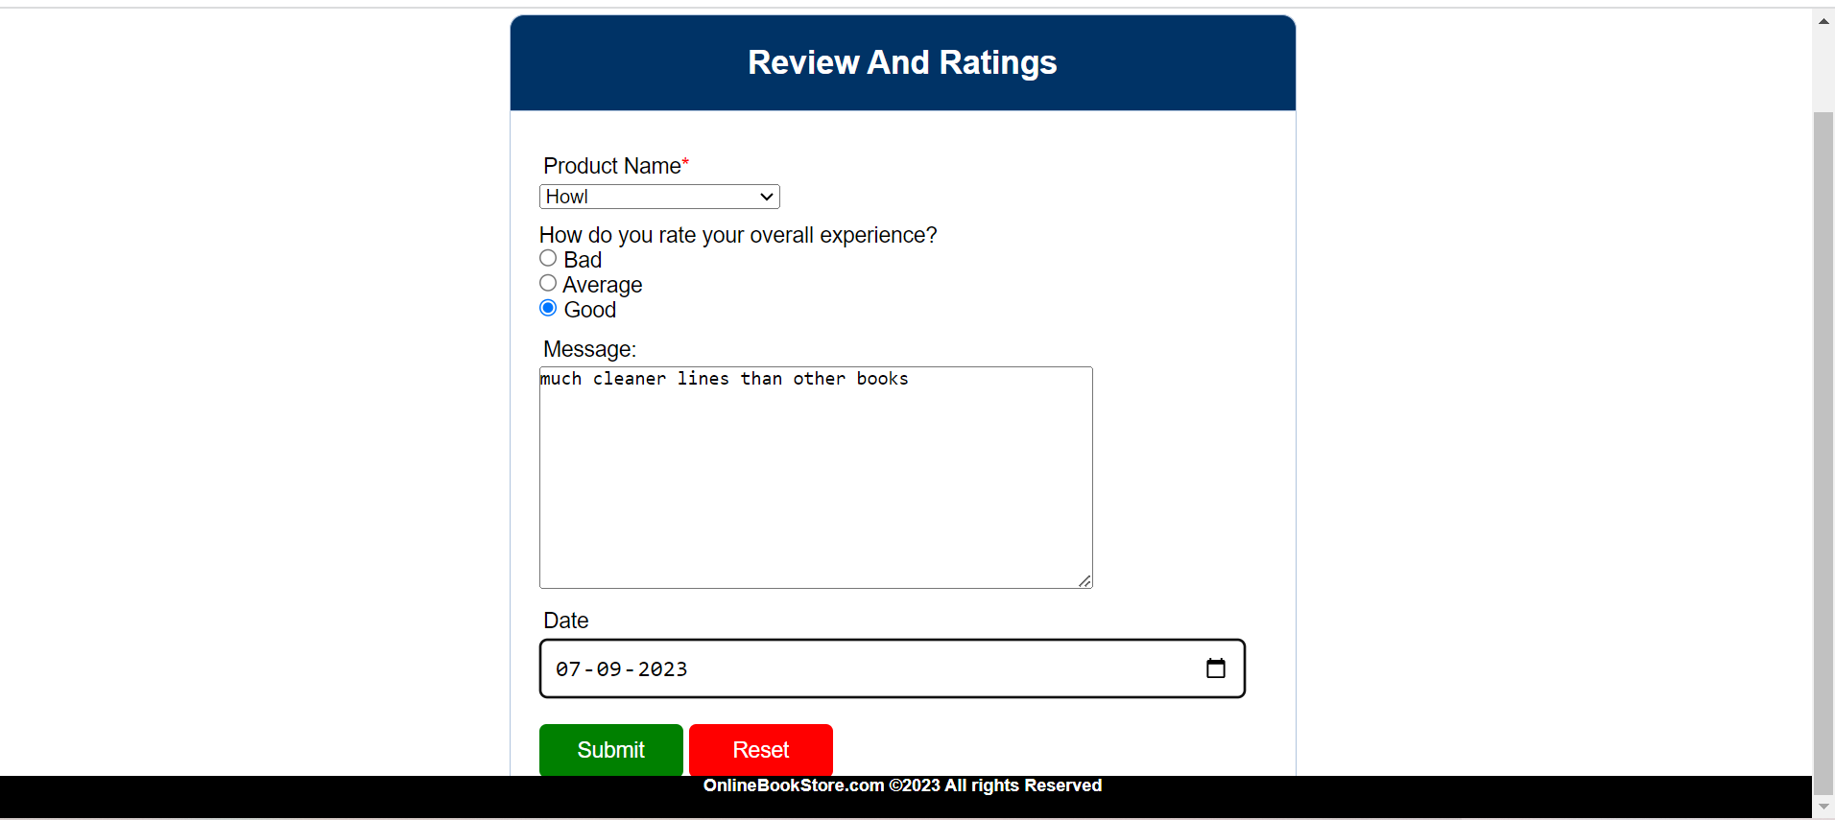

* **Contact us.php**

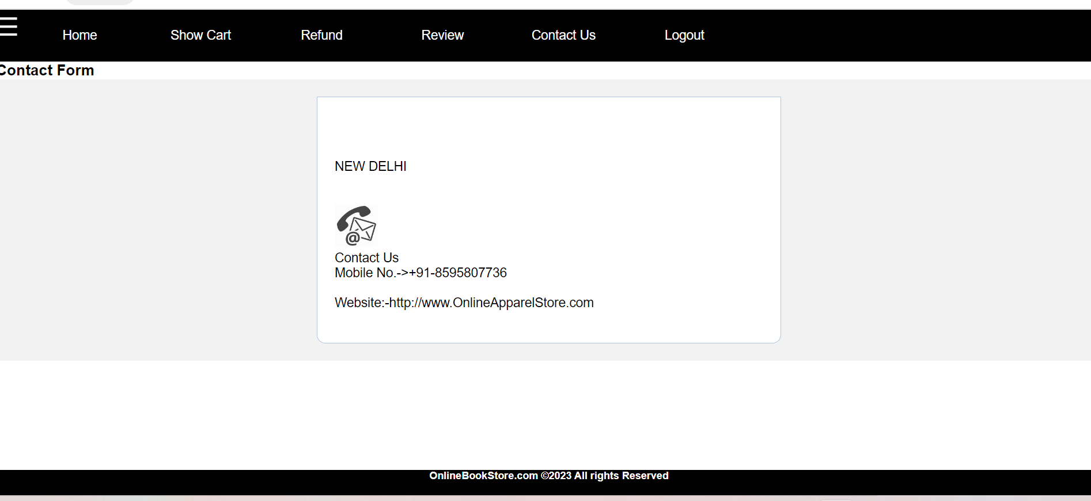

**ADMIN INTERFACE DESIGN**

* **Login.php**

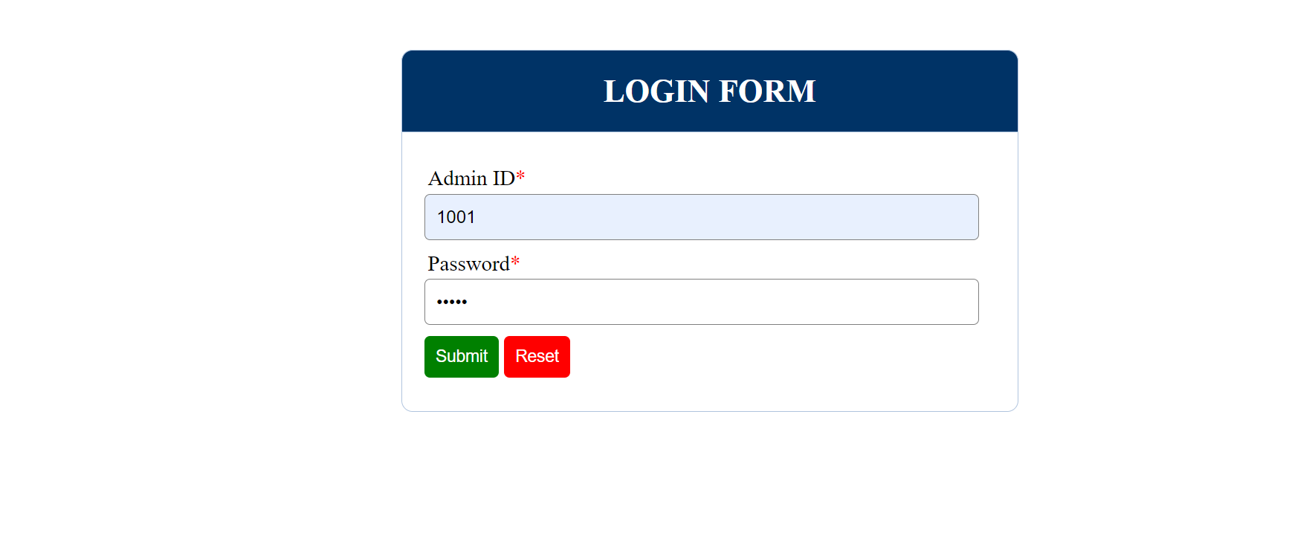

* **Dashboard.php**

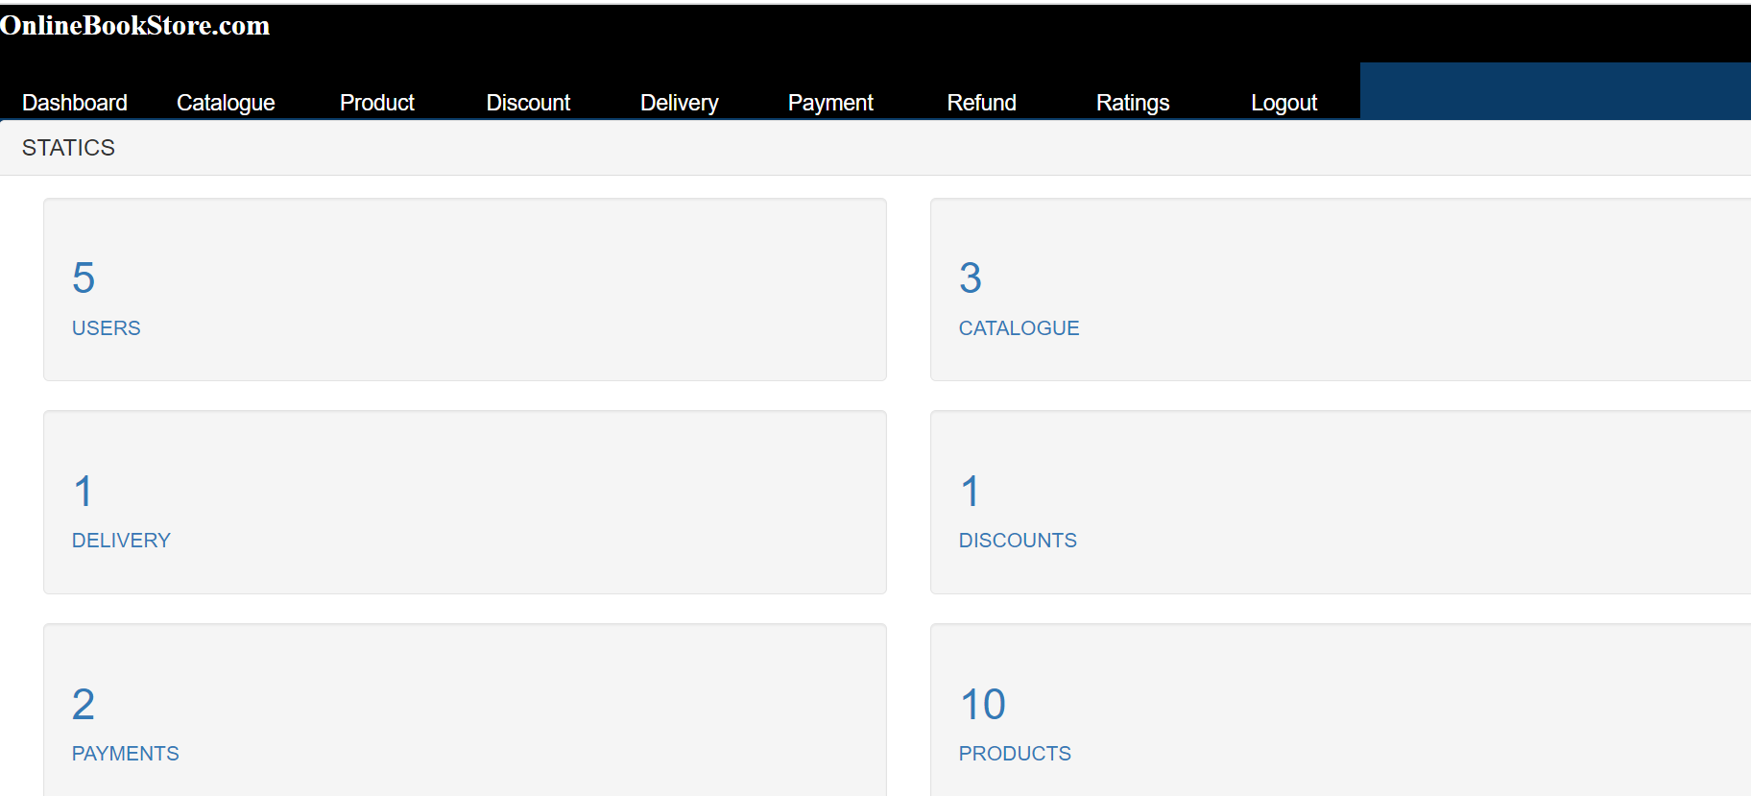

* **Catalogue.php**

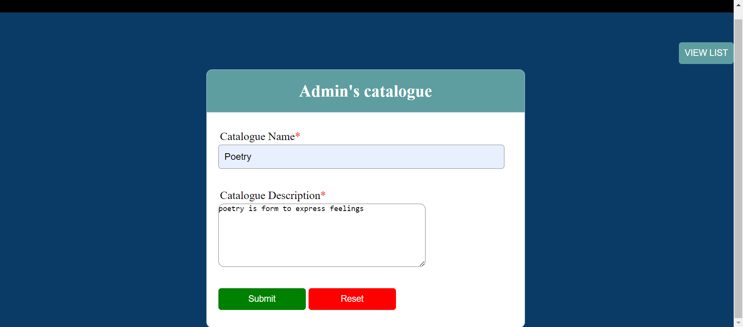

* **Product.php**

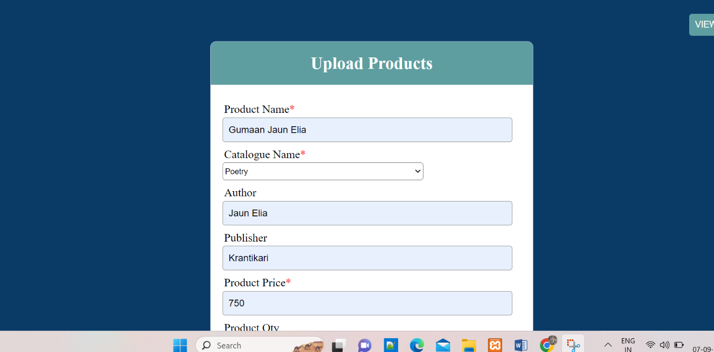

* **Discount.php**

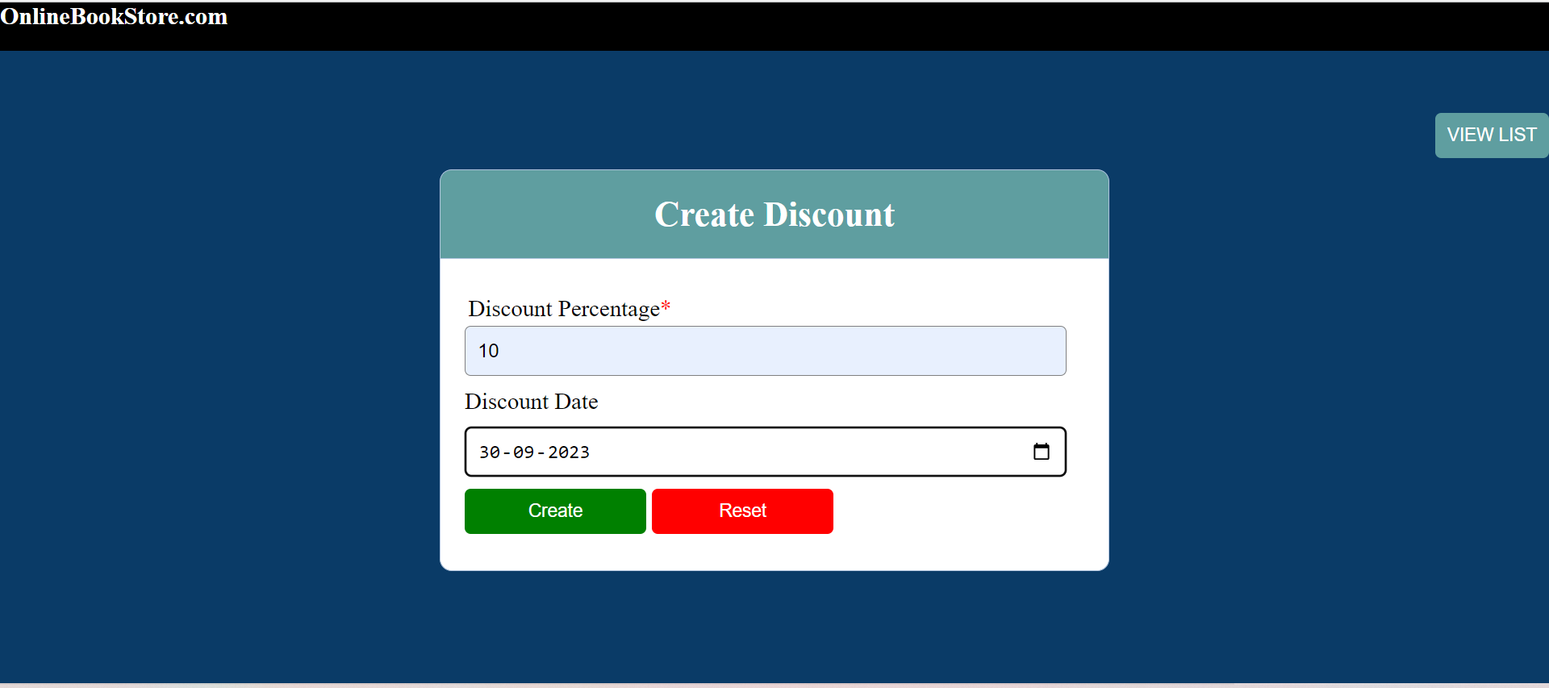

* **Delivery.php**

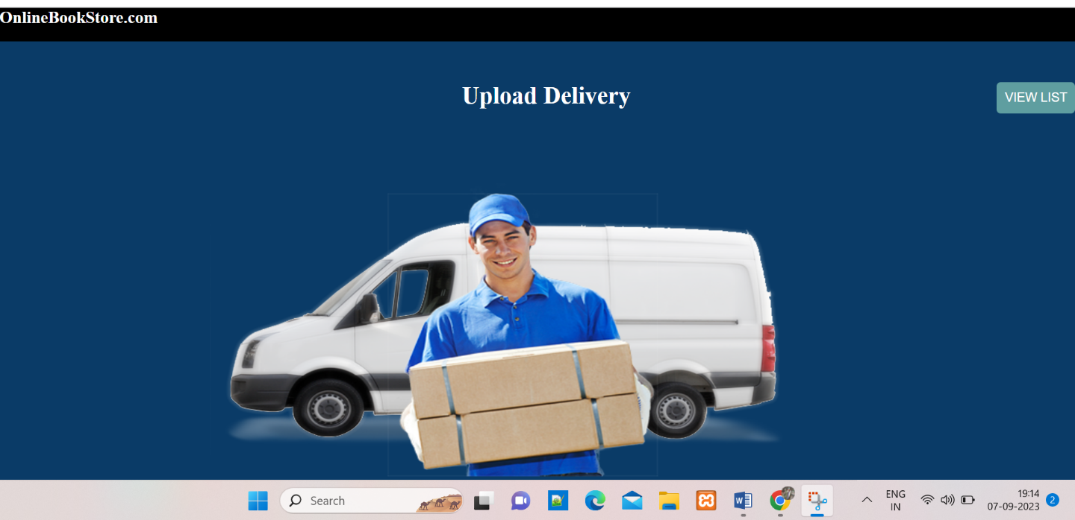

* **Payment.php**

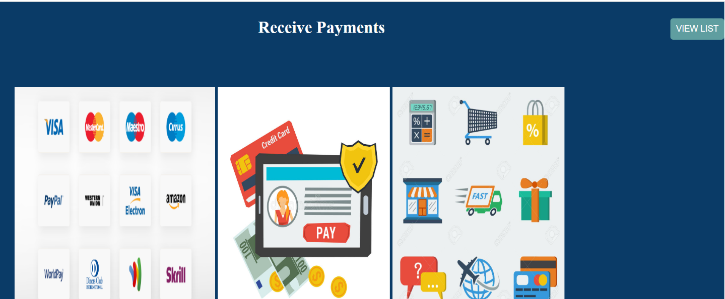

* **Refund.php**

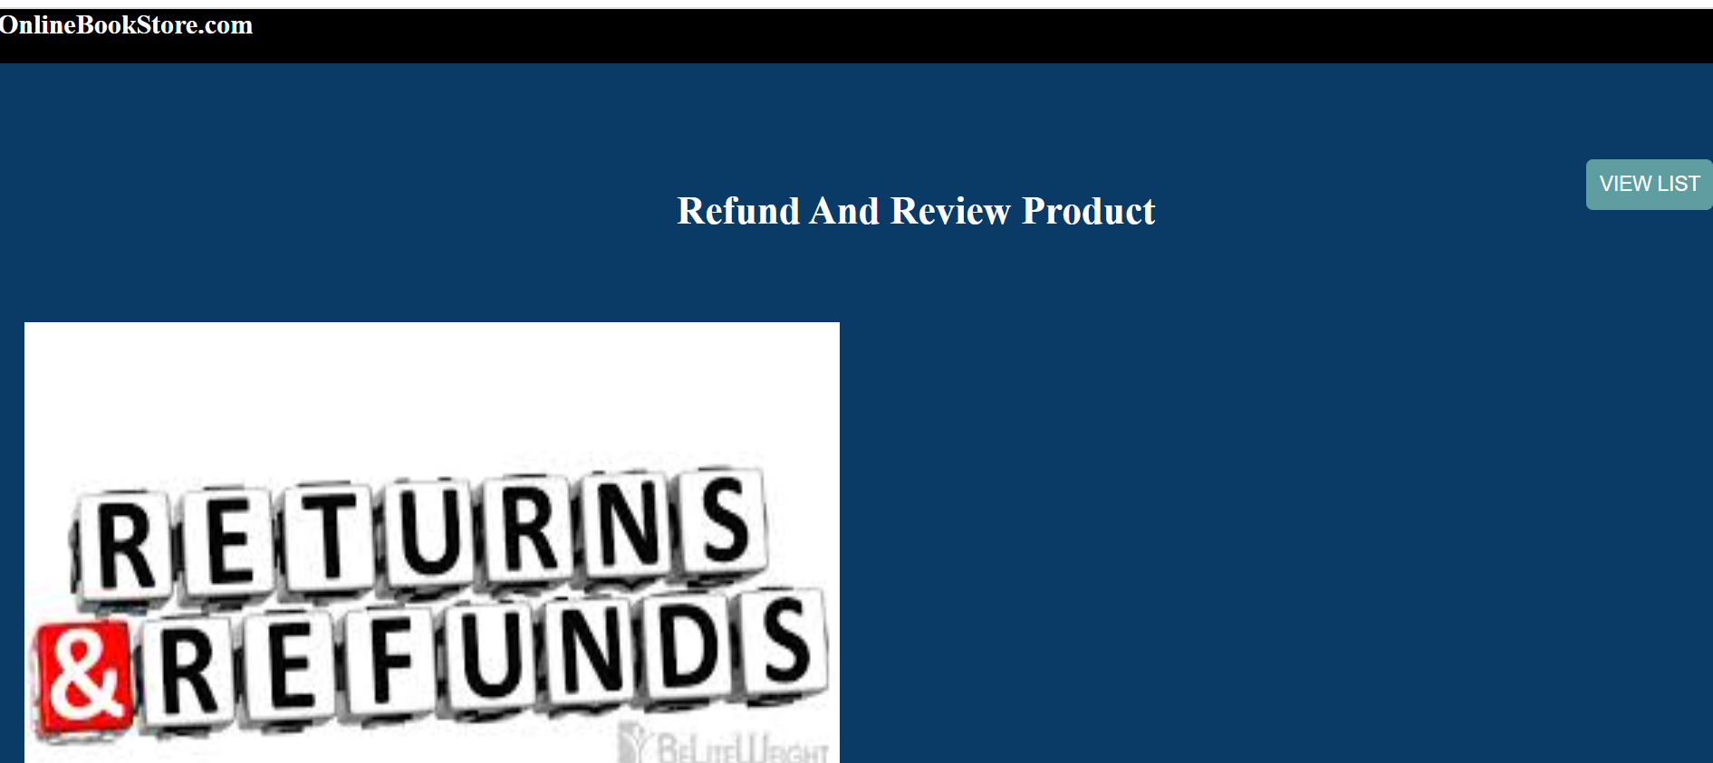

* **Ratings.php**

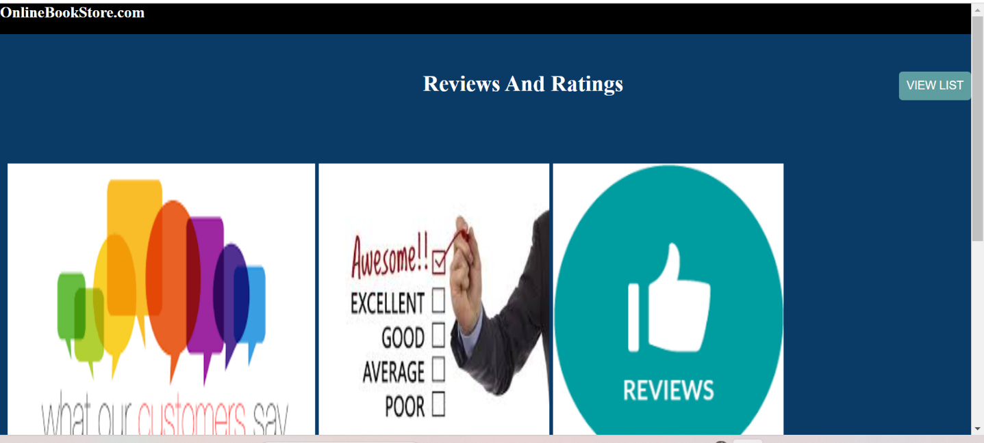

**CODING**

**ADMIN PANEL**

**/*A_Header.php*/**

<?php

session_start();

include "paras.php";

include "footer.php";

?>

<!DOCTYPE html>

<html>

<head>

<link type="text/css" rel="stylesheet" href="A_Design.css"/>

<title></title>

<style>

.menu-btn{

font-size:"18px";

}

.ul{

width:100% !important;

}

</style>

</head>

<body style="background-color:#0A3B67;">

<div class="f_DIV1" style="float:left;display:inline; ">

<p class="header-txt"><b>OnlineBookStore.com</b></p>

<ul class="ul">

<?php

if(isset($_SESSION['id']))

{?>

<li><a href="dashboard.php" style="color:white;" class="menu-btn">Dashboard</a></li>

<!-- <li><a href="About.php" class="menu-btn">About Us</a></li> -->

<li><a href="catalogue.php" class="menu-btn">Catalogue</a></li>

<li><a href="Product.php" class="menu-btn">Product</a></li>

<li><a href="Discount.php" class="menu-btn">Discount</a></li>

<li><a href="Delivery.php" class="menu-btn">Delivery</a></li>

<li><a href="payment.php" class="menu-btn">Payment</a></li>

<li><a href="refund.php" class="menu-btn">Refund</a></li>

<li><a href="rating.php" class="menu-btn">Ratings</a></li>

<li><a href="logout.php" class="menu-btn" >Logout</a></li>

<?php

}

?>

</ul>

</div>

<br/><br/><br/><br/>

</form>

</body>

</html>

**/*DASHBOARD.PHP*/**

<?php

include "A_Header.php";

include "paras.php";

?>

<!DOCTYPE html>

<html>

<head>

<title></title>

<link rel="stylesheet" type="text/css" href="style1.css">

<link rel="stylesheet" type="text/css" href="css/bootstrap.min.css"/>

</head>

<body>

<div class="panel panel-default ">

<div class="panel-heading">

<h3 class="panel-title">STATICS</h3>

</div>

<div class="panel-body">

<div class="col-sm-6">

<a class="link" href="">

<div class="well">

<h2><span aria-hidden="true"></span>

<?php

$query="select * from regs" ;

$r=mysqli_query($con,$query);

$count=mysqli_num_rows($r);

echo $count;

?>

</h2>

<h5>USERS</h5>

</div>

</a>

</div>

<div class="col-sm-6">

<a class="link" href="catalogue.php">

<div class="well">

<h2><span aria-hidden="true"></span>

<?php $query="select * from catalogue" ;

$r=mysqli_query($con,$query);

$count=0;

while($row=mysqli_fetch_assoc($r))

{

$count++;

}

echo $count;

?>

</h2>

<h5>CATALOGUE</h5>

</div>

</a>

</div>

<div class="col-sm-6">

<a class="link" href="delivery.php">

<div class="well">

<h2><span aria-hidden="true"></span>

<?php $query="select * from delivery" ;

$r=mysqli_query($con,$query);

$count=0;

while($row=mysqli_fetch_assoc($r))

{

$count++;

}

echo $count;

?>

</h2>

<h5>DELIVERY</h5>

</div>

</a>

</div>

<div class="col-sm-6">

<a class="link" href="discount.php">

<div class="well">

<h2><span aria-hidden="true"></span>

<?php $query="select * from discount" ;

$r=mysqli_query($con,$query);

$count=0;

while($row=mysqli_fetch_assoc($r))

{

$count++;

}

echo $count;

?>

</h2>

<h5>DISCOUNTS</h5>

</div>

</a>

</div>

<div class="col-sm-6">

<a class="link" href="payment.php">

<div class="well">

<h2><span aria-hidden="true"></span>

<?php $query="select * from payment" ;

$r=mysqli_query($con,$query);

$count=0;

while($row=mysqli_fetch_assoc($r))

{

$count++;

}

echo $count;

?>

</h2>

<h5>PAYMENTS</h5>

</div>

</a>

</div>

<div class="col-sm-6">

<a class="link" href="product.php">

<div class="well">

<h2><span aria-hidden="true"></span>

<?php $query="select * from product" ;

$r=mysqli_query($con,$query);

$count=0;

while($row=mysqli_fetch_assoc($r))

{

$count++;

}

echo $count;

?>

</h2>

<h5>PRODUCTS</h5>

</div>

</a>

</div>

<div class="col-sm-6">

<a class="link" href="review.php">

<div class="well">

<h2><span aria-hidden="true"></span>

<?php $query="select * from review" ;

$r=mysqli_query($con,$query);

$count=0;

while($row=mysqli_fetch_assoc($r))

{

$count++;

}

echo $count;

?>

</h2>

<h5>REVIEWS</h5>

</div>

</a>

</div>

<div class="col-sm-6">

<a class="link" href="Trolley.php">

<div class="well">

<h2><span aria-hidden="true"></span>

<?php $query="select * from Trolley";

$r=mysqli_query($con,$query);

$count=0;

while($row=mysqli_fetch_assoc($r))

{

$count++;

}

echo $count;

?>

</h2>

<h5>TROLLEY</h5>

</div>

</a>

</div>

<div class="col-sm-6">

<a class="link" href="sales.php">

<div class="well">

<h2><span aria-hidden="true"></span>

<?php $query="select * from sales" ;

$r=mysqli_query($con,$query);

$count=0;

while($row=mysqli_fetch_assoc($r))

{

$count++;

}

echo $count;

?>

</h2>

</div>

</a>

</div>

</div>

</div>

</body>

</html>

**/*CATALOGUE.PHP*/**

<?php

include "A_Header.php";

include "footer.php";

?>

<!DOCTYPE html>

<html>

<head>

<link rel="stylesheet" type="text/css" href="style1.css">

</head>

<body>

<div class="header">

<h2>Admin's catalogue</h2>

</div>

<div>

<a href="cat.php">

<input class="btn btn-primary btn-sm" align="right" style="float: right;margin-top:-120px; padding-bottom: : 0px;" type="button" name="addcatalogue" value="VIEW LIST">

</a>

</div>

<form method="POST" action="#">

<div class="input-group">

<label>Catalogue Name<span style="color:red;">*</span></label>

<input type="text" name="CAT_NAME"/>

</div>

<div class="input-group">

<br/>

<label>Catalogue Description<span style="color:red;">*</span></label>

<textarea name="CAT_DESC" cols="46" rows="7" style="border-radius:10px;"></textarea>

</div>

<div class="input-group">

<br/>

<button type="submit" style="background-color:green;width: 150px;" class="btn" name="btnsave">Submit</button>

<button type="Reset" style="background-color:red;width: 150px;" class="btn" >Reset</button>

</div>

</form>

</body>

</html>

<?php

if(isset($_POST['btnsave']))

{// print_r($_POST);echo "<br><br><br><br>" ;exit;

$CAT_NAME=$_POST['CAT_NAME'];

$CAT_DESC=$_POST['CAT_DESC'];

$query="INSERT INTO catalogue (CAT_NAME,CAT_DESC) VALUES ('$CAT_NAME','$CAT_DESC')";

if(mysqli_query($con,$query))

{

echo "<script>alert('catalogue added')</script>";

}

else

{

echo "<script>alert('catalogue failed to added')</script>";

}

}

?>

**/*CAT.PHP*/**

<?php

include "paras.php";

include "A_Header.php";

?>

<link href="A_Design.css" type="text/css" rel="stylesheet">

<div class="panel panel-default">

<div class="panel-heading main-color-bg" >

<h3 class="panel-title" style="color: white;"><center>Catalogue's list</center>

<a href="catalogue.php">

<input class="btn btn-primary btn-sm" align="right" style="float: right;margin-top: 0px; padding-bottom: : 0px;background: #368792; color: white;height: 40px;border-radius: 10px;" type="button" onclick="catalogue.php" name="addcatalogue" value="ADD CATALOGUE"></a> </h3>

</div>

<div class="panel-body">

<br/><br/>

<table class="table-format">

<tr>

<td class="thead">Sr. No. </td>

<td class="thead">Name</td>

<td class="thead"> Description</td>

</tr>

<?php

$query = "select * from catalogue";

$res=mysqli_query($con,$query);

while($row = mysqli_fetch_assoc($res))

{

?>

<form name="form" method="POST" action="#">

<tr>

<td class="tdata"><?php echo $row['CAT_ID']; ?></td>

<td class="tdata"><input type="text" class="txt-format" name="CAT_NAME" style="width:200px;" value="<?php echo $row['CAT_NAME']; ?>" required></td>

<td class="tdata"><input type="text" class="txt-format" name="CAT_DESC" style="width:500px;"value="<?php echo $row['CAT_DESC']; ?>"></td>

<td><button name="delete" type="submit" class="btndelete" value="<?php echo $row['CAT_ID']; ?>">Delete</button></td>

<td><button name="change" type="submit" class="btnedit" value="<?php echo $row['CAT_ID']; ?>">Edit</button></td>

</tr>

</form>

<?php

}

?>

<!-- ADD NEW CATALOGUES-->

<?php

if(isset($_POST['delete']))

{

$id=$_POST['delete'];

$q1 ="delete from catalogue where CAT_ID='$id'";

$result=mysqli_query($con,$q1);

if($result!=null)

{

echo "<script>alert('Record deleted');window.location='cat.php';</script>";

}

else

{

echo "id".$id." not deleted</br>";

}

}

?>

<?php

if(isset($_POST['change']))

{

$CAT_ID=$_POST['change'];

$CAT_NAME=$_POST['CAT_NAME'];

$CAT_DESC=$_POST['CAT_DESC'];

$q4="update catalogue set CAT_NAME='$CAT_NAME', CAT_DESC='$CAT_DESC' where CAT_ID='$CAT_ID'" ;

$r=mysqli_query($con,$q4);

if($r!=null)

{

echo "<script>alert('Record Updated');window.location='cat.php';</script>";

}

else

{

echo "id".$row['CAT_ID']." not updated</br>";

}

}

?>

**/*PRODUCT.PHP*/**

<?php

include "A_Header.php";

include "footer.php";

?>

<link rel="stylesheet" type="text/css" href="style1.css">

<link rel="stylesheet" type="text/css" href="A_Design.css"/>

<div class="header">

<h2>Upload Products</h2>

</div>

<div>

<a href="pro.php"> <input class="btn btn-primary btn-sm" align="right" style="float: right;margin-top: -120px; padding-bottom: : 0px;" type="button" name="addproduct" value="VIEW LIST"></a>

</div>

<form method="post" action="product.php" enctype="multipart/form-data">

<div class="input-group">

<label>Product Name<span style="color:red;">*</label>

<input type="text" name="PRO_NAME" value="">

</div>

<div class="input-group">

<label>Catalogue Name<span style="color:red;">*</label>

<select name="CAT_ID" class="txt-form">

<?php

$query="select * from catalogue ";

$r=mysqli_query($con,$query);

while($row=mysqli_fetch_assoc($r))

{

?>

<option value="<?php echo $row['CAT_ID'];?>"><?php echo $row['CAT_NAME'];?></option>

<?php

}

?></select>

</div>

<div class="input-group">

<label>Author</label>

<input type="text" name="Author" value="">

</div>

<div class="input-group">

<label>Publisher</label>

<input type="text" name="Publisher" value="">

</div>

<!-- <div class="input-group">

<label>Product Size</label>

<input type="number" name="PRO_SIZE">

</div> -->

<div class="input-group">

<label>Product Price<span style="color:red;">*</label>

<input type="text" name="PRO_PRICE" >

</div>

<div class="input-group">

<label>Product Qty</label>

<input type="text" name="PRO_Qty">

</div>

<div class="input-group">

<label>Discount<span style="color:red;">*</label>

<select name="DIS_ID" class="txt-form">

<?php

$query="select * from discount";

$r=mysqli_query($con,$query);

while($row=mysqli_fetch_assoc($r))

{

?>

<option value="<?php echo $row['DIS_ID'];?>"><?php echo $row['PERC_D'];?></option>

<?php

}

?></select>

</div>

<div>

<label>Product Image1<span style="color:red;">*</label>

<input type="file" name="PRO_IMAGE1" />

</div>

<div>

<label>Product Image2<span style="color:red;">*</span></label>

<input type="file" name="PRO_IMAGE2" />

</div>

<div class="input-group">

<br/>

<button type="submit" style="background-color:green;width: 150px;" class="btn" name="btnsave">Submit</button>

<button type="Reset" style="background-color:red;width: 150px;" class="btn" >Reset</button>

</div>

</form>

<?php

if(isset($_POST['btnsave']))

{

$PRO_NAME=$_POST['PRO_NAME'];

$CAT_ID=$_POST['CAT_ID'];

$Author=$_POST['Author'];

$Publisher=$_POST['Publisher'];

$PRO_PRICE=$_POST['PRO_PRICE'];

$PRO_Qty=$_POST['PRO_Qty'];

$DIS_ID=$_POST['DIS_ID'];

$p="Product/";

$p1="Product/";

$p=$p.basename($_FILES["PRO_IMAGE1"]["name"]);

move_uploaded_file($_FILES["PRO_IMAGE1"]["tmp_name"],$p);

$p1=$p1.basename($_FILES["PRO_IMAGE2"]["name"]);

move_uploaded_file($_FILES["PRO_IMAGE2"]["tmp_name"],$p1);

$query="insert into product(PRO_NAME,CAT_ID,Author,Publisher,PRO_PRICE,PRO_Qty,DIS_ID,PRO_IMAGE1,PRO_IMAGE2) values('$PRO_NAME','$CAT_ID','$Author','$Publisher','$PRO_PRICE','$PRO_Qty','$DIS_ID','"."Product/" . $_FILES["PRO_IMAGE1"]["name"]."','"."Product/" . $_FILES["PRO_IMAGE2"]["name"]."')";

if(mysqli_query($con,$query))

{

echo "<script>alert('product added')</script>";

}

else

{

echo "<script>alert('product failed to added')</script>";

}

}

?>

**/*PRO.PHP*/**

<?php

include "paras.php";

include "A_Header.php";

?>

<link href="A_Design.css" type="text/css" rel="stylesheet">

<div class="panel panel-default">

<div class="panel-heading main-color-bg" >

<h3 class="panel-title" style="color: white;"><center>Product's list</center>

<a href="product.php">

<input class="btn btn-primary btn-sm" align="right" style="float: right;margin-top: 0px; padding-bottom: : 0px;background: #368792; color: white;height: 40px;border-radius: 10px;" type="button" onclick="product.php" name="addproduct" value="ADD PRODUCTS"></a> </h3>

</div>

<div class="panel-body">

<br/><br/>

<table class="table-format">

<tr>

<td class="thead">S.No </td>

<td class="thead">NAME </td>

<td class="thead">AUTHOR</td>

<td class="thead">PUBLISHER</td>

<td class="thead">PRICE</td>

<td class="thead">DIS_ID</td>

</tr>

<?php

$query = "select * from product";

$res=mysqli_query($con,$query);

$i =0;

while($row = mysqli_fetch_assoc($res))

{

$i++

?>

<form name="form" method="POST" action="#">

<tr>

<td class="tdata"><?php echo $i; ?></td>

<td class="tdata"><input type="text" class="txt-format" name="PRO_NAME" style="width:80px;" value="<?php echo $row['PRO_NAME']; ?>" required></td>

<td class="tdata"><input type="text" class="txt-format" name="Author" style="width:80px;" value="<?php echo $row['Author']; ?>"></td>

<td class="tdata"><input type="text" class="txt-format" name="Publisher" style="width:80px;" value="<?php echo $row['Publisher']; ?>"></td>

<td class="tdata"><input type="text" class="txt-format" name="PRO_PRICE" style="width:80px;" value="<?php echo $row['PRO_PRICE']; ?>"></td>

<td class="tdata"><input type="text" class="txt-format" name="DIS_ID" style="width:80px;" value="<?php echo $row['DIS_ID']; ?>"></td>

<td><button name="delete" type="submit" class="btndelete" value="<?php echo $row['PRO_ID']; ?>">Delete</button></td>

<td><button name="change" type="submit" class="btnedit" value="<?php echo $row['PRO_ID']; ?>">Edit</button></td>

</tr>

</form>

<?php

}

?>

<!-- ADD NEW PRODUCTS-->

<?php

if(isset($_POST['delete']))

{

$del_id = $_POST['delete'];

$q1 = "delete from product where PRO_ID='$del_id'";

$result = mysqli_query($con,$q1);

if($result!=null)

{

echo "<script>alert('Record deleted');window.location='pro.php';</script>";

}

else

{

echo "id".$row['PRO_ID']." not deleted</br>";

}

}

?>

<?php

if(isset($_POST['change']))

{

$PRO_ID=$_POST['change'];

$PRO_NAME=$_POST['PRO_NAME'];

$Author=$_POST['Author'];

$Publisher=$_POST['Publisher'];

$PRO_PRICE=$_POST['PRO_PRICE'];

$DIS_ID=$_POST['DIS_ID'];

$q4="update product set PRO_NAME='$PRO_NAME',Author='$Author',PRO_BRAND='$PRO_BRAND',PRO_SIZE='$PRO_SIZE',PRO_PRICE='$PRO_PRICE',,DIS_ID='$DIS_ID'where PRO_ID='$PRO_ID'" ;

$r=mysqli_query($con,$q4);

if($r!=null)

{

echo "<script>alert('Record Updated');window.location='pro.php';</script>";

}

else

{

echo "id".$row['PRO_ID']." not updated</br>";

}

}

?>

**/*DISCOUNT.PHP*/**

<?php

include "A_Header.php";

include "footer.php";

?>

<link rel="stylesheet" type="text/css" href="style1.css">

<div class="header">

<h2>Create Discount</h2>

</div>

<div>

<a href="dis.php"> <input class="btn btn-primary btn-sm" align="right" style="float: right;margin-top: -120px; padding-bottom: : 0px;" type="button" name="adddiscount" value="VIEW LIST"></a>

</div>

<form method="post" action="discount.php">

<div class="input-group">

<label>Discount Percentage<span style="color:red;">*</label>

<input type="text" name="PERC_D" value="">

</div>

<label>Discount Date</label>

<div class="input-group">

<input type="date" name="date" value="">

</div>

<div class="input-group">

<button type="submit" style="background-color:green;width: 150px;" class="btn" name="btnsave">Create</button>

<button type="Reset" style="background-color:red;width: 150px;" class="btn" name="btnsave">Reset</button>

</div>

</form>

</body>

</html>

<?php

if(isset($_POST['btnsave']))

{

$PERC_D=$_POST['PERC_D'];

$Date=$_POST['date'];

$query="insert into discount(PERC_D,Date) values('$PERC_D','$Date')";

if(mysqli_query($con,$query))

{

echo "<script>alert('Discount added')</script>";

}

else

{

echo "<script>alert('Discount failed to added')</script>";

}

}

?>

**/*DIS.PHP*/**

<?php

include "paras.php";

include "A_Header.php";

?>

<link href="A_Design.css" type="text/css" rel="stylesheet">

<div class="panel panel-default">

<div class="panel-heading main-color-bg" >

<h3 class="panel-title" style="color: white;"><center>Discount's List</center>

<a href="discount.php">

<input class="btn btn-primary btn-sm" align="right" style="float: right;margin-top: 0px; padding-bottom: : 0px;background: #368792; color: white;height: 40px;border-radius: 10px;" type="button" onclick="discount.php" name="add discount" value="ADD DISCOUNT"></a> </h3>

</div>

<div class="panel-body">

<br/><br/>

<table class="table-format">

<tr>

<td class="thead">ID </td>

<td class="thead">Percentage</td>

<td class="thead">Discount Date</td>

</tr>

<?php

$query = "select * from discount";

$res=mysqli_query($con,$query);

while($row = mysqli_fetch_assoc($res))

{

?>

<form name="form" method="POST" action="#">

<tr>

<td class="tdata"><?php echo $row['DIS_ID']; ?></td>

<td class="tdata"><input type="text" class="txt-format" name="PERC_D" style="width:200px;" value="<?php echo $row['PERC_D']; ?>" required></td>

<td class="tdata"><input type="text" class="txt-format" name="Date" style="width:200px;" value="<?php echo $row['Date']; ?>"></td>

<td><button name="delete" type="submit" class="btndelete" value="<?php echo $row['DIS_ID']; ?>">Delete</button></td>

<td><button name="change" type="submit" class="btnedit" value="<?php echo $row['DIS_ID']; ?>">Edit</button></td>

</tr>

</form>

<?php

}

?>

<!-- ADD NEW DISCOUNTS-->

<?php

if(isset($_POST['delete']))

{

$del_id = $_POST['delete'];

$q1 = "delete from discount where DIS_ID='$del_id'";

$result = mysqli_query($con,$q1);

if($result!=null)

{

echo "<script>alert('Record deleted');window.location='dis.php';</script>";

}

else

{

echo "id".$row['DIS_ID']." not deleted</br>";

}

}

?>

<?php

if(isset($_POST['change']))

{

$DIS_ID=$_POST['change'];

$PERC_D=$_POST['PERC_D'];

$Date=$_POST['Date'];

$q4="update discount set PERC_D='$PERC_D', Date='$Date' where DIS_ID='$DIS_ID'" ;

$r=mysqli_query($con,$q4);

if($r!=null)

{

echo "<script>alert('Record Updated');window.location='cat.php';</script>";

}

else

{

echo "id".$row['DIS_ID']." not updated</br>";

}

}

?>

**/*DELIVERY.PHP*/**

<?php

include "A_Header.php";

include "footer.php";

?>

<link href="style1.css" type="text/css" rel="stylesheet">

<div class="banner">

<h2 style="color: white; margin-left: 550px;">Upload Delivery</h2>

</div>

<br/><br/><br/><br/>

<a href="del.php"> <input class="btn btn-primary btn-sm" text-align="right" style="float: right;margin-top: -120px; padding-bottom: : 0px;" type="button" name="adddelivery" value="VIEW LIST"></a>

</div>

<img src="Delivery.png" height="350px" width="700px" style="margin-left: 250px;" />

**/*DEL.PHP*/**

<?php

include "paras.php";

include "A_Header.php";

?>

<link href="A_Design.css" type="text/css" rel="stylesheet">

<div class="panel panel-default">

<div class="panel-heading main-color-bg" >

<h3 class="panel-title" style="color: white;"><center>Delivery's List</center>

<a href="delivery.php">

<input class="btn btn-primary btn-sm" align="right" style="float: right;margin-top: 0px; padding-bottom: : 0px;background: #368792; color: white;height: 40px;border-radius: 10px;" type="button" onclick="delivery.php" name="adddelivery" value="DELIVERY"></a> </h3>

</div>

<div class="panel-body">

<br/><br/>

<table class="table-format">

<tr>

<td class="thead">ID </td>

<td class="thead">PAYMENT </td>

<td class="thead">Product</td>

<td class="thead">Date</td>

<td class="thead">Address</td>

</tr>

<?php

$query = "select * from delivery";

$res=mysqli_query($con,$query);

while($row = mysqli_fetch_assoc($res))

{

?>

<form name="form" method="POST" action="#">

<tr>

<td class="tdata"><?php echo $row['DEL_ID']; ?></td>

<td class="tdata"><input type="text" class="txt-format" name="PAY_ID" style="width:80px;" value="<?php echo $row['PAY_ID']; ?>" required></td>

<td class="tdata"><input type="text" class="txt-format" name="PRO_ID" style="width:80px;" value="<?php echo $row['PRO_ID']; ?>"></td>

<td class="tdata"><input type="text" class="txt-format" name="DEL_date" style="width:100px;" value="<?php echo $row['DEL_date']; ?>"></td>

<td class="tdata"><input type="text" class="txt-format" name="address" value="<?php echo $row['address']; ?>"></td>

<td><button name="delete" type="submit" class="btndelete" value="<?php echo $row['DEL_ID']; ?>">Delete</button></td>

<td><button name="change" type="submit" class="btnedit" value="<?php echo $row['DEL_ID']; ?>">Edit</button></td>

</tr>

</form>

<?php

}

?>

<!-- ADD NEW DELIVERY-->

<?php

if(isset($_POST['delete']))

{

$del_id = $_POST['delete'];

$q1 = "delete from delivery where DEL_ID='$del_id'";

$result = mysqli_query($con,$q1);

if($result!=null)

{

echo "<script>alert('Record deleted');window.location='del.php';</script>";

}

else

{

echo "id".$row['DEL_ID']." not deleted</br>";

}

}

?>

<?php

if(isset($_POST['change']))

{

$DEL_ID=$_POST['change'];

$PAY_ID=$_POST['PAY_ID'];

$PRO_ID=$_POST['PRO_ID'];

$address=$_POST['address'];

$DEL_date=$_POST['DEL_date'];

$q4="update delivery set PAY_ID='$PAY_ID', PRO_ID='$PRO_ID',address='$address',DEL_date='$DEL_date' where DEL_ID='$DEL_ID'" ;

$r=mysqli_query($con,$q4);

if($r!=null)

{

echo "<script>alert('Record Updated');window.location='del.php';</script>";

}

else

{

echo "id".$row['DEL_ID']." not updated</br>";

}

}

?>

**/*PAYMENT.PHP*/**

<?php

include "A_Header.php";

include "footer.php";

?>

<link href="style1.css" type="text/css" rel="stylesheet">

<div class="banner">

<h2 style="color: white;margin-left: 450px;">Receive Payments</h2>

</div>

<br/><br/><br/><br/>

<a href="pay.php"> <input class="btn btn-primary btn-sm" text-align="right" style="float: right;margin-top: -120px; padding-bottom: : 0px;" type="button" name="adddelivery" value="VIEW LIST"></a>

</div>

<img src="peso.png" height="400px" width="350px" style="margin-left: 25px;"/>

<img src="vector.jpg" height="400px" width="300px"/>

<img src="vec.jpg" height="400px" width="300px"/>

<img src="icon.png" height="400px" width="340px"/>

**/*PAY.PHP*/**

<?php

include "paras.php";

include "A_Header.php";

?>

<link href="A_Design.css" type="text/css" rel="stylesheet">

<div class="panel panel-default">

<div class="panel-heading main-color-bg" >

<h3 class="panel-title" style="color: white;"><center>Payment's List</center>

<a href="payment.php">

<input class="btn btn-primary btn-sm" text-align="right" style="float: right;margin-top: 0px; padding-bottom: : 0px;background: #368792; color: white;height: 40px;border-radius: 10px;" type="button" onclick="pay.php" name="addpayment" value="Payment"></a> </h3>

</div>

<div class="panel-body">

<br/><br/>

<table class="table-format">

<tr>

<td class="thead">ID</td>

<td class="thead">PRODUCTS</td>

<td class="thead">TROLLEY ID</td>

<td class="thead">MODE OF PAYMENT</td>

<td class="thead">DATE</td>

<td class="thead">AMOUNT</td>

</tr>

<?php

$query = "select * from payment";

$res=mysqli_query($con,$query);

while($row = mysqli_fetch_assoc($res))

{

?>

<form name="form" method="POST" >

<tr>

<td class="tdata"><?php echo $row['PAY_ID']; ?></td>

<td class="tdata"><input type="text" class="txt-format" name="PRO_ID" style="width: 80px;" value="<?php echo $row['PRO_ID']; ?>" required></td>

<td class="tdata"><input type="text" class="txt-format" name="Trolley_id" value="<?php echo $row['Trolley_id']; ?>"></td>

<td class="tdata"><input type="text" class="txt-format" name="PAY_MODE" value="<?php echo $row['PAY_MODE']; ?>"></td>

<td class="tdata"><input type="text" class="txt-format" name="PAY_date" style="width: 100px;" value="<?php echo $row['PAY_date']; ?>"></td>

<td class="tdata"><input type="text" class="txt-format" name="Total_AMT" style="width: 100px;" value="<?php echo $row['Total_AMT']; ?>"></td>

<td><button name="delete" type="submit" class="btndelete" value="<?php echo $row['PAY_ID']; ?>">Delete</button></td>

<td><button name="change" type="submit" class="btnedit" value="<?php echo $row['PAY_ID']; ?>">Edit</button></td>

</tr>

</form>

<?php

}

?>

<!-- ADD NEW REVIEWS-->

<?php

if(isset($_POST['delete']))

{

$del_id = $_POST['delete'];

$q1 = "delete from payment where PAY_ID='$del_id'";

$result = mysqli_query($con,$q1);

if($result!=null)

{

echo "<script>alert('Record deleted');window.location='pay.php';</script>";

}

else

{

echo "id".$row['PAY_ID']." not deleted</br>";

}

}

?>

<?php

if(isset($_POST['change']))

{

$PAY_ID=$_POST['change'];

$PRO_ID=$_POST['PRO_ID'];

$Trolley_id=$_POST['Trolley_id'];

$PAY_MODE=$_POST['PAY_MODE'];

$PAY_date=$_POST['PAY_date'];

$Total_AMT=$_POST['Total_AMT'];

$q4="update payment set PAY_ID='$PAY_ID',PRO_ID='$PRO_ID',Trolley_id='$Trolley_id',PAY_MODE='$PAY_MODE',PAY_date='$PAY_date',Total_AMT='$Total_AMT' where PAY_ID='$PAY_ID'" ;

$r=mysqli_query($con,$q4);

if($r!=null)

{

echo "<script>alert('Record Updated');window.location='pay.php';</script>";

}

else

{

echo "id".$row['PAY_ID']." not updated</br>";

}

}

?>

**/*REFUND.PHP*/**

<?php

include "A_Header.php";

include "footer.php";

?>

<link href="style1.css" type="text/css" rel="stylesheet">

<br/><br/>

<div class="banner">

<h2 style="color: white;margin-left: 500px;">Refund And Review Product</h2>

</div>

<br/><br/><br/>

<a href="ref.php"> <input class="btn btn-primary btn-sm" align="right" style="float: right;margin-top: -120px; padding-bottom: : 0px;" type="button" name="addrefund" value="VIEW LIST"></a>

</div>

<img src="refu.jpg" height="400px" width="600px" style="margin-left: 20px;" />

<img src="refund1.png" height="400px" width="600px" style="margin-left: 100px;" />

**/*REF.PHP*/**

<?php

include "paras.php";

include "A_Header.php";

?>

<link href="A_Design.css" type="text/css" rel="stylesheet">

<div class="panel panel-default">

<div class="panel-heading main-color-bg" >

<h3 class="panel-title" style="color: white;"><center>Refund's List</center>

<a href="refund.php">

<input class="btn btn-primary btn-sm" align="right" style="float: right;margin-top: 0px; padding-bottom: : 0px;background: #368792; color: white;height: 40px;border-radius: 10px;" type="button" onclick="refund.php" name="add refund" value="Refund"></a> </h3>

</div>

<div class="panel-body">

<br/><br/>

<table class="table-format">

<tr>

<td class="thead">ID </td>

<td class="thead">PAYMENT</td>

<td class="thead">REASON</td>

<td class="thead">DATE</td>

<td class="thead">MOBILE NO</td>

</tr>

<?php

$query = "select * from refund";

$res=mysqli_query($con,$query);

while($row = mysqli_fetch_assoc($res))

{

?>

<form name="form" method="POST" >

<tr>

<td class="tdata"><?php echo $row['RP_ID']; ?></td>

<td class="tdata"><input type="text" class="txt-format" name="PAY_ID" style="width:200px;" value="<?php echo $row['PAY_ID']; ?>"></td>

<td class="tdata"><input type="text" class="txt-format" name="R_RSN" style="width:200px;" value="<?php echo $row['R_RSN']; ?>"></td>

<td class="tdata"><input type="text" class="txt-format" name="DATE" style="width:200px;" value="<?php echo $row['DATE']; ?>"></td>

<td class="tdata"><input type="text" class="txt-format" name="C_MOBILE " style="width:200px;" value="<?php echo $row['C_MOBILE']; ?>"></td>

<td><button name="delete" type="submit" class="btndelete" value="<?php echo $row['RP_ID']; ?>">Delete</button></td>

<td><button name="change" type="submit" class="btnedit" value="<?php echo $row['RP_ID']; ?>">Edit</button></td>

</tr>

</form>

<?php

}

?>

<!-- ADD NEW DISCOUNTS-->

<?php

if(isset($_POST['delete']))

{

$del_id = $_POST['delete'];

$q1 = "delete from discount where RP_ID='$del_id'";

$result = mysqli_query($con,$q1);

if($result!=null)

{

echo "<script>alert('Record deleted');window.location='ref.php';</script>";

}

else

{

echo "id".$row['RP_ID']." not deleted</br>";

}

}

?>

<?php

if(isset($_POST['change']))

{

$RP_ID=$_POST['change'];

$PAY_ID=$_POST['PAY_ID'];

$R_RSN=$_POST['R_RSN'];

$DATE=$_POST['DATE'];

$C_MOBILE=$_POST['C_MOBILE'];

$q4="update discount set PAY_ID='$PAY_ID', R_RSN='$R_RSN', DATE='$DATE', C_MOBILE='$C_MOBILE'where RP_ID='$RP_ID'" ;

$r=mysqli_query($con,$q4);

if($r!=null)

{

echo "<script>alert('Record Updated');window.location='ref.php';</script>";

}

else

{

echo "id".$row['RP_ID']." not updated</br>";

}

}

?>

**/*RATING.PHP*/**

<?php

include "A_Header.php";

include "footer.php";

?>

<link href="style1.css" type="text/css" rel="stylesheet">

<div class="banner">

<h2 style="color: white;margin-left: 550px;">Reviews And Ratings</h2>

</div>

<br/><br/><br/><br/>

<a href="rev.php"> <input class="btn btn-primary btn-sm" align="right" style="float: right;margin-top: -120px; padding-bottom: : 0px;" type="button" name="addrefund" value="VIEW LIST"></a>

</div>

<img src="rey.png" height="400px" width="400px" style="margin-left: 10px;"/>

<img src="rew.jpg" height="400px" width="300px" >

<img src="rewi.png" height="400px" width="300px"/>

<img src="cus.jpg" height="400px" width="320px"/>

**/*RATING.PHP*/**

<?php

include "paras.php";

include "A_Header.php";

?>

<link href="A_Design.css" type="text/css" rel="stylesheet">

<div class="panel panel-default">

<div class="panel-heading main-color-bg" >

<h3 class="panel-title" style="color: white;"><center>Review's list</center>

<a href="rating.php">

<input class="btn btn-primary btn-sm" align="right" style="float: right;margin-top: 0px; padding-bottom: : 0px;background: #368792; color: white;height: 40px;border-radius: 10px;" type="button" onclick="rating.php" name="addrating" value="ADD RATINGS"></a> </h3>

</div>

<div class="panel-body">

<br/><br/>

<table class="table-format">

<tr>

<td class="thead">S.NO</td>

<td class="thead">ID</td>

<td class="thead">Review</td>

<td class="thead">Rating</td>

<td class="thead">DATE</td>

</tr>

<?php

$query = "select * from review";

$res=mysqli_query($con,$query);

while($row = mysqli_fetch_assoc($res))

{

?>

<form name="form" method="POST" action="#">

<tr>

<td class="tdata"><?php echo $row['RR_ID']; ?></td>

<td class="tdata"><input type="text" class="txt-format" name="PRO_ID" style="width: 80px;" value="<?php echo $row['PRO_ID']; ?>"></td>

<td class="tdata"><input type="text" class="txt-format" name="R_MSG" value="<?php echo $row['R_MSG']; ?>"></td>

<td class="tdata"><input type="text" class="txt-format" name="RATING" value="<?php echo $row['RATING']; ?>"></td>

<td class="tdata"><input type="text" class="txt-format" name="Date" style="width: 100px;" value="<?php echo $row['Date']; ?>"></td>

<td><button name="delete" type="submit" class="btndelete" value="<?php echo $row['RR_ID']; ?>">Delete</button></td>

<td><button name="change" type="submit" class="btnedit" value="<?php echo $row['RR_ID']; ?>">Edit</button></td>

</tr>

</form>

<?php

}

?>

<!-- ADD NEW REVIEWS-->

<?php

if(isset($_POST['delete']))

{

$del_id = $_POST['delete'];

$q1 = "delete from review where RR_ID='$del_id'";

$result = mysqli_query($con,$q1);

if($result!=null)

{

echo "<script>alert('Record deleted');window.location='rev.php';</script>";

}

else

{

echo "id".$row['RR_ID']." not deleted</br>";

}

}

?>

<?php

if(isset($_POST['change']))

{

$RR_ID=$_POST['change'];

$PRO_ID=$_POST['PRO_ID'];

$R_MSG=$_POST['R_MSG'];

$RATING=$_POST['RATING'];

$Date=$_POST['Date'];

$q4="update review set PRO_ID='$PRO_ID',R_MSG='$R_MSG',RATING='$RATING',Date='$Date' where RR_ID='$RR_ID'" ;

$r=mysqli_query($con,$q4);

if($r!=null)

{

echo "<script>alert('Record Updated');window.location='rev.php';</script>";

}

else

{

echo "id".$row['RR_ID']." not updated</br>";

}

}

?>

**/*SALES.PHP*/**

<?php

include "A_Header.php";

include "footer.php";

?>

<link rel="stylesheet" type="text/css" href="style1.css">

<link rel="stylesheet" type="text/css" href="A_Design.css">

<div class="header">

<h2>Sales</h2>

</div>

<div>

<a href="sale.php"> <input class="btn btn-primary btn-sm" align="right" style="float: right;margin-top: -120px; padding-bottom: : 0px;" type="button" name="addsales" value="VIEW LIST"></a>

</div>

<form method="post" action="sales.php">

<div class="input-group">

<label>Product Name<span style="color:red;">*</label>

<select name="PRO_ID" class="txt-form">

<?php

$query="select * from product ";

$r=mysqli_query($con,$query);

while($row=mysqli_fetch_assoc($r))

{

?>

<option value="<?php echo $row['PRO_ID'];?>"><?php echo $row['PRO_NAME'];?></option>

<?php

}

?></select>

</div>

<div class="input-group">

<label>Total Amount<span style="color:red;">*</label>

<input type="number" name="AMT" value="">

</div>

<div class="input-group">

<label>Date Of Sales</label>

<input type="date" name="D_Date" value="">

</div>

<div class="input-group">

<br/>

<button style="background-color:green;width: 150px;" class="btn" name="btnsave">Submit</button>

<button type="Reset" style="background-color:red;width: 150px;" class="btn" >Reset</button>

</div>

</form>

</body>

</html>

<?php

if(isset($_POST['btnsave']))

{

$PRO_ID=$_POST['PRO_ID'];

$AMT=$_POST['AMT'];

$D_Date=$_POST['D_Date'];

$query="insert into sales(PRO_ID,AMT,D_Date) values('$PRO_ID','$AMT','$D_Date')";

if(mysqli_query($con,$query))

{

echo "<script>alert('sales added')</script>";

}

else

{

echo "<script>alert('sales failed to added')</script>";

}

}

?>

**/*SALE.PHP*/**

<?php

include "paras.php";

include "A_Header.php";

?>

<link href="A_Design.css" type="text/css" rel="stylesheet">

<div class="panel panel-default">

<div class="panel-heading main-color-bg" >

<h3 class="panel-title" style="color: white;"><center>Sales's list</center>

<a href="sales.php">

<input class="btn btn-primary btn-sm" align="right" style="float: right;margin-top: 0px; padding-bottom: : 0px;background: #368792; color: white;height: 40px;border-radius: 10px;" type="button" onclick="sales.php" name="addsales" value="ADD SALES"></a> </h3>

</div>

<div class="panel-body">

<br/><br/>

<table class="table-format">

<tr>

<td class="thead">S.NO</td>

<td class="thead">PRODUCT ID</td>

<td class="thead">AMOUNT</td>

<td class="thead">DATE OF SALES</td>

</tr>

<?php

$query = "select * from sales";

$res=mysqli_query($con,$query);

while($row = mysqli_fetch_assoc($res))

{

?>

<form name="form" method="POST" action="#">

<tr>

<td class="tdata"><?php echo $row['SALES_ID']; ?></td>

<td class="tdata"><input type="text" class="txt-format" name="PRO_ID" value="<?php echo $row['PRO_ID']; ?>"></td>

<td class="tdata"><input type="text" class="txt-format" name="AMT" value="<?php echo $row['AMT']; ?>"></td>

<td class="tdata"><input type="text" class="txt-format" name="D_Date" value="<?php echo $row['D_Date']; ?>"></td>

<td><button name="delete" type="submit" class="btndelete" value="<?php echo $row['SALES_ID']; ?>">Delete</button></td>

<td><button name="change" type="submit" class="btnedit" value="<?php echo $row['SALES_ID']; ?>">Edit</button></td>

</tr>

</form>

<?php

}

?>

<!-- ADD NEW SALES-->

<?php

if(isset($_POST['delete']))

{

$del_id = $_POST['delete'];

$q1 = "delete from sales where SALES_ID='$del_id'";

$result = mysqli_query($con,$q1);

if($result!=null)

{

echo "<script>alert('Record deleted');window.location='sale.php';</script>";

}

else

{

echo "id".$row['SALES_ID']." not deleted</br>";

}

}

?>

<?php

if(isset($_POST['change']))

{

$SALES_ID=$_POST['change'];

$CAT_ID=$_POST['CAT_ID'];

$T_AMT=$_POST['T_AMT'];

$Date=$_POST['Date'];

$q4="update sales set CAT_ID='$CAT_ID',T_AMT='$T_AMT',Date='$_Date' where SALES_ID='$SALES_ID'" ;

$r=mysqli_query($con,$q4);

if($r!=null)

{

echo "<script>alert('Record Updated');window.location='sale.php';</script>";

}

else

{

echo "id".$row['SALES_ID']." not updated</br>";

}

}

?>

**/*LOGIN.PHP*/**

<?php

include "paras.php";

session_start();

?>

<!DOCTYPE html>

<html>

<head>

<title>LOGIN FORM</title>

<link rel="stylesheet" type="text/css" href="style1.css">

<style>

.header {

background: #003366;

}

button[name=register_btn] {

background: #003366;

}

</style>

</head>

<body>

<div class="header">

<h2>LOGIN FORM</h2>

</div>

<form method="POST" action="#">

<div class="input-group">

<label>Admin ID<span style="color:red;">*</label>

<input type="text" name="txtid" placeholder="Enter ID" required/>

</div>

<div class="input-group">

<label>Password<span style="color:red;">*</label>

<input type="password" name="txtpass" placeholder="Enter Password"/>

</div>

<div class="input-group">

<button type="submit" style="background-color:green;" class="btn" name="btnsave">Submit</button>

<button type="Reset" style="background-color:red;" class="btn" >Reset</button>

</div>

</form>

</body>

</html>

<?php

if(isset($_POST['btnsave']))

{

$id=$_POST['txtid'];

$pass=$_POST['txtpass'];

$q="SELECT * from admin WHERE ADM_ID='$id' and PASS='$pass'";

$r=mysqli_query($con,$q);

$count=mysqli_num_rows($r);

if($count==1)

{

$_SESSION['id']=$id;

echo "<script>window.location='dashboard.php'</script>";

}

else

{

echo "<script>alert('Login Failed');window.location='login.php'</script>";

}

}

?>

**/*LOGOUT.PHP*/**

<?php

session_start();

?>

<?php

if(isset($_SESSION['id']))

{

session_destroy();

echo "<script>alert('Logout Sucessfuly');window.location='login.php';</script>";

}

?>

**/*CONNECT.PHP*/**

<?php

$con=mysqli_connect("localhost","root","","apparel");

if(!$con)

{

die(" not connect to database ");

}

else

{

//echo "connect to database";

}

?>

**/*VALIDATION.PHP*/**

<?php

if(isset($_SESSION['id']))

{

}

else

{ echo "<script>alert('Login Your Account');window.location='login.php';</script>";

}

?>

**/*A_DESIGN.CSS*/**

.f_DIV1

{

background-color: black;

height: 40px;

width:100%;

}

.img1

{

height: 350px;

width: 100%;

background-image: 600px;

}

.h-txt1

{

color:white;

}

/*body{

margin: 0;

padding: 0;

background-size: cover;

font-family: sans-serif;

font-size: 20px ;

}

ul li a:hover {

background-color: grey;

color: white;

transform: scale(1.2);

border-radius:10px

}

ul li ul li{

display: none;

}

ul li:hover ul li{

display: block;

}

div{

border-radius:10px;

width:100%;

}

p{

margin: 0px;

background-color:white;

padding: 0px;

height: 30px;

color:black;

font-size: 15px;

}

.divider{

margin-top: 40px;

background-color:grey;

height: 5px;

}

*/

ul{

margin:0px;

padding:0px;

background-size: cover;

list-style: none;

}

ul li{

background-size: cover;

float:left;

height:40px;

background-color: black;

opacity: 1;

line-height:40px;

text-align: center;

font-size:10px;

}

ul li a{

text-decoration: none;

color:white;

display:block;

}

.thead

{

width: 150px;

color: white;

text-align: center;

}

.tdata

{

width: 150px;

text-align: center;

height: 50px;

color: white;

}

.btndelete

{

background-color: #872B12;

font-family: callabri;

font-size:20px;

width: 150px;

color: white;

border-radius: 10px;

height: 30px;

}

.btnedit

{

background-color: #2F7AA1;

font-family: callabri;

font-size:20px;

width: 150px;

height: 30px;

color: white;

border-radius: 10px;

}

.txt-format

{

width: 250px;

height: 30px;

border-radius: 10px;

}

.table-format

{

border-collapse: collapse;

}

.menu-btn

{

font-size: 15px;

color:white;

padding: 10px;

width: 105px;

}

.header-txt

{

color:white;

font-family: cookie;

font-size:20px;

width:150px;

}

.txt-form

{

width: 340px;

height: 30px;

border-radius: 5px;

}

**/*STYLE1.CSS*/**

* { margin: 0px; padding: 0px; }

body {

font-size: 120%;

background: white;

}

.header {

width: 40%;

margin: 50px auto 0px;

color: white;

background: #5F9EA0;

text-align: center;

border: 1px solid #B0C4DE;

border-bottom: 50px;

border-radius: 10px 10px 0px 0px;

padding: 20px;

}

form, .content {

width: 40%;

margin: 0px auto;

padding: 20px;

border: 1px solid #B0C4DE;

background: white;

border-radius: 0px 0px 10px 10px;

}

.input-group {

margin: 10px 0px 10px 0px;

}

.input-group label {

display: block;

text-align: left;

margin: 3px;

}

.input-group input {

height: 30px;

width: 93%;

padding: 5px 10px;

font-size: 16px;

border-radius: 5px;

border: 1px solid gray;

}

#user_type {

height: 40px;

width: 98%;

padding: 5px 10px;

background: white;

font-size: 16px;

border-radius: 5px;

border: 1px solid gray;

}

.btn {

padding: 10px;

font-size: 15px;

color: white;

background: #5F9EA0;

border: none;

border-radius: 5px;

}

.error {

width: 92%;

margin: 0px auto;

padding: 10px;

border: 1px solid #a94442;

color: #a94442;

background: #f2dede;

border-radius: 5px;

text-align: left;

}

.success {

color: #3c763d;

background: #dff0d8;

border: 1px solid #3c763d;

margin-bottom: 20px;

}

.profile_info img {

display: inline-block;

width: 50px;

height: 50px;

margin: 5px;

float: left;

}

.profile_info div {

display: inline-block;

margin: 5px;

}

.profile_info:after {

content: "";

display: block;

clear: both;

}

div.stars {

width: 270px;

display: inline-block;

}

input.star { display: none; }

label.star {

float: right;

padding: 10px;

font-size: 36px;

color: #444;

transition: all .2s;

}

input.star:checked ~ label.star:before {

content: '\f005';

color: #FD4;

transition: all .25s;

}

input.star-5:checked ~ label.star:before {

color: #FE7;

text-shadow: 0 0 20px #952;

}

input.star-1:checked ~ label.star:before { color: #F62; }

label.star:hover { transform: rotate(-15deg) scale(1.3); }

label.star:before {

content: '\f006';

font-family: FontAwesome;

}

**USER PANEL**

**/*INDEX.PHP*/**

<?php

include "paras.php";

include "A_User.php";

include "draw.php";

?>

<style>

.card{

background-color:#8c8f8cdd;

color:white;

}

a{

text-decoration:none;

}

img{

padding-top:5px;

}

</style>

<form method="POST">

<div class="input-group">

<input type="text" name="PRO_NAME" style="width: 1000px;margin-left: 2%;border-radius: 10px;" placeholder=" Product Name" value=""/>

<button type="submit" style="background-color:green;width: 150px;border-radius: 10px;" name="btnsearch">Search</button>

</div>

<!-- <div class="input-group">

<input type="text" name="PRO_NAME1" style="width: 350px;margin-left: 2%;border-radius: 10px;" placeholder=" Product Name" value=""/>

<input type="text" name="PRO_NAME2" style="width: 350px;margin-left: 2%;border-radius: 10px;" placeholder=" Product Name" value=""/>

<button type="submit" style="background-color:green;width: 150px;border-radius: 10px;" name="btncompare">Compare</button>

</div> -->

<?php

$query="select * from product";

if(isset($_POST['btnsearch']))

{

$PRO_NAME=$_POST['PRO_NAME'];

if($PRO_NAME==null)

{

global $query;

}

else

{

global $query;

$query="select * from product where PRO_NAME='$PRO_NAME'";

}

}

$r=mysqli_query($con,$query);

echo '<table width="100%">';

$i = 0; ?>

<?php

while($row=mysqli_fetch_assoc($r))

{

if ($i==0){

echo '<tr>';

}

?>

<td style="text-align: center;">

<a href="view.php?id2=<?php echo $row['PRO_ID'];?>">

<div class="card">

<input type="hidden" name="PRO_ID" value="<?php echo $row['PRO_ID']?>"/>

<img src="<?php echo '../admin/'.$row['PRO_IMAGE1']?>" height="200" width="170"/><br/>

<p name="P_size"><?php echo $row['PRO_NAME']?></p>

<p name="P_size"><?php echo $row['Publisher']?></p>

<p name="P_size">Price :-<?php echo $row['PRO_PRICE']?></p>

</div>

</a>

<hr/>

</td>

<?php

if ($i>2){

$i=0;

echo '</tr>';

};

$i++;

?>

<?php

}

?>

**/*PARAS.PHP*/**

<?php

$con=mysqli_connect("localhost","root","","apparel");

if(!$con)

{

die(" not connect to database ");

}

else

{

#echo "connect to database";

}

?>

**/*A_USER.PHP*/**

<?php

session_start();

?>

<?php

include "footer.php";

include "paras.php";

?>

<!DOCTYPE html>

<html>

<head>

<link type="text/css" rel="stylesheet" href="A_Design1.css"/>

<title></title>

<style type="text/css">

body {font-family: Arial, Helvetica, sans-serif;}

/* Full-width input fields */

input[type=text], input[type=password] {

width: 100%;

padding: 12px 20px;

margin: 8px 0;

display: inline-block;

border: 1px solid #ccc;

box-sizing: border-box;

}

/* Set a style for all buttons */

button {

background-color: #4CAF50;

color: white;

padding: 14px 20px;

margin: 8px 0;

border: none;

cursor: pointer;

width: 100%;

}

button:hover {

opacity: 0.8;

}

/* Extra styles for the cancel button */

.cancelbtn {

width: auto;

padding: 10px 18px;

background-color: #f44336;

}

/* Center the image and position the close button */

.imgcontainer {

text-align: center;

margin: 24px 0 12px 0;

position: relative;

}

img.avatar {

width: 40%;

border-radius: 50%;

}

.container {

padding: 16px;

}

span.psw {

float: right;

padding-top: 16px;

}

/* The Modal (background) */

.modal {

display: none; /* Hidden by default */

position: fixed; /* Stay in place */

z-index: 1; /* Sit on top */

left: 0;

top: 0;

width: 100%; /* Full width */

height: 100%; /* Full height */

overflow: auto; /* Enable scroll if needed */

background-color: rgb(0,0,0); /* Fallback color */

background-color: rgba(0,0,0,0.4); /* Black w/ opacity */

padding-top: 60px;

}

/* Modal Content/Box */

.modal-content {

background-color: #fefefe;

margin: 5% auto 15% auto; /* 5% from the top, 15% from the bottom and centered */

border: 1px solid #888;

width: 80%; /* Could be more or less, depending on screen size */

}

/* The Close Button (x) */

.close {

position: absolute;

right: 25px;

top: 0;

color: #000;

font-size: 35px;

font-weight: bold;

}

.close:hover,

.close:focus {

color: red;

cursor: pointer;

}

/* Add Zoom Animation */

.animate {

-webkit-animation: animatezoom 0.6s;

animation: animatezoom 0.6s

}

@-webkit-keyframes animatezoom {

from {-webkit-transform: scale(0)}

to {-webkit-transform: scale(1)}

}

@keyframes animatezoom {

from {transform: scale(0)}

to {transform: scale(1)}

}

/* Change styles for span and cancel button on extra small screens */

@media screen and (max-width: 300px) {

span.psw {

display: block;

float: none;

}

.cancelbtn {

width: 100%;

}

}

</style>

<style>

body {

font-family: "Lato", sans-serif;

}

.sidenav {

height: 100%;

width: 0;

position: fixed;

z-index: 1;

top: 0;

left: 0;

background-color: #111;

overflow-x: hidden;

transition: 0.5s;

padding-top: 60px;

}

.sidenav a {

padding: 8px 8px 8px 32px;

text-decoration: none;

font-size: 25px;

color: #818181;

display: block;

transition: 0.3s;

}

.sidenav a:hover {

color: #f1f1f1;

}

.sidenav .closebtn {

position: absolute;

top: 0;

right: 25px;

font-size: 36px;

margin-left: 50px;

}

@media screen and (max-height: 450px) {

.sidenav {padding-top: 15px;}

.sidenav a {font-size: 18px;}

}

</style>

<script>

function openNav() {

document.getElementById("mySidenav").style.width = "250px";

}

function closeNav() {

document.getElementById("mySidenav").style.width = "0";

}

</script>

</head>

<body>

<!--<div class="f_DIV1" style="height:60px;">-->

<div id="mySidenav" class="sidenav">

<a href="javascript:void(0)" class="closebtn" onclick="closeNav()">&times;</a>

<?php

$query1="select * from catalogue";

$r=mysqli_query($con,$query1);

while($row=mysqli_fetch_assoc($r))

{

?>

<!-- <<a href="">home</a> -->

<a href="check_catalogue.php?id=<?php echo $row['CAT_ID']; ?>" ><?php echo $row['CAT_NAME']; ?></a>

<?php

}

?>

</div>

<ul width="100%">

<li><span style="font-size:30px;cursor:pointer;color:white;" onclick="openNav()">&#9776;</span>

</li>

<!-- <li style="width: 290px; height:40px;"><p style="background-color:black;color:white;font-family: cookie"><b><i>OnlineApparelStore.com</b></i></p></li>-->

</ul>

<ul>

<div class="f_DIV1" style="height:60px;">

<?php

if(isset($_SESSION['Smobile']))

{?>

<li><a href="index.php" class="menu-btn">Home</a></li>

<li><a href="cart.php" class="menu-btn">Show Cart</a></li>

<li><a href="Refund.php" class="menu-btn">Refund</a></li>

<li><a href="review1.php" class="menu-btn">Review</a></li>

<li><a href="cont.php" class="menu-btn">Contact Us</a></li>

<li><a href="logout.php" class="menu-btn">Logout</a></li>

<?php

}

else

{?>

<li><a href="index.php" class="menu-btn">Home</a></li>

<li><a href="register.php" class="menu-btn">Register</a></li>

<li><a href="login.php" class="menu-btn">Login</a></li>

<?php

}

?>

<li>

<div id="id01" class="modal">

<form class="modal-content animate" action="#" method="POST">

<div class="imgcontainer">

<span onclick="document.getElementById('id01').style.display='none'" class="close" title="Close Modal">&times;</span>

<img src="apparel/images/shop.jpeg">

</div>

<div class="container">

<label for="C_MOBILE"><b>Customer's Mobile No.</b></label>

<input type="text" placeholder="Enter Customer Mobile No." name="C_MOBILE" required>

<label for="PASS"><b>Password</b></label>

<input type="password" placeholder="Enter Password" name="PASS" required>

<button type="submit" name="btnsave">Login</button>

<label>

<input type="checkbox" checked="checked" name="remember"> Remember me

</label>

</div>

<div class="container" style="background-color:#f1f1f1">

<button type="button" onclick="document.getElementById('id01').style.display='none'" class="cancelbtn">Cancel</button>

<span class="PASS">Forgot <a href="#">password?</a></span>

</div>

</form>

</div></li>

</ul>

</li>

<!-- <li><a href="register.php" class="btn_des">Register</a></li>

<li><a href="mlogin.php" class="btn_des">Login</a></li> -->

</div>

<!--<style>

body {

font-family: Arial;

}

* {

box-sizing: border-box;

}

form.example input[type=text] {

padding: 10px;

font-size: 17px;

border: 1px solid grey;

float: left;

width: 80%;

background: #f1f1f1;

}

form.example button {

float: right;

width: 20%;

padding: 10px;

background: #2196F3;

color: white;

font-size: 17px;

border: 1px solid grey;

border-left: none;

cursor: pointer;

}

.btnsearch{

background-color: white;

color: black;

}

form.example button:hover {

background: #0b7dda;

}

form.example::after {

content: "";

clear: both;

display: table;

}

</style>

<form class="example" action="#" style="margin:auto;max-width:300px">

<input type="search" placeholder="Search.." name="search"/>

<input class="btnsearch" type="submit" value="&#128269"/>

</form>-->

<!-- <img src="app.jpg" height="800px" width="100%" />-->

</body>

</html>

**/*A_DESIGN1.CSS*/**

.f_DIV1

{

background-color: black;

height: 40px;

width:100%;

}

.img1

{

height: 350px;

width: 100%;

background-image: 600px;

}

.h-txt1

{

color: #23665F;

}

/*body{

margin: 0;

padding: 0;

background-size: cover;

font-family: sans-serif;

font-size: 20px ;

}

ul{

margin:0px;

padding:0px;

background-size: cover;

list-style: none;

}

ul li{

background-size: cover;

float:left;

width:75px;

height:40px;

background-color: black;

opacity: 1;

line-height:40px;

text-align: center;

font-size:10px;

}

ul li a{

text-decoration: none;

color:white;

display:block;

}

ul li a:hover {

background-color: grey;

color: white;

transform: scale(1.2);

border-radius:10px

}

ul li ul li{

display: none;

}

ul li:hover ul li{

display: block;

}

div{

border-radius:10px;

width:100%;

}

p{

margin: 0px;

background-color:white;

padding: 0px;

height: 30px;

color:black;

font-size: 15px;

}

.divider{

margin-top: 40px;

background-color:grey;

height: 5px;

}*/

ul{

margin:0px;

padding:0px;

background-size: cover;

list-style: none;

}

ul li{

background-size: cover;

float:left;

height:40px;

background-color: black;

opacity: 1;

line-height:40px;

text-align: center;

font-size:10px;

}

ul li a{

text-decoration: none;

color:white;

display:block;

}

.thead

{

width: 150px;

color: white;

text-align: center;

}

.tdata

{

width: 150px;

text-align: center;

height: 50px;

color: white;

}

.btndelete

{

background-color: #872B12;

font-family: callabri;

font-size:20px;

width: 150px;

color: white;

border-radius: 10px;

height: 30px;

}

.btnedit

{

background-color: #2F7AA1;

font-family: callabri;

font-size:20px;

width: 150px;

height: 30px;

color: white;

border-radius: 10px;

}

.txt-format

{

width: 250px;

height: 30px;

border-radius: 10px;

}

.table-format

{

border-collapse: collapse;

}

.menu-btn

{

font-size: 15px;

color:white;

padding: 10px;

width: 120px;

}

.header-txt

{

color:white;

font-family: cookie;

font-size:20px;

width:150px;

}

.txt-form

{

width: 340px;

height: 30px;

border-radius: 5px;

}

**/*STYLE2.CSS*/**

* { margin: 0px; padding: 0px; }

body {

font-size: 15px;

background: white;

border-spacing: 2px;

}

.header {

width: 40%;

margin: 10px auto 0px;

color: white;

background: blue;

text-align: center;

border: 1px solid #B0C4DE;

border-bottom: 50px;

border-radius: 10px 10px 0px 0px;

padding: 20px;

}

form, .content {

width: 40%;

margin: 0px auto;

padding: 20px;

border: 1px solid #B0C4DE;

background: white;

border-radius: 0px 0px 10px 10px;

}

.input-group {

margin: 10px 0px 10px 0px;

}

.input-group label {

display: block;

text-align: left;

margin: 3px;

}

.input-group input {

height: 30px;

width: 93%;

padding: 5px 10px;

font-size: 16px;

border-radius: 5px;

border: 1px solid gray;

}

#user_type {

height: 40px;

width: 98%;

padding: 5px 10px;

background: white;

font-size: 16px;

border-radius: 5px;

border: 1px solid gray;

}

.btn {

padding: 10px;

font-size: 15px;

color: white;

background: #5F9EA0;

border: none;

border-radius: 5px;

}

.error {

width: 92%;

margin: 0px auto;

padding: 10px;

border: 1px solid #a94442;

color: #a94442;

background: #f2dede;

border-radius: 5px;

text-align: left;

}

.success {

color: #3c763d;

background: #dff0d8;

border: 1px solid #3c763d;

margin-bottom: 20px;

}

.profile_info img {

display: inline-block;

width: 50px;

height: 50px;

margin: 5px;

float: left;

}

.profile_info div {

display: inline-block;

margin: 5px;

}

.profile_info:after {

content: "";

display: block;

clear: both;

}

**/*REGISTER.PHP*/**

<?php

include "paras.php";

?>

<!DOCTYPE html>

<html>

<head>

<title>REGISTRATION FORM</title>

<link rel="stylesheet" type="text/css" href="style2.css">

<style>

.header {

background: #003366;

}

button[name=register_btn] {

background: #003366;

}

</style>

</head>

<body>

<div class="header">

<h2>REGISTRATION FORM</h2>

</div>

<form method="POST" action="#">

<div class="input-group">

<label>Customer's First Name<span style="color:red;">*</label>

<input type="text" name="C_FNAME" required>

</div>

<div class="input-group">

<label>Customer's Last Name<span style="color:red;">*</label>

<input type="text" name="C_SNAME">

</div>

<div class="input-group">

<label>Customer's Mobile No.<span style="color:red;">*</label>

<input type="text" name="C_MOBILE">

</div>

<div class="input-group">

<label>Password<span style="color:red;">*</label>

<input type="password" name="PASS">

</div>

<div class="input-group">

<label>Confirm Password<span style="color:red;">*</label>

<input type="password" name="C_PASS">

</div>

<div class="input-group">

<label>Address<span style="color:red;">*</label>

<textarea name="ADDRESS" height=6000 width=40px></textarea>

</div>

<div class="input-group">

<button type="submit" style="background-color:green;" class="btn" name="btnsave">Submit</button>

<button type="submit" style="background-color:red;" class="btn" name="btnsave">Reset</button>

</div>

</form>

<marquee><p><b>Sales Offered 50% OFF</b></p></marquee>

</body>

</html>

<?php

if(isset($_POST['btnsave']))

{

$C_FNAME=$_POST['C_FNAME'];

$C_SNAME=$_POST['C_SNAME'];

$C_MOBILE=$_POST['C_MOBILE'];

$PASS=$_POST['PASS'];

$C_PASS=$_POST['C_PASS'];

$ADDRESS=$_POST['ADDRESS'];

$query=mysqli_query($con,"INSERT INTO `regs`(`PASS`, `C_MOBILE`, `C_FNAME`, `C_SNAME`, `ADDRESS`) VALUES ('$PASS','$C_MOBILE','$C_FNAME','$C_SNAME','$ADDRESS')");

if($query==true)

{

echo "<script>alert('user added')</script>";

header('Location: login.php');

}

else

{

echo "<script>alert('users failed to added')</script>";

}

}

?>

**/*LOGIN.PHP*/**

<?php

session_start();

include "paras.php";

?>

<!DOCTYPE html>

<html>

<head>

<title>USER LOGIN FORM</title>

<link rel="stylesheet" type="text/css" href="style2.css">

<style>

.header {

background: #003366;

}

button[name=register_btn] {

background: #003366;

}

</style>

</head>

<body>

<div class="header">

<h2>LOGIN FORM</h2>

</div>

<form method="POST" action="#">

<div class="input-group">

<label>Customer Mobile No<span style="color:red;">*</label>

<input type="text" name="txtid" placeholder="Enter Mobile No" required />

</div>

<div class="input-group">

<label>Password<span style="color:red;">*</label>

<input type="password" name="txtpass" placeholder="Enter Password"/>

</div>

<div class="input-group">

<button type="submit" style="background-color:green;" class="btn" name="btnsave">Submit</button>

<button type="Reset" style="background-color:red;" class="btn" >Reset</button>

</div>

</form>

</body>

</html>

<?php

if(isset($_POST['btnsave']))

{

$id=$_POST['txtid'];

$pass=$_POST['txtpass'];

$q="SELECT * from regs WHERE C_MOBILE='$id' and PASS='$pass'";

$r=mysqli_query($con,$q);

$count=mysqli_num_rows($r);

if($count==1)

{

$_SESSION['Smobile']=$id;

echo "<script>alert('Successfully');window.location='index.php'</script>";

}

else

{

echo "<script>alert('Login Failed');window.location='login.php'</script>";

}

}

?>

**/*CHECK_CATALOGUE.PHP*/**

<?php

include "paras.php";

include "A_User.php";

$id=$_GET['id'];

?>

<form method="POST">

<br>

<div class="input-group">

<input type="text" name="PRO_NAME" style="width: 1000px;margin-left: 2%;border-radius: 10px;" placeholder=" Product Name" value=""/>

<button type="submit" style="background-color:green;width: 150px;border-radius: 10px;" name="btnsearch">Search</button>

</div><br><br>

<!-- <div class="input-group">

<input type="text" name="PRO_NAME1" style="width: 350px;margin-left: 2%;border-radius: 10px;" placeholder=" Product Name" value=""/>

<input type="text" name="PRO_NAME2" style="width: 350px;margin-left: 2%;border-radius: 10px;" placeholder=" Product Name" value=""/>

<button type="submit" style="background-color:green;width: 150px;border-radius: 10px;" name="btncompare">Compare</button>

</div> -->

<?php

$query="select * from product where CAT_ID='$id'";

if(isset($_POST['btnsearch']))

{

$PRO_NAME=$_POST['PRO_NAME'];

if($PRO_NAME==null)

{

global $query;

}

else

{

global $query;

$query="select * from product where CAT_ID='$id' and PRO_NAME='$PRO_NAME'";

}

}

$r=mysqli_query($con,$query);

echo '<table width="">';

$i = 0; ?>

<?php

while($row=mysqli_fetch_assoc($r))

{

if ($i==0){

echo '<tr>';

}

?>

<form method="POST">

<td style="text-align: center;">

<a href="view.php?id2=<?php echo $row['PRO_ID'];?>">

<input type="hidden" name="PRO_ID" value="<?php echo $row['PRO_ID']?>"/>

<img src="<?php echo '../admin/'.$row['PRO_IMAGE1']?>" height="150" width="130"/><br/>

<label name="P_size"><?php echo $row['PRO_NAME']?></label><br/><br/>

<label name="P_size"><?php echo $row['Publisher']?></label><br/><br/>

Price :<label name="P_size"><?php echo $row['PRO_PRICE']?></label><br/><br/>

</a>

<br/><br/><br/><br/>

</td>

</td>

<?php

if ($i>2){

$i=0;

echo '</tr>';

};

$i++;

?>

</form>

<?php

}

?>

**/*VIEW.PHP*/**

<?php

include "paras.php";

include "A_User.php";

$mobile=$_SESSION['Smobile'];

$id3=$_GET['id2'];

?>

<!DOCTYPE html>

<html>

<head>

<title></title>

</head>

<body>

<?php

$query="select * from product where PRO_ID=$id3";

$result=mysqli_query($con,$query);

while($row=mysqli_fetch_assoc($result))

{

?>

<div style="background-color:silver;width: %;display: grid; grid-template-columns: auto;float: center;margin: 50px; border-radius: 20px;padding: 20px" align="center">

<div style="font-size: 20px ; padding:0; margin:0;text-align: center;"><img height="200" width="250" src="<?php echo '../admin/'.$row['PRO_IMAGE1']; ?>"></div><br>

<form accept="#" method="POST">

<table text-align="center">

<tr style="height: 50px">

<td>Product Name</td><td><?php echo $row['PRO_NAME'] ?></td>

</tr>

<tr style="height: 50px">

<td>Author</td><td><?php echo $row['Author'] ?></td>

</tr>

<tr style="height: 50px">

<td>Product Price</td><td><input type="text" style="background-color: silver;border:none;" name="PRO_PRICE" id="price" value="<?php echo $row['PRO_PRICE'] ?>" readonly></td>

</tr>

<tr style="height: 50px">

<td>Product Quantity</td>

<td>

<select style="background-color:silver;height:50px;border:2px solid grey;" name="txtq" id="item" onchange="ChangeValue();">

<option value="0">select quantity</option>

<?php

for($i=1;$i<=5;$i++)

{ ?>

<option value="<?php echo $i ?>"><?php echo $i ?></option>

<?php

$dis=$row['DIS_ID'];

$q="select * from discount where DIS_ID='$dis'";

$r=mysqli_query($con,$q);

$row1=mysqli_fetch_assoc($r);

$discount=$row1['PERC_D'];

}

?>

<script type="text/javascript">

function ChangeValue()

{

var disc=document.getElementById('disc').value;

var r=document.getElementById('price').value;

var p=document.getElementById('item').value;

var t=document.getElementById('total').value=r*p;

document.getElementById('distotal').value=t-(t*disc/100);

}

</script>

</td>

</tr>

<tr style="height: 50px">

<td>TOTAL:</td><td><input style="background-color: silver;border:none;" type="text" name="txttotal" id="total" value="<?php echo $row['PRO_PRICE'] ?>" readonly ></td>

</tr>

<tr style="height: 50px"><td>Discount:</td><td><input style="background-color: silver;border:none;" type="text" id="disc" name="discount" value="<?php echo $discount ?>" readonly></td></tr>

<tr style="height: 50px"><td>After Discount total price:</td><td><input style="background-color: silver;border:none;" type="text" id="distotal" name="distotal" value="" readonly></td></tr>

<tr style="height: 50px">

<td colspan="2"><button type="submit" name="btnsave" value="<?php echo $row['PRO_ID'];?>">ADD TO TROLLEY</button></td>

</tr>

</table>

</form>

</div>

<?php

}

?>

</body>

</html>

<?php

if(isset($_POST['btnsave']))

{

$id=$_POST['btnsave'];

$price=$_POST['PRO_PRICE'];

$quantity=$_POST['txtq'];

$tamt=$_POST['distotal'];

$date=date("Y-m-d");

$r=mysqli_query($con,"INSERT INTO `trolley`(PRO_ID, C_MOBILE, PRO_PRICE, PRO_QUANTITY, Total_AMT, T_Date,T_STATUS) VALUES ('$id3','$mobile','$price','$quantity','$tamt','$date','no')");

if(!$r)

{

// echo $id."<br>".$mobile."<br>".$price."<br>".$quantity."<br>".$tamt."<br>".$date;exit;

echo "<script>alert('Failed');window.location='Home.php';</script>";

}

else

{

$id=$con->insert_id;

$_SESSION["id"]=$id;

echo "<script>alert('Item is added in Trolley');window.location='cart.php'</script>";

}

}

?>

<!-- -->

**/*CART.PHP*/**

<?php

include "paras.php";

include "A_User.php";

?>

<br/><br/>

<div id="section5" style="margin-left: 10%;">

<br/>

<hr style="margin-right:110px;" />

<?php

$query="select t.Trolley_id,t.PRO_ID,t.Total_AMT,t.PRO_QUANTITY,p.PRO_ID,p.PRO_NAME,p.PRO_IMAGE1,p.PRO_IMAGE2,p.PRO_PRICE from trolley t join product p on t.PRO_ID=p.PRO_ID";

$r=mysqli_query($con,$query);

echo '<table width="">';

$i = 0; ?>

<?php

while($row=mysqli_fetch_assoc($r))

{

if ($i==0){

echo '<tr>';

}

?>

<form method="POST">

<td style="text-align: center;">

<input type="hidden" name="Trolley_id" value="<?php echo $row['Trolley_id']?>"/>

<input type="hidden" name="PRO_ID" value="<?php echo $row['PRO_ID']?>"/>

<img src="<?php echo '../admin/'.$row['PRO_IMAGE1']?>" height="150" width="130"/><br>

Book Price :- <label name="P_size"><?php echo $row['PRO_PRICE']?></label><br/><br/>

Qty :- <label name="P_size"><?php echo $row['PRO_QUANTITY']?></label><br/><br/>

With Discount :- <label name="P_size"><?php echo $row['Total_AMT']?></label><br/><br/>

<a href="payment.php?Trolley_id=<?php echo $row['Trolley_id']; ?>&PRO_ID=<?php echo $row['PRO_ID'];?>&Total_AMT=<?php echo $row['Total_AMT'];?>">

Buy Now

</a>

<button name="btndelete" style="background-color: red;" value="<?php echo $row['Trolley_id'];?>">

Remove

</button>

<br/><br/><br/><br/>

<hr/>

</td>

<?php

if ($i>2){

$i=0;

echo '</tr>';

};

$i++;

?>

<?php

}

?>

<?php

if(isset($_POST['btnbuy']))

{

$s=$_POST['btndelete'];

}

?>

<?php

if(isset($_POST['btndelete']))

{

$s=$_POST['btndelete'];

$q="delete from trolley where Trolley_id='".$s."' ";

if(mysqli_query($con,$q))

{

echo "<script>alert('Record Deleted');window.location='cart.php'</script>";

}

else

{

echo "<script>alert('Could not Delete');window.location='cart.php'</script>";

}

}

?>

**/*PAYMENT.PHP*/**

<?php

include "A_User.php";

include "footer.php";

?>

<!DOCTYPE html>

<html>

<head>

<title>Payment</title>

<link rel="stylesheet" type="text/css" href="style2.css"/>

<link rel="stylesheet" type="text/css" href="A_Design1.css"/>

<style>

.header {

background: #003366;

}

button[name=To Pay_btn] {

background: #003366;

}

.txt-form

{

width: 340px;

height: 30px;

border-radius: 5px;

}

</style>

</head>

<body>

<div class="header">

<h2>Payment</h2>

</div>

<div>

</div>

<form method="post">

<div class="input-group">

<label>Payment<span style="color:red;">*</label>

<select name="PAY_MODE" class="txt-form">

<option value="Credit">Credit Card</option>

<option value="Credit">Debit Card</option>

<option value="Credit">Cash On Delivery</option>

</select>

</div>

<div class="input-group">

<br/>

<button type="submit" style="background-color:green;width: 250px;" class="btn" name="btnsave">Pay Now</button>

</div>

</form>

</div>

</div>

</form>

</body>

</html>

<?php

if(isset($_POST['btnsave']))

{

$PRO_ID=$_REQUEST['PRO_ID'];

$Trolley_id=$_REQUEST['Trolley_id'];

$PAY_MODE=$_POST['PAY_MODE'];

$PAY_date=date('Y-m-d');

$Total_AMT=$_REQUEST['Total_AMT'];

$query="insert into payment(PRO_ID,Trolley_id,PAY_MODE,PAY_date,Total_AMT) values('$PRO_ID','$Trolley_id','$PAY_MODE','$PAY_date','$Total_AMT')";

if(mysqli_query($con,$query))

{

$pid=$con->insert_id;

$_SESSION['id']=$pid;

$_SESSION['PRO_ID']=$PRO_ID;

echo "<script>window.location='Delivery.php';</script>";

}

else

{

echo "<script>alert('Could not completed')</script>";

}

}

?>

**/*DELIVERY.PHP*/**

<?php

include "A_User.php";

include "footer.php";

?>

<link rel="stylesheet" type="text/css" href="style2.css">

<link rel="stylesheet" type="text/css" href="A_Design1.css"/>

<style>

.header {

background: #003366;

}

button[name=To Pay_btn] {

background: #003366;

}

.txt-form

{

width: 340px;

height: 30px;

border-radius: 5px;

}

</style>

<div class="header">

<h2>Delivery Status</h2>

</div>

<form method="post" action="#">

<div class="input-group">

<label>Delivery Address</label>

<textarea cols="50" rows="5" name="address">

</textarea>

</div>

<div>

<label>Delivery Date</label>

<input type="text" name="DEL_date" value="<?php

$date=date_create(date('Y-m-d'));

date_add($date,date_interval_create_from_date_string("7 days"));

echo date_format($date,"Y/m/d");

?>" readonly >

</div>

<div class="input-group">

<br/>

<button type="submit" style="background-color:green;width: 250px;" class="btn" name="btnsave">Submit</button>

</div>

</form>

</body>

</html>

<?php

if(isset($_POST['btnsave']))

{

$PAY_ID=$_SESSION['id'];

$PRO_ID=$_SESSION['PRO_ID'];

$DEL_date=$_POST['DEL_date'];

$address=$_POST['address'];

$query="insert into delivery(PAY_ID,PRO_ID,DEL_date,address) values('$PAY_ID','$PRO_ID','$DEL_date','address')";

if(mysqli_query($con,$query))

{

echo "<script>alert('Delivery added')</script>";

}

else

{

echo "<script>alert('Delivery failed to added')</script>";

}

}

?>

**/*REVIEW.PHP*/**

<?php

include "A_User.php";

include "paras.php";

?>

<link rel="stylesheet" type="text/css" href="style2.css">

<link rel="stylesheet" type="text/css" href="A_Design1.css"/>

<style>

.header {

background: #003366;

}

button[name=To Pay_btn] {

background: #003366;

}

.txt-form

{

width: 340px;

height: 30px;

border-radius: 5px;

}

</style>

<div class="header">

<h2>Review And Ratings</h2>

</div>

<form method="post" action="#">

<div class="input-group">

<label>Product Name<span style="color:red;">*</label>

<select name="PRO_ID">

<?php

$query="select * from product ";

$r=mysqli_query($con,$query);

while($row=mysqli_fetch_assoc($r))

{

?>

<option value="<?php echo $row['PRO_ID'];?>"><?php echo $row['PRO_NAME'];?></option>

<?php

}

?></select>

</div>

<div class="row">

<div class="col-sm-12 form-group">

<label>How do you rate your overall experience?</label>

<p>

<label class="radio-inline">

<input type="radio" name="experience" id="radio_experience" value="bad" >

Bad

</label></p>

<p><label class="radio-inline">

<input type="radio" name="experience" id="radio_experience" value="average" >

Average

</label></p>

<p><label class="radio-inline">

<input type="radio" name="experience" id="radio_experience" value="good" >

Good

</label></p>

</p>

</div>

<div class="input-group">

<label>Message:</label>

<textarea cols='50' rows='10' name="R_MSG"></textarea>

</div>

<div class="input-group">

<label>Date</label>

<input type="date" name="Date">

</div>

<button type="submit" style="background-color:green;width: 100px;" class="btn" name="btnsave">Submit</button>

<button type="Reset" style="background-color:red;width: 100px;" class="btn" name="btnsave">Reset</button>

</form>

</body>

</html>

<?php

if(isset($_POST['btnsave']))

{

$PRO_ID=$_POST['PRO_ID'];

$R_MSG=$_POST['R_MSG'];

$experience=$_POST['experience'];

$Date=$_POST['Date'];

$query="insert into review(PRO_ID,R_MSG,RATING,Date)values('$PRO_ID','$R_MSG','$experience','$Date')";

if(mysqli_query($con,$query))

{

echo "<script>alert('Rewiew added')</script>";

}

else

{

echo "<script>alert('Review failed to added')</script>";

}

}

?>

**/*REFUND.PHP*/**

<?php

include "paras.php";

include "A_User.php";

?>

<link href="A_Design1.css" type="text/css" rel="stylesheet">

<link href="style2.css" type="text/css" rel="stylesheet">

<style>

.header {

background: #003366;

}

button[name=To Pay_btn] {

background: #003366;

}

.txt-form

{

width: 340px;

height: 30px;

border-radius: 5px;

}

</style>

<div class="header">

<h2>Payment</h2>

</div>

<form name="form" method="POST" >

<div class="input-group">

<label>Payment ID<span style="color:red;">*</label>

<select name="PAY_ID" style="width:95%;height:40px;">

<option value="">--- Select ---</option>

<?php

$mob=$_SESSION['Smobile'];

$query = "select p.PAY_ID,p.Trolley_id,t.Trolley_id,t.C_MOBILE from payment p join trolley t on p.Trolley_id=t.Trolley_id where t.C_MOBILE='$mob'";

$res=mysqli_query($con,$query);

while($row = mysqli_fetch_assoc($res))

{

echo "<option value='".$row['PAY_ID']."'>".$row['PAY_ID']."</option>";

}

?>

</select>

</div>

<div class="input-group">

<label>Reason<span style="color:red;">*</label>

<input type="text" class="txt-format" placeholder="Reason" name="R_RSN" style="width: 350px;height: 80px;">

</div>

<div class="input-group">

<button name="btnsave" type="submit" class="btnedit" style="height: 40px;">Refund</button>

</div>

</td>

<td class="tdata"></td>

<td></td>

</tr>

</form>

<?php

if(isset($_POST['btnsave']))

{

$PAY_ID=$_POST['PAY_ID'];

$R_RSN=$_POST['R_RSN'];

$DATE=date('Y-m-d');

$C_MOBILE=$_SESSION['Smobile'];

$query="insert into refund(PAY_ID,R_RSN,DATE,C_MOBILE) values('$PAY_ID','$R_RSN','$DATE','$C_MOBILE')";

if(mysqli_query($con,$query))

{

echo "<script>alert('Product Refunded');window.location='A_User.php';</script>";

}

else

{

echo "<script>alert('Could not completed')</script>";

}

}

?>

**/*CONTACT.PHP*/**

<?php

include "paras.php";

include "A_User.php";

?>

<!DOCTYPE html>

<html>

<head>

<link rel="stylesheet" type="text/css" href="style2.css">

<link rel="stylesheet" type="text/css" href="A_Design1.css">

<style>

.header {

background: #003366;

}

button[name=register_btn] {

background: #003366;

}

</style>

<meta name="viewport" content="width=device-width, initial-scale=1">

<style>

body {font-family: Arial, Helvetica, sans-serif;}

input[type=text], select, textarea {

width: 100%;

padding: 12px;

border: 1px solid #ccc;

border-radius: 4px;

box-sizing: border-box;

margin-top: 6px;

margin-bottom: 16px;

resize: vertical;

}

input[type=submit] {

background-color: #4CAF50;

color: white;

padding: 12px 20px;

border: none;

border-radius: 4px;

cursor: pointer;

}

input[type=submit]:hover {

background-color: #45a049;

}

.container {

border-radius: 5px;

background-color: #f2f2f2;

padding: 20px;

}

</style>

</head>

<body>

<h3>Contact Form</h3>

<div class="container">

<form method="POST" action="">

<br/><br/><br/>

<label for="">NEW DELHI</label><br/><br/><br/>

<div class="">

<tr>

<td>

<img src="download.png" style="width:50px; ">

</td>

<td><div class="text">Contact Us </div></td>

</tr>

</div>

<label for="">Mobile No.->+91-8595807736</label><br/><br/>

<label for="">Website:-http://www.OnlineApparelStore.com</label><br/><br/>

</form>

</div>

</body>

</html>

**/*PRODUCT.PHP*/**

<?php

include "paras.php";

include "A_User.php";

?>

<!DOCTYPE html>

<html>

<head>

<title></title>

</head>

<body>

<?php

$query="select * from product";

$result=mysqli_query($con,$query);

while($row=mysqli_fetch_assoc($result))

{

?>

<a href="view.php?id2=<?php echo $row['PRO_ID'];?>">

<div style="background-color:silver;width:30%;display: grid; grid-template-columns: auto;float: left;margin: 10px;" >

<div style="font-size: 20px ; padding:0; margin:0;text-align: center;"><img src="<?php echo 'apparel/images/'.$row['PRO_IMAGE1']; ?>"></div><br>

<div style="font-size: 20px ; padding:0; margin:0;text-align: center;"><h3><?php echo $row['PRO_NAME'] ?></h3></div><br>

<div style="font-size: 20px ; padding:0; margin:0;text-align: center;">Company:<?php echo $row['PRO_BRAND']?></div><br>

<div style="font-size: 20px ; padding:0; margin:0;text-align: center;">Price:<?php echo $row['PRO_PRICE']?></div><br>

</div>

</a>

<?php

}

?>

</body>

</html>

**/*LOGOUT.PHP*/**

<?php

session_start();

?>

<?php

if(isset($_SESSION['Smobile']))

{

session_destroy();

echo "<script>alert('Logout Sucessfuly');window.location='login.php';</script>";

}

?>

**/*FOOTER.PHP*/**

<!DOCTYPE html>

<html>

<head>

<meta name="viewport" content="width=device-width, initial-scale=1">

<style>

.footer {

position:fixed;

left: 0;

bottom: 0;

width: 100%;

background-color:black;

color: white;

text-align: center;

height:30px;

font-size: 8px;

}

</style>

</head>

<body>

<div class="footer">

<h2>OnlineBookStore.com &copy;2023 All rights Reserved</h2>

</div>

</body>

</html>

**/*DRAW.PHP*/**

<?php

include "paras.php";

?>

<!DOCTYPE html>

<html>

<head>

<meta name="viewport" content="width=device-width, initial-scale=1">

<style>

* {box-sizing: border-box}

body {font-family: Verdana, sans-serif; margin:0}

.mySlides {display: none}

img {vertical-align: middle;}

/* Slideshow container */

.slideshow-container {

max-width: 1000px;

position: relative;

margin: auto;

}

/* Next & previous buttons */

.prev, .next {

cursor: pointer;

position: absolute;

top: 50%;

width: auto;

padding: 16px;

margin-top: -22px;

color: white;

font-weight: bold;

font-size: 18px;

transition: 0.6s ease;

border-radius: 0 3px 3px 0;

}

/* Position the "next button" to the right */

.next {

right: 0;

border-radius: 3px 0 0 3px;

}

/* On hover, add a black background color with a little bit see-through */

.prev:hover, .next:hover {

background-color: rgba(0,0,0,0.8);

}

/* Caption text */

.text {

color: #f2f2f2;

font-size: 15px;

padding: 8px 12px;

position: absolute;

bottom: 8px;

width: 100%;

text-align: center;

}

/* Number text (1/5 etc) */

.numbertext {

color: #f2f2f2;

font-size: 12px;

padding: 8px 12px;

position: absolute;

top: 0;

}

/* The dots/bullets/indicators */

.dot {

cursor: pointer;

height: 15px;

width: 15px;

margin: 0 2px;

background-color: #bbb;

border-radius: 50%;

display: inline-block;

transition: background-color 0.6s ease;

}

.active, .dot:hover {

background-color: #717171;

}

/* Fading animation */

.fade {

-webkit-animation-name: fade;

-webkit-animation-duration: 1.5s;

animation-name: fade;

animation-duration: 1.5s;

}

@-webkit-keyframes fade {

from {opacity: .4}

to {opacity: 1}

}

@keyframes fade {

from {opacity: .4}

to {opacity: 1}

}

/* On smaller screens, decrease text size */

@media only screen and (max-width: 300px) {

.prev, .next,.text {font-size: 11px}

}

</style>

</head>

<body>

<div class="mySlides fade">

<img src="app.jpg" style="width:100%">

<div class="text"></div>

</div>

<div class="mySlides fade">

<img src="let.jpg" style="width:100%">

<div class="text"></div>

</div>

<div class="mySlides fade">

<img src="stop.jpg" style="width:100%">

<div class="text"></div>

</div>

</div>

<a class="prev" onclick="plusSlides(-1)">&#10094;</a>

<a class="next" onclick="plusSlides(1)">&#10095;</a>

<br>

<div style="text-align:center">

<span class="dot" onclick="currentSlide(1)"></span>

<span class="dot" onclick="currentSlide(2)"></span>

<span class="dot" onclick="currentSlide(3)"></span>

</div>

<script>

var slideIndex = 1;

showSlides(slideIndex);

function plusSlides(n) {

showSlides(slideIndex += n);

}

function currentSlide(n) {

showSlides(slideIndex = n);

}

function showSlides(n) {

var i;

var slides = document.getElementsByClassName("mySlides");

var dots = document.getElementsByClassName("dot");

if (n > slides.length) {slideIndex = 1}

if (n < 1) {slideIndex = slides.length}

for (i = 0; i < slides.length; i++) {

slides[i].style.display = "none";

}

for (i = 0; i < dots.length; i++) {

dots[i].className = dots[i].className.replace(" active", "");

}

slides[slideIndex-1].style.display = "block";

dots[slideIndex-1].className += " active";

}

</script>

</body>

</html>

**TESTING**

The process of evaluating software during the development process or at the end of the development process to determine whether it satisfies specified business requirements.

Validation Testing ensures that the product actually meets the client's needs. It can also be defined as to demonstrate that the product fulfills its intended use when deployed on appropriate environment.

It answers to the question, Are we building the right product?

## Validation Testing - Workflow:

Validation testing can be best demonstrated using V-Model. The Software/product under test is evaluated during this type of testing.

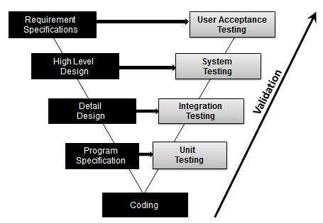

#### Software Testing

Software testing is the process of evaluation a software item to detect differences between given input and expected output. Also to assess the feature of A software item. Testing assesses the quality of the product. Software testing is a process that should be done during the development process. In other words software testing is a verification and validation process.

#### Verification

Verification is the process to make sure the product satisfies the conditions imposed at the start of the development phase. In other words, to make sure the product behaves the way we want it to.

#### Validation

Validation is the process to make sure the product satisfies the specified requirements at the end of the development phase. In other words, to make sure the product is built as per customer requirements.

#### Basics of software testing

There are two basics of software testing: blackbox testing and whitebox testing.

##### Blackbox Testing

Black box testing is a testing technique that ignores the internal mechanism of the system and focuses on the output generated against any input and execution of the system. It is also called functional testing.

##### **White**box**Testing**

White box testing is a testing technique that takes into account the internal mechanism of a system. It is also called structural testing and glass box testing.

Black box testing is often used for validation and white box testing is often used for verification.

#### Types of testing

There are many types of testing like

* Unit Testing
* Integration Testing
* Functional Testing
* System Testing
* Stress Testing
* Performance Testing
* Usability Testing
* Acceptance Testing
* Regression Testing
* Beta Testing

##### Unit Testing

Unit testing is the testing of an individual unit or group of related units. It falls under the class of white box testing. It is often done by the programmer to test that the unit he/she has implemented is producing expected output against given input.

##### Integration Testing

Integration testing is testing in which a group of components are combined to produce output. Also, the interaction between software and hardware is tested in integration testing if software and hardware components have any relation. It may fall under both white box testing and black box testing.

##### Functional Testing

Functional testing is the testing to ensure that the specified functionality required in the system requirements works. It falls under the class of black box testing.

##### System Testing

System testing is the testing to ensure that by putting the software in different environments (e.g., Operating Systems) it still works. System testing is done with full system implementation and environment. It falls under the class of black box testing.

##### Stress Testing

Stress testing is the testing to evaluate how system behaves under unfavorable conditions. Testing is conducted at beyond limits of the specifications. It falls under the class of black box testing.

##### Performance Testing

Performance testing is the testing to assess the speed and effectiveness of the system and to make sure it is generating results within a specified time as in performance requirements. It falls under the class of black box testing.

##### Usability Testing

Usability testing is performed to the perspective of the client, to evaluate how the GUI is user-friendly? How easily can the client learn? After learning how to use, how proficiently can the client perform? How pleasing is it to use its design? This falls under the class of black box testing.

##### Acceptance Testing

Acceptance testing is often done by the customer to ensure that the delivered product meets the requirements and works as the customer expected. It falls under the class of black box testing.

##### Regression Testing

Regression testing is the testing after modification of a system, component, or a group of related units to ensure that the modification is working correctly and is not damaging or imposing other modules to produce unexpected results. It falls under the class of black box testing.

##### Beta Testing

Beta testing is the testing which is done by end users, a team outside development, or publicly releasing full pre-version of the product which is known as beta version. The aim of beta testing is to cover unexpected errors. It falls under the class of black box testing.

**TECHNIQUES AND STRATEGIES OF TESTING**

## Testing Strategies

A **Testing strategy** is a general approach to the testing process rather than a method of devising particular system or component tests. Different testing strategies may be adopted depending on the type of system to be tested and the development process used. There are two different strategies available: **Top-Down Testing**and**Bottom-Up Testing.**

In **Top-Down Testing**, high levels of a system are tested before testing the detailed components. The application is represented as a single abstract component with sub-components represented by **stubs**. Stubs have the same interface as the component but very limited functionality.

After the top-level component has been tested, its **sub-components** are implemented and tested in the same way. This process continues recursively until the bottom - level components are implemented. The whole system may then be completely tested. Top-down testing should be used with **top-down program development** so that a system component is tested as soon as it is coded. Coding and testing are a single activity with no separate component or module testing phase.

If top-down testing is used, unnoticed **design errors** may be detected at an early stage in the testing process. As these errors are usually structural errors, early detection means that extensive re-design re-implementation may be avoided. Top-down testing has the further advantage that we could have a **prototype system** available at a very early stage, which itself is a psychological boost. Validation can begin early in the testing process as a demonstrable system can be made available to the users.

**Bottom-Up Testing** is the opposite of Top-Down. It involves testing the modules at the lower levels in the hierarchy, and then working up the hierarchy of modules until the final module is tested. This type of testing is appropriate for **object-oriented systems** in that individual objects may be tested using their own test drivers. They are then integrated and the object collection is tested.

## Testing Terminology

The purpose of testing is to attempt to detect to logic errors in the code. The code should be tested using as many different types of data input as possible. It is estimated that the testing phase can take 50% of the time allocated for project development. Therefore, testing should be **planned** and **thorough**.

### Integration Testing

**Integration testing** is testing the whole program when **all** of the modules are put together.

### Test Case

A **test case** is a set of data which is prepared in order to test that the program produces the predicted result.

### Test Plan

A **test plan** is a list of test cases which cover all circumstances which can arise. Each test case should detail the expected results.

The **actual results** of a test run are compared with the **expected results** for that test case to determine whether the test has been successful.

## Testing Report

In the documentation of the project given as assessment there are several sections, which should be included. These are:

1. A **Test Strategy** - This should give an account of your testing as the program developed. It should also lay out clearly your systematic choice of test data and the reasons for doing so. It would not normally actually give the data although some examples can be given where it helps to explain the idea. It normally explain the ideas in the order in which they were carried out.
2. **Test Data with expected results**. This time the actual data entered should be given. The data should correspond with the strategy already explained. You should always work out the expected answers in advance.
3. The **actual output** of the test runs should be included to show that the expected results have been obtained.
4. A **diary of errors and testing** should be kept. This should be entered in at the time that they occur. It should be a record of the development of the program in its 'error free' state.

## Testing and Debugging

"Program testing can be used to show the presence of bugs, but never to show their absence!" (Dijkstra)

"If debugging is the process of removing software bugs, then programming must be the process of putting them in." (Anon)

*"There are two ways to write error-free programs. Only the third one works." (Anon)*

One of the first things you will discover in writing programs is that a program rarely runs correctly first time. In fact, errors are so common in programming that they have their own special name: **Bugs**. The process of correcting, or getting rid of bugs is called **Debugging.**

When considering the kind of tests to apply, a **systematic approach** should be used and **test cases** should be developed which will uncover common classes of errors. Never rely on intuition. The data collected during the testing should be kept as a means of demonstrating the correct operation of the program. This is important for future maintenance.

## Types of Program Error

Program errors:

|  |
| --- |
| There are three basic categories of program errors:  1. Syntax Errors  2. Run-time Errors  3. Logic Flaws |

In the first two cases when an error occurs, the computer displays an **'Error Message'**, which describes the error, and its cause. Unfortunately, error messages are often **difficult to interpret**, and are sometimes **misleading**. In the final case, the program will not show an error message but it will not do what the programmer wanted it to do.

## Syntax Errors

These errors are the easiest to find because they are highlighted by the compiler. Error messages are given. This type of error is caused by the failure of the programmer to use the correct **grammatical rules** of the language.

Syntax errors are detected, and displayed, by the **compiler** as it attempts to translate your program, ie: the **Source**code into the **Object** code. If a program has a syntax error it cannot be translated, and the program will not be executed.

The compiler tries to highlight syntax errors where there seems to be a problem, however, it is not perfect and sometimes the compiler will indicate the next line of code as having the problem rather than the line of code where the problem actually exists.

## Run-Time Errors

Run-time errors are detected by the computer and displayed **during** execution of a program.

They will halt the program when they occur but they often do not show up for some time.

A run-time error occurs when the user directs the computer to perform an **illegal operation**, eg:

* Dividing a number by zero
* Assigning a variable to the wrong type of variable
* Using a variable in a program before assigning a value to it.

When a run-time error occurs, the computer stops executing your program, and displays a **diagnostic message**that indicates the line where the error occurred.

## Logic Flaws

These are the hardest errors to find as they do not halt the program. They arise from faulty thinking on behalf of the programmer. They can be very troublesome.

These are mistakes in a program's logic.

Programs with logic errors will often compile, execute, and output results. However, at least some of the time the output will be incorrect. Error messages will generally not appear if a logic error occurs, this makes logic errors very difficult to locate and correct.

## Debugging

**Debugging** is the process of finding and resolving defects or problems within a computer program that prevent correct operation of [computer software](https://en.wikipedia.org/wiki/Computer_software) or a [system](https://en.wikipedia.org/wiki/System).

Debugging, in computer programming and engineering, is a multistep process that involves identifying a problem, isolating the source of the problem, and then either correcting the problem or determining a way to work around it. The final step of debugging is to test the correction or workaround and make sure it works.

In [software development](http://whatis.techtarget.com/definition/software-development), debugging involves locating and correcting [code](http://whatis.techtarget.com/definition/code) errors in a computer program. Debugging is part of the [software testing](http://whatis.techtarget.com/definition/software-testing)process and is an integral part of the entire software development lifecycle. The debugging process starts as soon as code is written and continues in successive stages as code is combined with other units of programming to form a software product. In a large program that has thousands and thousands of lines of code, the debugging process can be made easier by using strategies such as [unit tests](http://searchsoftwarequality.techtarget.com/definition/unit-testing), [code reviews](http://searchsoftwarequality.techtarget.com/definition/code-review) and [pair programming](http://searchsoftwarequality.techtarget.com/definition/Pair-programming).

Once an error has been identified, it is necessary to actually find the error in the code. At this point, it can be useful to look at the code's logging and use a stand-alone debugger tool or the debugging component of an integrated development environment ([IDE](http://searchsoftwarequality.techtarget.com/definition/integrated-development-environment)). Invariably, the bugs in the functions that get most use are found and fixed first. In some cases, the [module](http://whatis.techtarget.com/definition/module) that presents the problem is obvious, while the line of code itself is not. In that case, unit tests -- such as JUnit and xUnit, which allow the programmer to run a specific function with specific inputs -- can be helpful in debugging.

The standard practice is to set up a "breakpoint" and run the program until that breakpoint, at which time program execution stops. The debugging component of an IDE typically provides the programmer with the capability to view [memory](http://searchstorage.techtarget.com/definition/memory-card) and see variables, run the program to the next breakpoint, execute just the next line of code, and, in some cases, change the value of variables or even change the contents of the line of code about to be executed.

[Source code](http://searchmicroservices.techtarget.com/definition/source-code) analyzers, which include security, common code errors and complexity analyzers, can also be helpful in debugging. A complexity analyzer can find modules that are so intricate as to be hard to understand and test. Some tools can actually analyze a test run to see what lines of code were not executed, which can aid in debugging. Other debugging tools include advanced [logging](http://whatis.techtarget.com/definition/log-log-file) and simulators that allow the programmer to model how an app on a mobile device will display and behave.

Some tools, especially [open source](http://whatis.techtarget.com/definition/open-source) tools and [scripting languages](http://searchwindevelopment.techtarget.com/definition/scripting-language), do not run in an IDE and require a more manual approach to debugging. Such techniques include dropping values to a log, extensive "print" statements added during code execution or hard-coded "wait" commands that simulate a breakpoint by waiting for keyboard input at specific times.

The use of the word bug as a synonym for error originated in engineering. The term's application to computing and the inspiration for using the word debugging as a synonym for [troubleshooting](http://whatis.techtarget.com/definition/troubleshooting)

**VALIDATIONS**

* **Admin catalogue**

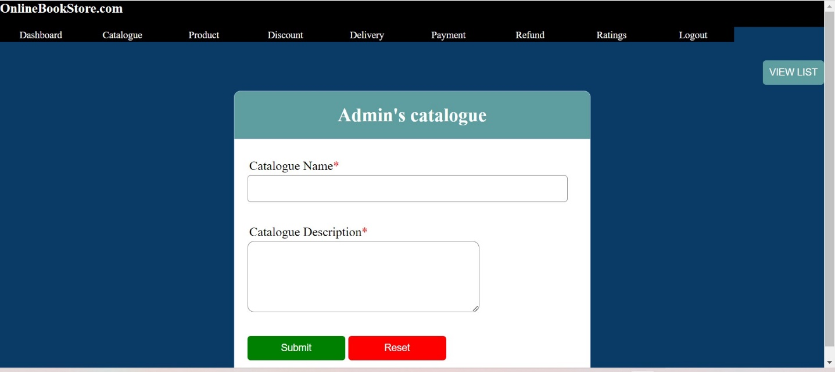

* **Discount Provided**

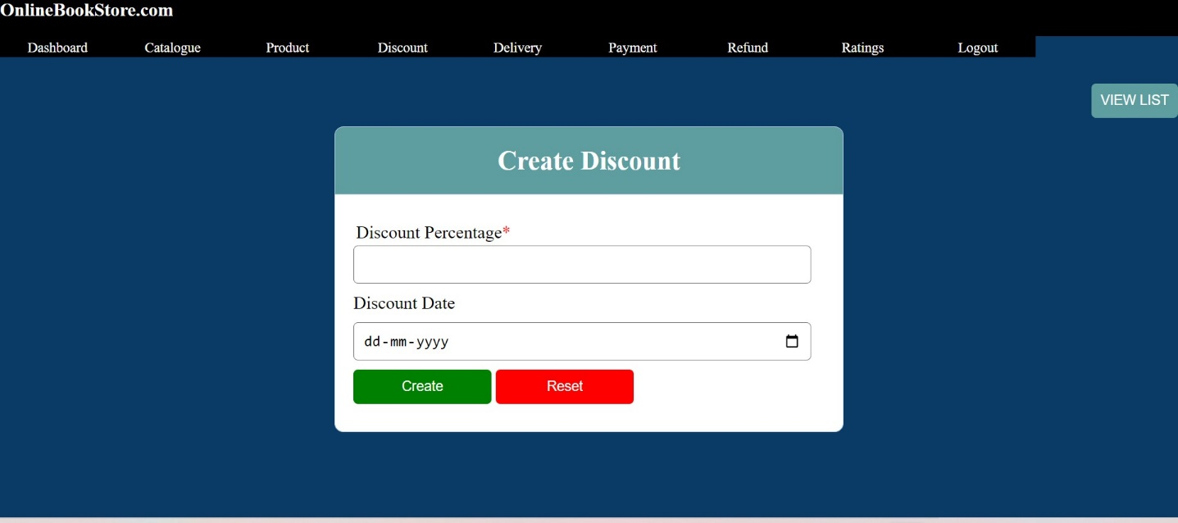

* **Upload Products**

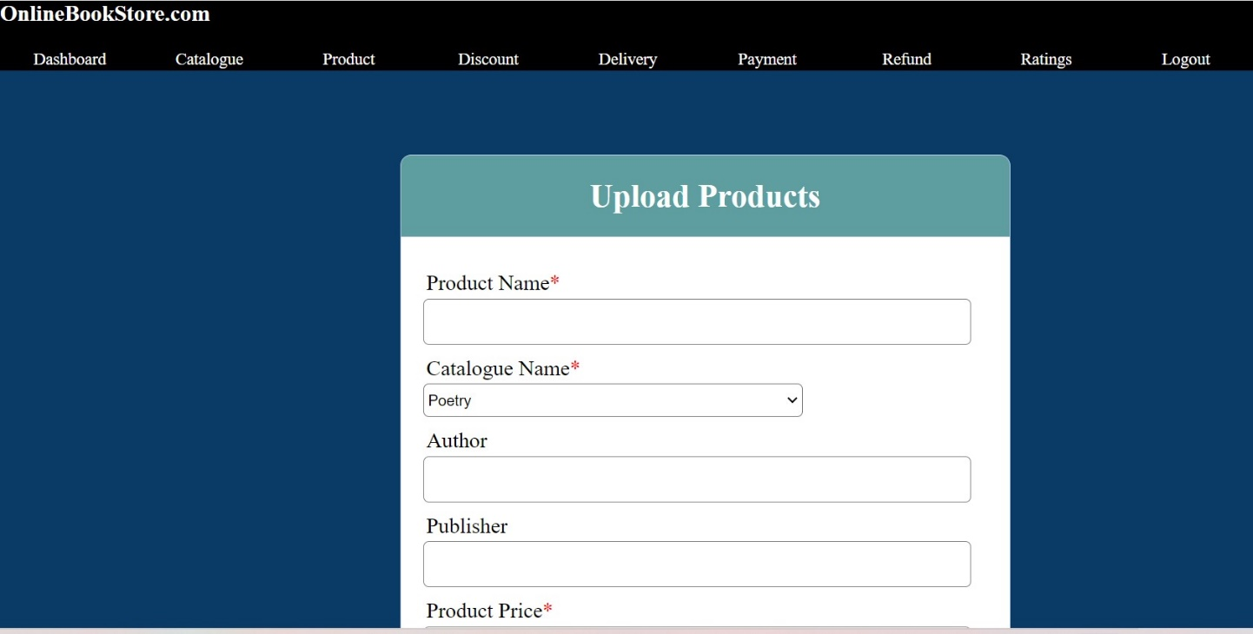

* **User’s Refund**

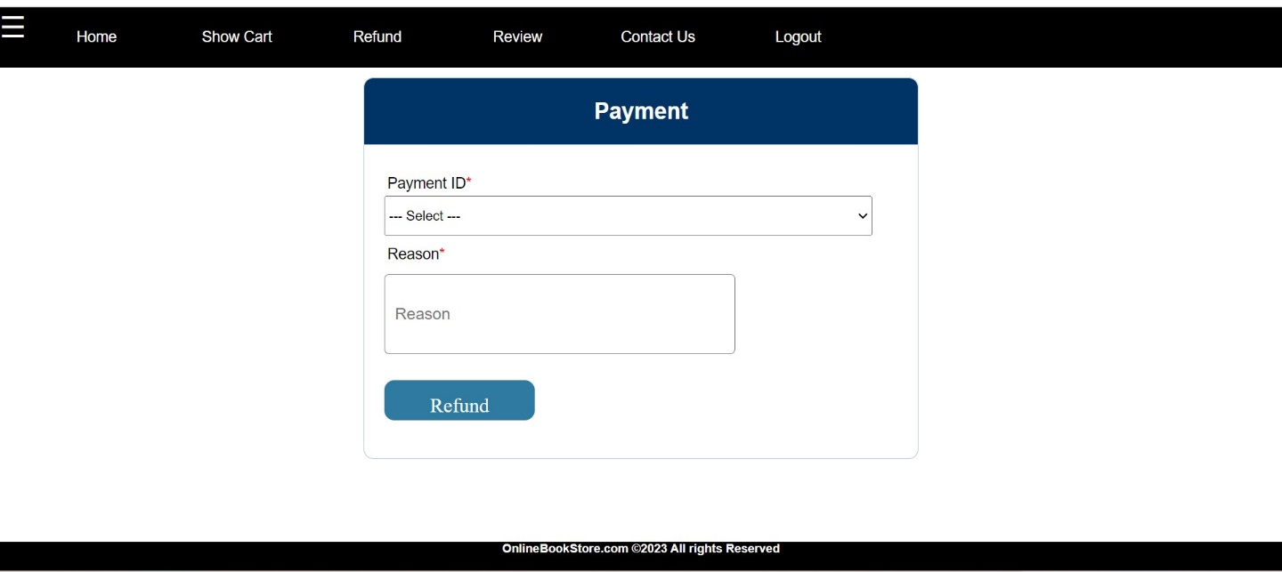

* **User’s Registration**

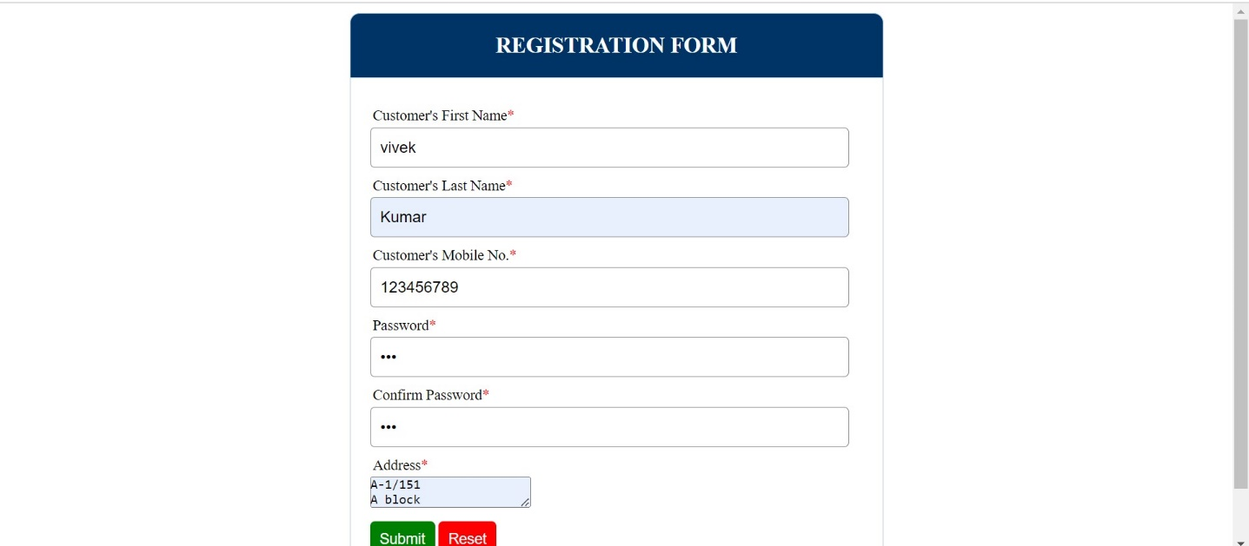

**SYSTEM SECURITY**

Security is essential part of any transaction that takes place over the internet. customer will loose his/her faith in e-business if its security is compromised. following are the essential requirements:-

Confidential:-Information should not be accessible to unauthorized person .it should not be intercepted during transmission.

Firewall:-Systems must be protected by a firewall that allows those incoming connections necessary to fulfill the business need of the system. Client system which has no business need to provide network services must deny all incoming connections.

Use unique Passwords for administrator accounts:-Privileged accounts must use unique passwords that are not shared among multiple systems. Credentials which are managed centrally, such as the NetID/password combination, are considered a single account, regardless of how many systems they provide access to.

Enable session Timeout:-Sessions must be locked or closed after some reasonable period.

Major security measures are as follows:-

* Encryption:-It is a very effective and practical way to safeguard the data being transmitted over the network. Sender of the information encrypts the data using the same or different secret code.
* Digital Signature:-Digital signature ensures the authenticity of the information. A digital signature is a e-signature authenticated through encryption and password.
* Security Certificates:-Security certificate is unique digital id used to verify identity of an individual website or customer.

**REPORTS**

* **Catalogue’s List**

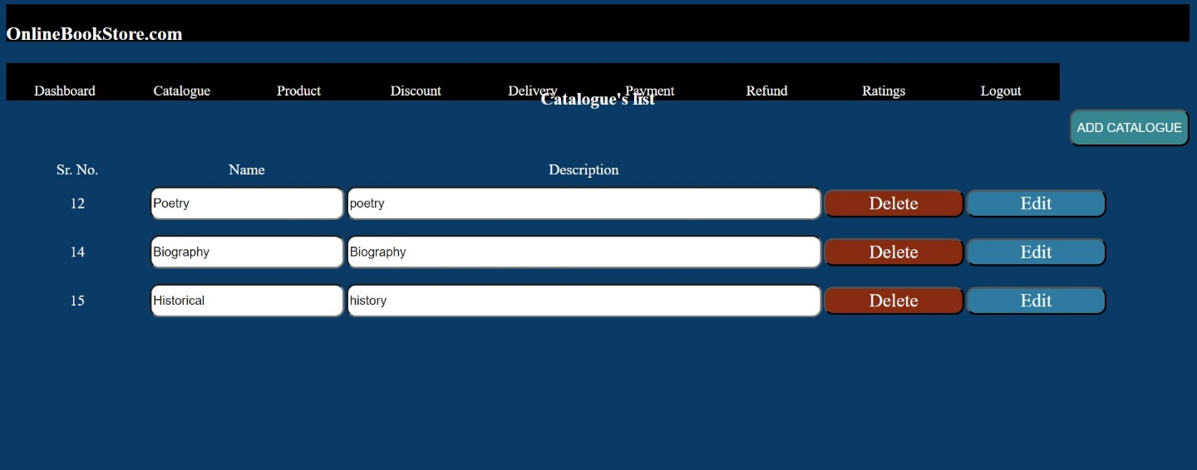

* **Discount’s List**

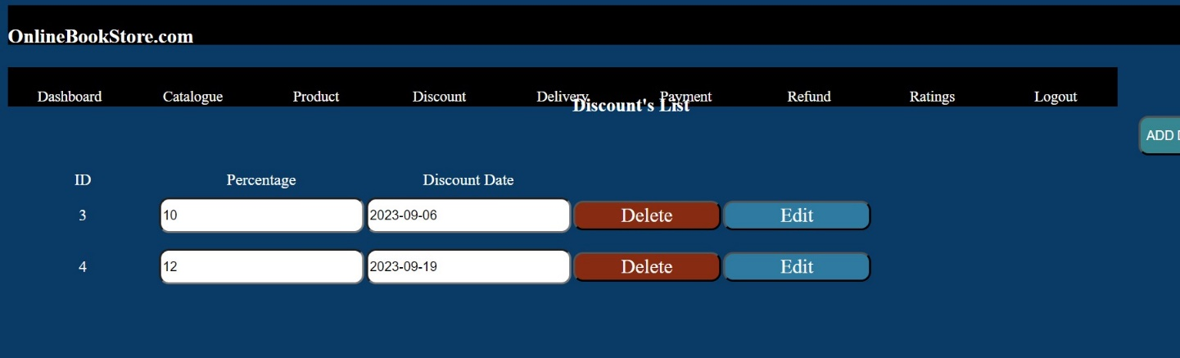

* **Product’s List**

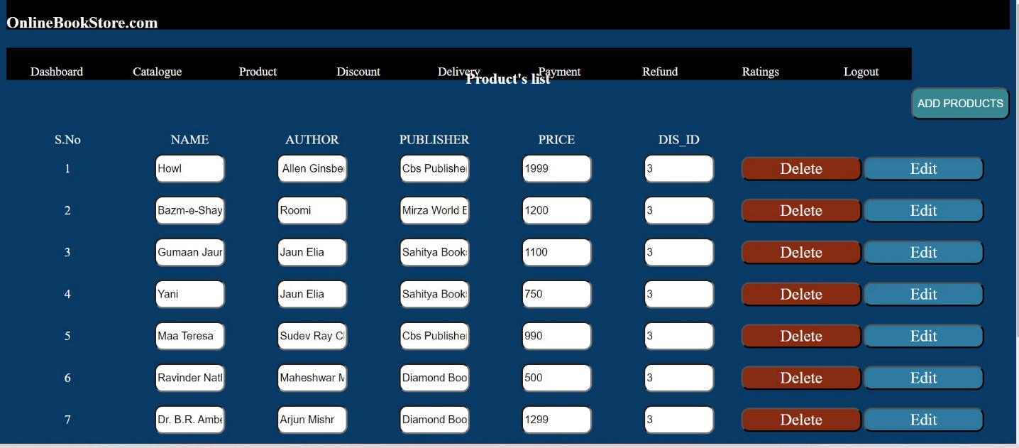

* **Payment’s List**

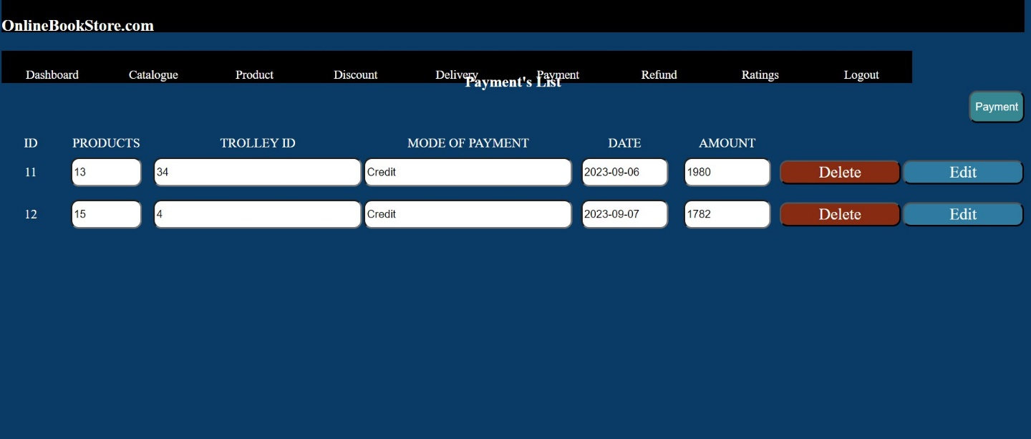

* **Delivery’s List**

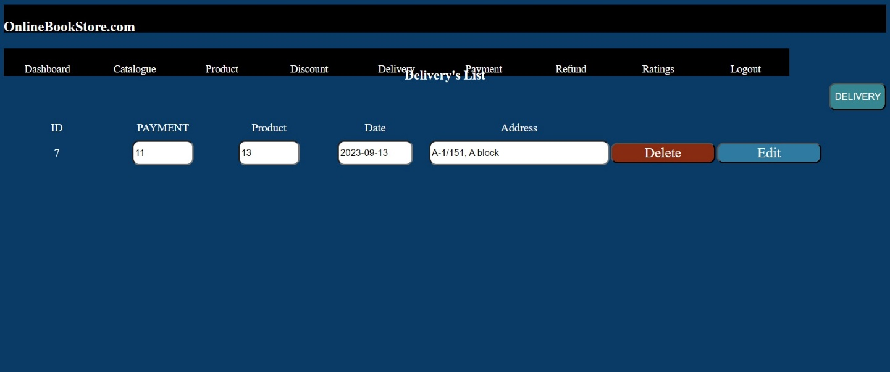

* **REFUND LIST**

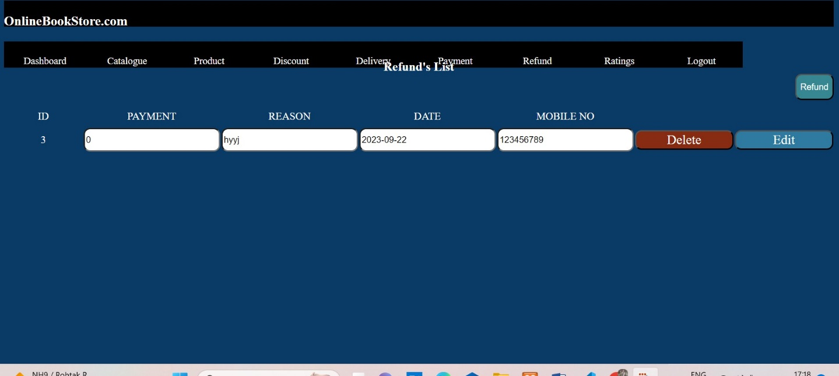

**FUTURE SCOPE**

This project can enhanced after adding some more useful modules in the project. Utmost care and back-up procedures must be established to ensure 100% successful implementation of the computerized Search system. The future of this project is not limited in specific area but have a wide range. To make the project most powerful in future I have the maximum criteria. More triggers will be added to this system once they got identified with ease of understanding.

The most positive point of this project is that it is easy to understandable and accessible by any user which is either related to computer or not and its Feedback mechanism is also a measure functionality of this project which help us to scale the future of this system to higher level.

**LIMITATIONS**

When a concept is developed it moves through iterations of changes as per user clarity. In this website I tried to maintain the best feature of ecommerce website and tried to maintain piece of processes to get automated to get user every pieces of comfort. In the due courses systems based on internet based do not allow user to take feel of products available. which is overcome with the concept of cash on delivery concept and more triggers like SMS alerts for new products and wish list concept will be few next iterations going to be planned after success of this iteration.

**BIBLIOGRAPHY**

I have taken help and references from below given books name and website etc

**BOOKS**

* IGNOU Study Material, BCS-051Software Engineering(1-3 BLOCKS)
* MCS-014 System Analysis
* A Practitioner’s Approach

By- Roger S. Pressman

Bruce R.Maxim

* PHP And MySQL Web Development

By-Luke Weling

* Web Link
* Google search
* E-Online Shopping Transaction Wikipedia

**LINKS**

* <https://www.w3schools.com/php/>
* <https://www.tutorialspoint.com/mysql>
* <https://www.smartdraw.com/data-flow-diagram>